

Evaluating Talent Selection in a Scottish Football Academy: The Role of the FA 4 Corner Model in Identifying High-Potential Players

Ross Ireland
MPhil Sports Studies Pathway
June 2025

Supervised by
Ross Walker & Guy Wilkinson

Acknowledgements
I would like to express my gratitude to those who supported me throughout this research project.
Firstly, I would like to thank David Stevenson who played an influential role in the partnership between the organisation that sponsored the degree and the University of Stirling and without him I would not have been in the position to partake in this research.
Secondly, I am very thankful to my advisors at the University of Stirling, Ross Walker and Guy Wilkinson for your guidance and support which helped guide this project.
I would also like to thank the professional football academy and the participants of this study, who generously donated their time to make the research possible.
Finally, I would like to give a special mention to my parents who have shown me unwavering support throughout my personal, academic and now professional life and for which I am deeply grateful.
Table of Contents
Abstract 7
1.0 Introduction 8
1.1 Background 8
1.2 Rationale 10
1.3 Outline 11
2.0 Literature Review 12
2.1 Introduction 12
2.2 Talent Selection Models 13
2.2.1 Physical and Technical Dominated Models 14
2.2.2 Potential v Performance Based Models 16
2.3 The 4 Corner Model: Overview 17
2.3.1 Technical/Tactical 18
2.3.2 Physical 20
2.3.3 Psychological 21
2.3.4 Social Attributes 22
2.3.5 Application of the 4 Corner Model 24
2.4 Key Gaps in Literature 25
2.5 Value of the Research 25
2.6 Conclusion 26
3.0 Research Processes, Methods and Methodology 28
3.1 Introduction 28
3.2 Research Approach 29
3.2.1 Interpretivist Approach 29
3.2.2 Qualitative 29
3.2.3 Quantitative 31
3.2.4 Justification for Methodological Approach 34
3.3 Research Design 34
3.3.1 Previous Research Implications and Other Researchers’ Work 34
3.3.2 Research Questions 36
3.3.3 Case Study 37
3.3.4 Participants 38
3.4 Research Matters 40
3.4.1 Access 40
3.4.2 Involvement-Detachment 40
3.4.3 Ethics 41
3.5 Data Collection Phases 42
3.5.1 Timeline of Data Collection Phases 42
3.5.2 Pilot 43
3.5.3 Main Research: Focus Group 44
3.5.4 Follow Up: Questionnaire 46
3.6 Data Analysis 47
3.6.1 Thematic Analysis 47
3.6.2 Quantitative Analysis 51
3.7 Research Limitations 51
3.8 Concluding Remarks 52
4.0 Findings 53
4.0.1 Introduction 53
4.1. Focus Group Results 53
4.2. Theme One: Outplaying and Game Intelligence 53
4.2.1 Outplaying 54
4.2.2 Game Intelligence 57
4.3 Theme Two: Speed and Power 59
4.3.1 Speed and Power 59
4.3.2 Objective and Subjective Physical Testing 61
4.4 Theme Three: Psychosocial Player Profiling 63
4.4.1 Self-Sufficiency and Resilience 63
4.4.2 Difficulty in Measuring Psychosocial Factors 67
4.5 Theme Four: High Potential Identification 68
4.6 Questionnaire Results 71
4.6.1 Introduction to Questionnaire 71
4.6.2 Theme One: Technical Characteristics Linked to High Potential Selection 72
4.6.3 Theme Two: Physical Characteristics Linked to High Potential Selection 73
4.6.4 Theme Three: Psychological Characteristics Linked to High Potential Selection 74
4.6.5 Theme Four: The Impact of a Standout Attribute in Identifying High-Potential Players 76
4.7 Conclusion 79
5.0 Discussion 81
5.1 Context 81
5.1.1 Technical/Tactical 81
5.1.2 Physical 83
5.1.3 Psychosocial 84
5.1.4 High Potential Identification 85
5.1.5 Broader Elite Sport Context 86
6.0 Conclusion 88
6.1 Summary of Key Findings 88
6.2 High Potential Characteristics 88
6.3 The Role of the 4 Corner Model in High Potential Identification 89
6.4 Implications for Practice 90
6.5 Limitations 90
6.6 Recommendations for Future Research 91
6.7 Recommendations to Include Wider Sporting Practices 93
Tables and Figures 102
Figure 1: Key parts of the identification, selection and development process in soccer (Williams et al., 2020) 102
Figure 2: Code window 103
Figure 3: Combination of Codes 104
Table 2:1 Technical/Tactical Research Sources 105
Table 3.1: Literature Review Research Findings 106
Table 3.2: Focus Group Participants 107
Appendices 108
Appendix A: Participant Information Sheet 108
Appendix B: Consent Form 111
Appendix C: Focus Group Outline and Questions 112
Appendix D: Segment from Focus Group Transcript 114
Appendix E: Questionnaire Questions and Responses 117
Question and Response 1 117
Question and Response 2 118
Question and Response 3 119
Question and Response 4 120
Question and Response 5 121
Question and Response 6 122
Question and Response 7 123
Question and Response 8 124
Question and Response 9 125
Question and Response 10 126

List of Abbreviations

EPPP Elite Player Performance Programme
FA Football Association
FP Foundation Phase
GPS Global Positioning System
GUEP General University Ethics Panel
HPPP High Potential Player Programme
PDP Professional Development Phase
SFA Scottish Football Association
TD Talent Development
TS Talent Selection
UK United Kingdom
YDP Youth Development Phase

Abstract
Talent selection in football is a complex, multifaced process with various models being developed to assess player potential across various domains. This study aimed to explore the process of identifying high potential in academy players of those between the age groups of U13-U18, using the Football Association (FA) 4 Corner model as a method for talent selection in the context of a single case study. A focus group was conducted with six key academy performance staff across all departments within the academy’s multidisciplinary structure. Insights from the data analysis of this discussion informed the development of a questionnaire which was subsequently distributed to twenty-five academy staff members within the case study, including the existing case study participants. Thematic analysis was used to identify key themes in the selection process to provide results which were representative of the study population. Findings revealed that within each sub-corner in the 4 Corner model, there was specific attributes which held greater importance than others when measuring high potential. However, accurately pinpointing these attributes and confidently predicting a player’s potential remained a complex and challenging process. Characteristics such as ‘outplaying’, ‘game intelligence’, ‘speed and power’, ‘movement qualities’, ‘resilience’ and ‘self-sufficiency’ were identified as individualistic traits of a high potential player. While there was no specific order or pattern between these traits, it was concluded that high potential players typically exhibit either a distinctive super-strength within one area of the model that sets them apart or demonstrated consistently high-performance levels across at least three of the model’s corners simultaneously. The study emphasises that to truly understand a player’s high potential ability, a dynamic and flexible assessment approach is required. Balancing objective data and subjective insights is crucial to understand a player’s full potential.

Key Words: Academy Football; High-Potential Player Selection; 4 Corner Model; Scotland; Talent Identification

1.0 Introduction

1.1 Background
Football academies are structured development environments established by professional clubs to identify, nurture, and develop young players with the key aim of producing players who can transition into the first team setup (Richardson et al., 2012). Academies provide a programme that offers technical coaching, physical conditioning, psychological support and other educational provisions. Historically, talent selection and the development of young players in the country improved drastically following the introduction of the FA Premier League Academy System in 1998, after recommendations from the Charter for Quality (Football Association, 1997). This Charter identified at the time that participation levels amongst youngsters are as high as ever recorded and levels of quality in all aspects of academy football need to be raised. The changes saw a shift towards long-term player growth and a football education that was holistic and measured.
In the modern day, each academy has its own vision and objectives which are specific to their processes or programme in which they deliver to their players. A report on youth academies across Europe identified that Ajax (Holland) aim to have three players make it to the first team every two seasons, while Barcelona (Spain) aims to have a senior squad which consists of players from the academy (European Club Association, 2018). The same report found that 50% of clubs across Europe see added economic value as an objective for the youth academy, seeking not only a pathway of first team players but also a return on potential academy investment.
In the UK, the FA 4 Corner model was introduced to enhance the transition process between academy and first team, encouraging coaches to consider individual and collective progress within the key areas: technical/tactical, physical, psychological and social (Football Association, 2020). It was described as a tool that could be used to observe their team, reflect on their ability or make decisions that support development offering a tool for clubs to assess players from both a talent development TD) and talent selection (TS) perspective. Diouf et al., (2024) in their study on the player perception of the 4 Corner model identified that the model is prominent within English football development pathways and has been adopted by professional academies operating under the Elite Player Performance Plan (EPPP). The EPPP was introduced in 2012 as a method to further professionalise and standardise youth developments across all levels of the game, focussing on education, coaching, elite performance, and categorisation (Premier League, 2011). The FA 4 Corner model is said to be the cornerstone of the National Coach Education Curriculum (Football Association, 2016) and underpins the England DNA for the national player development performance pathway (Football Association, 2014). In response to significant change in England, the Scottish Football Association (SFA) launched initiatives such as performance schools programme and strategic partnerships to integrate academic education with elite football practice.
Despite this, the SFA published a report on the ‘Transition Phase’ that takes place between male academy and first team football (Gould and Docherty, 2024). The governing body states that Scottish football is “significantly underachieving its potential” with just three of the male top-flight teams being able to say they provided over 2,000 minutes playing time for Scots aged under 21 across last season’s 2023/24 fixtures (Duncan, 2024). The nation is currently facing a challenge with the limited number of young Scottish players progressing into its top division. This raises an important discussion around potential and how players are being selected and developed within their respective programmes. The SFA are tasked with selecting the countries best talent at youth level to compete on the international stage. Each year the SFA select an Under-16 squad to compete in the Victory Shield against the other home nations, made up of the best talent across academies in Scotland (Scottish Football Association, 2024). When analysing the talent selection process for the Victory Shield from the years 2009 to 2012, the current data suggests that across 86 players who were selected over this period, there are no players playing in Europe’s top five leagues, and only eight players (9%) playing in Scotland’s premier division (Transfermarkt, 2024). Surprisingly 66% of those players who were categorised to be potential future Scotland players at their age are no longer professional footballers. Although there may be other factors which contribute to these substantial figures, it is evident that Scotland has an issue when it comes to predicting future ability.
The SFA’s report highlighted shortcomings in clubs’ internal processes as a significant barrier to progress in youth development (Gould and Docherty, 2024). An internal process currently being used by various academies to mitigate the challenges with transitioning academy players into the first team is the High Potential Player Programmes (HPPP), also known as talent groups. The HPPP is made up of a group of academy players who have been selected as having the ‘highest potential’, used in academies within the UK. They are tracked closely within a group setting, designed to streamline the pathway between the academy and the first team. While speaking on the Training Ground Guru podcast, previous Liverpool assistant manager Pep Ljinders explained the benefit of using a talent group: “The academy is normally a competitor for the scouting department. So, we brought the best talent together in all the age groups to show them to the first-team coach, because the relationship between the manager and youth player is what makes a good academy” (Training Ground Guru, 2023). While talent groups act as a process for streamlining and maximising the potential within an academy, there remain questions over how players are selected into these groups and what characteristics are required for a player to be named ‘high potential’.

1.2 Rationale
The rationale for this study is rooted in the challenges surrounding the transition from academy to first-team football. It is clear there is a need for an improved talent selection process to more accurately determine which players possess the highest potential and thus maximise this potential within the academy.
This study addresses a notable gap in the current literature by offering a real-life academy case study which explores the characteristics and processes for a player to be included in a HPPP. A significant amount of the existing research in this field discusses talent selection in broad terms (O’Connor and Larkin, 2016) but there is a lack of research into the process of differentiating players with the highest potential from other players in the academy.
Contextualising the research within a current club environment adds value to the study. This helps bridge the gap between academic models, such as the 4 Corner model and the real word of football operations and processes. While the data is not representative of all academies in Scotland, it can provide interesting takeaways which add to the existing body of talent selection knowledge. While the 4 Corner model is a widely adopted tool in talent coaching and development (Diouf et al., 2024), it was evident that there was limited research that uses it as a primary analytical framework in academic studies. This positions the dissertation in an unfamiliar space, using a model that is well known, but its use hasn’t been deeply explored when selecting potential.

1.3 Outline
The aim of this research is to understand which characteristics within the 4 Corner model are the most influential for a player to be considered as high potential. To achieve the aims of this research, the dissertation firstly explores existing literature on talent selection frameworks, with a focus on the FA 4 Corner model and its comparison with other talent selection models in football. Secondly, a two-round case study methodology involving key academy staff across a range of multi-disciplinary departments, provides both qualitative and quantitative insights that were representative of the single case’s talent selection process. The results and findings were thematically analysed following the conclusion of each round. The analysis process identified recurring traits that were desired for high-potential players, to refine the focus between each round. Finally, the discussion section connects the findings to current practices and provides recommendations for future research.

2.0 Literature Review

2.1 Introduction
Talent selection is a critical process that shapes the future of elite-level performance and the success of an academy in its role supplying a first team squad with young players. As football academies and clubs invest heavily in selecting and developing players, the frameworks used to evaluate potential talent have become more important. Among the most prominent method is the FA 4 Corner Model which acts as a holistic approach to talent development and selection.
A scoping review was adopted as the method to collate existing literature on talent selection, and its models. A scoping review seeks to present an overview of a potentially large and diverse body of literature pertaining to a broad topic, in this case talent selection (Pham et al., 2014). Arsksey & O’Malley (2005) suggest that a scoping review is a beneficial process for exploring available evidence, identifying key concepts, approaches, and research gaps in the field. This was useful for this specific study to capture the available literature on talent selection and following this, select and synthesise the most relevant information in relation to the research area and question.
This literature review aims to critique the existing research on talent selection in football, with a particular emphasis on the FA 4 Corner model and its comparison to alternative models in practice. The role of the selection process within the 4 Corner model is to identify young players’ performance qualities and the potential to progress and develop into top players who can excel in pressurised environment. Despite its holistic approach and intentions, questions remain around its ability to capture all aspects of a player’s potential. The psychosocial factors are often subjective and difficult to quantify when measuring potential. In critiquing the relevant models and approaches to selecting talent, this literature review aims to highlight any gaps in research particularly around the models’ influence in predicting potential in young players as opposed to assessing current performance.

2.2 Talent Selection Models
In football, talent selection is a critical aspect of identifying and developing future elite players. Various models and frameworks have been designed to guide the selection process; each offering a unique perspective on how to assess and nurture young talent. The player pathway model (figure 1) serves as the foundation upon which future elite athletes are identified, nurtured, and developed. The identification and development processes in modern day football are illustrated by Williams et al., (2020) in Figure 1:
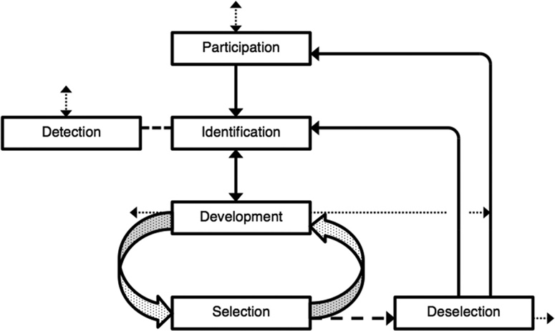

Figure 1: Key parts of the identification, selection and development process in soccer (Williams et al., 2020)
Williams and Reilly (2000) define talent selection as the ongoing process of choosing players within the development programme who demonstrate attributes suitable for progression to a future squad or team, such as the next age group team in a youth academy. The process of ‘deselection’ involves removing players from the development programme who no longer demonstrate the attributes to participate in, or to be selected for, future squads or teams.
Talent selection has become an integral part of many nations athlete development systems because nations increasingly rely on structured, evidence-based processes to identify and nurture long-term potential, rather than leaving progression to chance (Vaeyens et al., 2008). Talent is assumed to be multidimensional, and coaches or recruiters report several criteria they consider important for talent selection (Lath et al., 2021). Several talent selection models exist in football, each with a different focus or approaches to identifying potential. The comparison between the 4 Corner model and other models highlights the diversity in these frameworks.
In Lath et al., (2021)’s research exploring the practice of the ‘coaches’ eye’ in talent selection they suggest that the coaches’ eye includes both the assessments of an athlete’s potential and the selection decision for or against this athlete. This judgement and decision process was defined as intuitive, experienced-based, subjective, and holistic. This process is an explanation for a coach’s decision without assessing it under a specific model or title. In the opinion of Roberts et al., (2019), the coaches’ eye is the primary contributor to the whole decision-making process in talent selection. However, it appears difficult for coaches to explicitly determine the criteria they use to determine whether an athlete has talent (Roberts et al., 2019). Subjectivity remains a persistent challenge in talent selection, coaches or selectors relying on personal judgement, intuition, and prior experience can introduce bias and inconsistency into decision-making (Christensen, 2009).

2.2.1 Physical and Technical Dominated Models
Various talent selection models, especially those used in early talent selection, focus heavily on the physical and technical attributes. Vaeyens et al., (2008) state that in such studies, players are evaluated specifically on their measurable abilities such as speed, endurance, dribbling skills, and ball control. However, Abbott and Collins (2004) argue that these approaches often overlook players who are late developers, smaller in mass or size in comparison to their peers but may excel in other areas such as technical or psychological skills.
A recent longitudinal study by Dugdale et al., (2021) exploring the selection process between successful and unsuccessful academy graduates, found that reselected players were lesser in stature and body mass than deselected players. The findings suggest that reselection is not a product of anthropometric criteria and therefore a pathway for selection remains open for later maturing players. In relation to the stature and size of a young player Zuber et al., (2016) used holistic testing patterns such as motor abilities, technical skills and biological maturity as an instrument for predicting the performance of young players over a three-year period. It was concluded that highly skilled players were still among the late developers at the age of 12 and 13, however, they appeared to be able to make up for this deficit over the next year and then have more than twice as good a chance of achieving top level of performance.
However, this context around late developers is not applicable to every academy. Some academies will place greater emphasis on physical aspects, whereas some may be more focused on producing technically gifted players. The coaching methodology and style of play which an academy follows may also impact talent selection and the perceived ideal size or physical makeup of each player. Taylor and Collins (2019) research on ‘why high potential players don’t make it’ found that the lack of physical skills was a main reason. Coaches in the research explained “Some didn’t grow as expected, he just fell away. Fantastic prospect at 11, just way too small at 17” (p. 17).
Similarly, when looking at body build, height and other physical factors and their relationship with professional contracts in U14-16 French National Football Academy players, those players who did gain a professional contract were taller, heavier, and had a higher jump height (Le Gall et al., 2010). Physical and anthropometric factors can often be associated with current ability, which favors early developed players because of their advanced physical qualities such as strength, speed, power and over body size (Malina, 2014). These physical attributes can be misinterpreted as markers of long-term potential, leading coaches to prioritise maturity-related performance rather than underlying talent (Lovell et al., 2015). This could also have accounted for the fact that in French academies there might be a greater focus on the physical attributes of players to meet the rigorous physical demands in comparison to those of British academies. However, making broad generalisations based on nationality might be unjust as these differences could be more specific to individual clubs and their respective academies, or to the current coaching philosophy for the national squad.
Focusing on specific physical or technical qualities alone can create biases and decisions based on an incomplete picture of a player’s potential (Kite et al., 2024). The 4 Corner model, in contrast, provides a more balanced assessment by considering psychosocial dimensions that may also be predictive of long-term success, especially in late developing players.

2.2.2 Potential v Performance Based Models
Collins and McNamara (2012) explore that between talent selection models a key distinction between perspective and approach is those that prioritise potential versus those that emphasise immediate performance in young players. The process of a performance-based model favours academies who prioritise winning and selecting their current best players while potential-based models consider players from a broader perspective, such as including psychosocial aspects and they assess players on their potential to reach the first team in addition to their current performance.
Performance based models involve assessing a player solely on measurable outcomes of current performance. Murr et al., (2018) researched the objective nature of using such models and found that the indicators of talent were identified from a physical perspective (speed and stamina), and a technical perspective (dribbling and shooting). Performance-based models are frequently relied on due to their simplicity and ability to quantify information however despite the simplicity in the process the model fails to consider the player and the academies long term goal. Judging players specifically from a technical and tactical perspective disregards the psychosocial and external factors which complete a player’s makeup. Models such as this operate in a similar fashion to the physical and technical dominated models as discussed in 2.2.1. While slightly different due to the potential perspective that can be utilised in the technical and physical model, both show limiting factors in favoring early maturing players. Ford et al., (2012) reinforces this limitation, explaining that while physical attributes give players an immediate advantage compared to their less developed peers, it may not necessarily be a predictor for long term success.
On the other hand, potential-based models focus on the attributes that may be harder to detect but are often important for the future of a player’s success. These models place greater emphasis on psychosocial factors. When assessing key traits for long term success, MacNamara and Collins (2015) believe that a player’s resilience, motivation, and ability to work cohesively in a team are also key predictors of potential. Bayli and Hamilton (2004) believe that potential-based models are more applicable to environments where the focus is on long-term athlete development (LTAD). Success in matches or competition in these environments is still an important factor, but maximising potential over a longer period is the main goal for an academy. In the context of a football academy, potential-based models are not about identifying the best performing player at U14 level but identifying those who have the greatest chance making it into the first team.
The 4 Corner model, which will be explored in greater detail in 2.3, integrates both potential and performance elements to offer a more a balanced and holistic approach. Acknowledging both immediate skills and future growth indicators aims to bridge the gap between potential and performance-based models.

2.3 The 4 Corner Model: Overview
The 4 Corner model is widely used in football academies in England, introduced officially by the English FA which first appeared in the early 2000s (Football Association, 2020). The FA 4 Corner model was developed to guide the holistic development of young football players by focusing on four interrelated areas. These include:
- Technical/Tactical: Skill execution and understanding of game strategy
- Physical: Attributes such as strength, agility and endurance
- Psychological: Mental characteristics like resilience, leadership, and motivation
- Social: Communication, personality, and emotional intelligence
Each specific corner within the model represents a different domain which impacts a player’s performance. The model acts as a tool which highlights the interaction and relationship between these areas, recognising that talent and potential require more than just technical or physical qualities. The English FA (2020) state that the 4 Corner Model acts as a comprehensive approach to talent selection, designed to assess a player’s ability and potential on the four key areas. They described the model as ‘the cornerstone of the National Coach Education Curriculum’ which ‘underpins the England DNA for the nation’s player development pathway’.
Larkin and O’Connor (2017) praise the model’s ability to assess important factors such as psychological resilience and social adaptability. The model targets the process of selecting and developing a sustained elite level performance to increase the sustainability of academies structures and enhance the talent selection process.

2.3.1 Technical/Tactical
When it comes to talent selection in academy football, the technical and tactical aspects play an integral role in the 4 Corner model framework. These elements emphasise the skills and understanding of the game necessary for young players to progress and succeed. Within the FA’s model the technical/tactical section focuses on a player’s ability at ball mastery (ball skills), practice (understanding/ability in training practices), and group play (ability to compete in a game setting) (English Football Association, 2020).
Existing research shows that the technical and tactical stage is often ranked on both a subjective (Dugdale et al., 2021) and objective (Kelly et al., 2021) basis. Subjectively testing uses a coach rating system, where the coach provides his/her opinion on a player’s technical capabilities. Technical tests and existing match data however provide an objective score where players are scored within the drill on a time or specialised basis or alternatively have an output score from the data collected within a competitive match. Table 2.1 identifies three prominent pieces of research in this field. Dugdale et al., (2021), Kelly et al., (2021), and Huijgen et al., (2014) all used a subjective and/or objective system to rank a players technical/tactical ability.
Source | Subjective/Objective Data | Academy/Age Group Involved in Research | Technical Characteristics Used for Player Assessment
A Multidisciplinary Investigation into the Talent Identification and Development Process in an English Football Academy  (Kelly et al., 2021) | Objective | English Professional Football Academy  98 players across:  FDP (U9-U11)  YDP (U12-U16) | Technical Tests:  - Ball Juggling  - Slalom Dribble  - Shooting Accuracy  - Lob Pass  Match Analysis Stats:  - Reliability in Possession  - Pass Completion  - Tackle Completion  - Block Completion  - Loose Ball Received  - Dribble Completion  - Total Touches  - Goals Scored
Selected, Deselected, and Reselected: A Case Study Analysis of Attributes Associated with Player Reselection Following Closure of a Youth Soccer Academy  (Dugdale et al., 2021) | Subjective | Scottish Professional Academy  79 players:  (U11-U17) | Coach Rating Criteria:  - First Touch  - Striking the Ball  - 1v1  - Decision Making  - Technique Under Pressure  - Running with the Ball  - X-Factor  - General Game Understanding  - Game Sense/Awareness  - Anticipation  - Consistent Execution  - Vision  - Team Understanding  - Defensive Ability
Multidimensional Performance Characteristics in Selected and De-Selected Talented Soccer Players  (Hujgen et al., 2014) | Objective & Subjective | Dutch Professional Academy: Development Groups | Technical Tests:  - Peak Shuttle Dribble  - Repeated Shuttle Dribble  - Slalom Dribble Performance  Tactical Characteristics:  - Knowing about Ball Actions  - Positioning and Decisions  - Acting in Changing Situations

Table 2:1 Technical/Tactical Research Sources
The key findings by Kelly et al., (2021) demonstrated that from a technical and tactical perspective, greater lob pass (technical tests) and average dribble completion percentage (match analysis statistics) were the most important features that contributed towards player review ratings. The benefit of objective data such as the average dribble completion percentages is that it provides the coaches with raw data to back up or counter any existing perceptions they had on the player. Dugdale et al., (2021) found that when examining the coach ratings, the largest differences between reselected and deselected players was game understanding, game sense/awareness and anticipation, and the smallest difference for the rating of striking the ball.
The technical tests explored by Huijgen et al., (2014) were a repeated version of the previous physical tests which were conducted within their own study but, on this occasion, including a ball in the technical test. While this is a simplistic method with a clear focus on dribbling, previous studies have shown that dribbling the ball is a technical skill that is able to discriminate players of different technical levels (Figueiredo et al., 2009).
Huijgen et al., (2014) research found that ‘peak dribbling’, ‘peak sprinting’ and ‘positioning’ accounted for almost 70% of the attributes of talented players. Interestingly in this research, the subjective results were accounted from the players judging their own tactical ability against players who were described as ‘top players’ in their age category. While this data can still be used to show what selected and deselected players believe their ability to be, using it as a judgement in the process may provide inaccuracy due to the bias nature of judging one’s own performance.
While the research in table 2.1 explores the use of technical and tactical characterisation, in each study the physiological, psychological and other external attributes were also researched as part of a broader, holistic decision-making strategy of reviewing young players development.

2.3.2 Physical
This corner evaluates the physical attributes of the player such as speed, agility, endurance, and strength. Physical fitness is crucial in football where the game demands high levels of athleticism and is a prevalent monitoring and measurement strategy used within football for both young and senior populations (Dugdale et al., 2021). Fitness testing results provide objective context in talent selection processes, complimenting existing technical and tactical evaluations. This is especially useful in positions that require greater outputs of speed, power, and agility. Physical testing can also act as a benchmark to compare players. Existing data can be used to contrast with previous academy graduates who are now performing in a first team environment.
The research by Dugdale et al., (2021) concluded that successful academy graduates would outperform unsuccessful academy graduates across a range of physical fitness tests, and that these differences were particularly pronounced within older age groups. This study suggests that physical testing significantly influences the decision-making process, particularly within the older academy age groups in this specific case. Similarly, a case study analysis of attributes associated with player reselection following closure of a youth football academy highlighted favoritism to players who were strong in physical tests. When examining physical attributes standardised by age group, ‘reselected’ players performed better than ‘deselected’ players in all fitness tests (Dugale et al., 2021). When analysing the data, it was found that the biggest difference between reselected and deselected players was observed between the ‘5m sprint’ and ‘20m sprint’.
Research by Goto et al., (2015) explored the relationship between U9 and U10 players who were either retained or released at English academies, in relation to Global Positioning System (GPS) data. It was found that the retained group covered a greater distance than the released group during a match. Their research suggests that a youth player's ability to cover significant distance on the pitch is often a key factor in shaping opinions about their potential. This finding is also consistent when comparing players at the top level of the sport. Mohr et al., (2003) found that elite professional players have been shown to cover a 5% longer total distance and 28% greater high intensity running during a match compared to moderate professional players.

2.3.3 Psychological
The psychological corner focuses on a player's mental attributes. Gledhill et al., (2017) study explored key psychological factors suggested as important for successful (talented) footballers. Factors included self-control, task orientation, adaptive perfectionism, intrinsic motivation, resilience, anticipatory skills and coping strategies. When discussing the psychological corner within the 4 Corner model, the FA stated that they “aim to developed reflective, resourceful and resilient England players who display outstanding confidence, creativity, concentration, communication, control and commitment” (Football Association, 2014). These psychological characteristics and behaviors are considered important for long-term development and success in high-performance environments. Ivarsson et al.’s (2020) research concluded that psychological factors cannot be used as a sole deciding factor in player recruitment, retention and release strategies, however it would appear appropriate to include these in the overall decision-making process.
The literature examined suggests that for the psychological factors and football talent, coach ratings (Dugdale et al., 2021) and self-evaluation (Kelly et al., 2021) are the method’s most frequently used to measure a player’s mentality and other psychological needs. Coach ratings were used within a Scottish academy setting with academy players being rated on factors such as coachability, positive attitude, confidence, competitiveness, personality, professionalism and others (Dugdale et al., 2021). This research found that ‘reselected’ players were rated higher than ‘deselected’ players by coaches for all attributes within the psychological category. The largest difference rating between those selected or not was ‘professionalism’. Huijgen et al., (2014) identified that votes for ‘concentration’ had the greatest effect between selected and deselected players between two academies from the Netherlands. Although professionalism and concentration are distinct concepts, one could argue that they are interconnected, both falling within the broader scope of demonstrating professionalism.
Musculus and Lobinger (2018) have described the core psychological characteristics required for a successful football player as an umbrella term for both personality traits as well as psychological skills. Their research concluded that accurately assessing psychological traits in football players is challenging because they are complex and not always easy to measure however despite its challenging nature, it is important to know what the reoccurring psychological characteristics are for those academy players who are continually selected to progress. A review from 2017 including 43 global studies and 14,977 participants concluded that self-regulation, resilience, commitment, and discipline had the greatest impact on a player’s development (Gledhill et al., 2017).
While being aware of the psychological factors which influence selection, it is also important to understand the factors and reasoning for a player’s deselection. Research by Taylor and Collins (2019) explored the most common reasons for failure amongst a group of 60 high potential athletes. One reoccurring reason was the individual lack of sufficient psychological resources, such as one-to-one psychological support or support addressing motivation and commitment. While a player may have the physical and technical attributes for attaining elite performance, the support an academy player needs to fully enhance development may be insufficient (Baker and Young, 2014).
It is evident psychological assessment, and input plays an important role in both talent selection and development of young players and highlights the importance of a holistic approach. The 4 Corner model evaluates players across a broader spectrum, considering psychological and social aspects alongside the more commonly assessed domains. This approach ensures that talent selection processes do not overlook or undervalue players who may excel in non-physical attributes, which can be critical to long-term success in football.

2.3.4 Social Attributes
The social corner assesses how a player interacts with teammates, coaches, and other members of the team environment, as well as their home life and social circumstances (Football Association, 2014). Attributes such as communication, leadership, teamwork, and emotional intelligence are evaluated in this domain. The social components of the 4 Corner model help academies identify players with high emotional intelligence, communication skills, and leadership potential, which are often key differentiators in a professional team environment (Larkin & O’Connor, 2017). Larkin and O’Connor suggest a lack of sociological factors in the selection process could be a limiting factor for clubs, with many researchers urging the use of a multidisciplinary approach. Williams and Reilly (2000) indicate the inclusion of psychological and sociological qualities within this process may provide a more holistic description of potential talent.
When considering the social impacts which can affect the selection process and a player’s development, McDowell (2023) believes that there are many contributing factors, such as where you grow up, who your parents are, your early life experiences, your friends, your first coach in sport, your siblings and your outlook on life. Williams et al., (2020) also identified the potential predictors of high performance in youth football players from each sports science discipline, the key sociological factors included: family support, hours of practice, socio-economic background, area lived in, education and cultural background. Models outlining the potential predictors of talent in football highlight the need for the consideration of sociological factors such as parental support, cultural background, and hours of practice (Williams and Reilly, 2000).
Research by Taylor and Collins (2019) exploring the reason why identified high potential players didn’t meet their expected performance level, further explored social issues. Five broad reasons were identified with one being ‘maladaptive family input’. Through an interview process with academy coaches, players families were seen as being a significant factor in the derailing of performance potential. Some parents’ behavior was described by coaches as “family from hell”, “uncle putting his oar in”, “mother like a frightened rabbit”, or being set up to fail by families who spoiled them “God they thought the sun shone out of his arse. He got everything he wanted…sometimes without even asking” (p. 15). However, it is important to note that the research was conducted once the player has left the club due to shortcomings. The research does not identify the importance or relevance that the player’s family or other social factors had on the overall impact within the decision-making process. The research focuses directly on the social effects on the players individual development, without evidence to show how it can negatively or positively impact the player in the talent selection process.
While Taylor and Collins (2019) and Williams et al., (2010) explore the predictors and explanations regarding the social aspects that influence the development of a player, it remains unclear how much this expertise and knowledge is used within academies in the selection process. One of the most significant advantages of the 4 Corner model is its ability to profile players across multiple domains, creating a comprehensive assessment of talent (Ford et al., 2010). However, for this benefit to be utilised it requires a nuanced approach from coaches and recruiters, recognising that physical and technical attributes are only part of the equation. Williams and Reilly (2000) believe this may require additional training for coaches to effectively assess psychosocial traits, which are often more subjective than physical and technical measures.

2.3.5 Application of the 4 Corner Model
While the 4 Corner model provides significant benefits in the talent selection process, there are also challenges in its application and validity of its process. The application of the 4 Corner model requires a shift in the talent selection structure and planning of many clubs which can be a challenge for academies that traditionally emphasise early physical and technical skills as the overriding judgement of potential. Clubs and coaches will naturally have different requirements for their players dependent on their and the club’s philosophy and ethos, and will therefore interpret aspects of the model differently, placing greater emphasis on certain corners of the model. Coaches or recruiters must learn to evaluate players across all four dimensions, to create a more holistic and well-rounded approach on the player within the selection process (Williams & Reilly, 2000).
Implementing a process that involves each corner in the 4 Corner model is not cost effeceint for academies, particularly smaller clubs with limited budgets. The model requires a more detailed player evaluation system which may involve recruiting specialists in psychology and improving the education of current coaches (Williams & Drust, 2012). However, the long-term benefits and financial return in developing all-rounded talented players could be argued as a justification for this investment.
The inclusion of the psychosocial corners introduces challenges as these aspects are often difficult to quantify. Assessing a player’s resilience, communication skills, or leadership potential is more subjective than measuring technical skills or physical speed and reliant on individual coaches’ opinions thus potentially leading to bias (Vaeyens et al., 2008). Finding more accurate ways to assess both these corners could further develop the model’s execution in its role to select the best talent.

2.4 Key Gaps in Literature
Previous research has explored key areas such as the attributes associated with player reselection (Dugdale et al., 2021), the multidimensional performance characteristics in talent selection (Hujgen et al., 2014), and the reason why high potential players don’t make it as professionals (Taylor and Collins, 2019). Some of the previous researchers have explored the characteristics separating those who are selected or de-selected from an academy, or the reasons why a player falls short.
A key gap within the existing literature is research looking at the use of talent selection models as a method of identifying the finite handful of players who are regarded as ‘high potential’ and most likely to be first team players, in comparison to the other players still deemed good enough to be in the academy.
While the existing research provides a basis for thought and discussion on the topic, there is a lack of study on the identifiable key attributes or characteristics which separate the ‘good’ from the ‘elite’ in youth football players. Identifying the factors which contribute to a player being considered as ‘high potential’ can provide a variety of benefits such as ensuring greater emphasis and application can be applied towards these players to boost their individual development further.
Another key gap in the literature is the lack of data and transparency available from individual clubs on their talent selection processes. The competitive and confidential nature of the football industry restricts the availability of case study-based literature. Limited research makes it challenging to create comparisons and recommendations that can be used as ‘best in practice’ when identifying talent in clubs.

2.5 Value of the Research
This research aims to add value to the existing talent selection research in youth football academies. As the game continues to develop, the dynamic and makeup of academies and processes, also continue to change. The recent implementation and increase in the use of talent groups or high potential player programs (HPPP) in academies, plays a significant role in this research. Talent groups are made up of a group of academy players who have been selected as having the ‘highest potential’ who can be tracked closely as part of a group, designed to streamline the pathway between academy and first-team level (Austin, 2023).
As the use of talent groups or HPPP continue to be utilised, increased questions will rise around the selection process of players who are at the elite end of the spectrum in the academy’s player makeup. Currently there is little research exploring the use of talent groups and the selection process; therefore, it is of interest to further investigate this underrepresented area in talent selection literature to gain a better understanding of the key factors that contribute to a player being considered as having a ‘high potential’.

2.6 Conclusion
The main aim of this literature review was to critically examine the 4 Corner model, in comparison to other talent selection methods used in youth football. Initially, the placement of talent selection within the identification and development process was identified, to provide a basis and context for the remainder of the review.
Other methods of selecting talent were explored to critique and create comparisons between the 4 Corner model and historical talent selection approaches. Both physical and technical dominated models and the performance v potential-based models, provide historical context on the existing systems present in many organisations. It was concluded that both models and methods provide greater simplicity in the process but lack a holistic outcome and view on the player to enhance the success of talent selection.
The 4 Corner model however offers a comprehensive approach which encourages the assessment of the technical and physical factors while identifying the psychosocial factors which also impact the selection process. The technical and tactical corner assesses players both in an objective and subjective way identifying dribbling as an important characteristic throughout the literature in measuring talent, while other factors such as game intelligence and awareness were also stressed as important but more difficult to identify. The physical research focused predominantly on testing scores, with strength and speed being the most desired traits. The lack of subjective assessment in the physical corner failed to provide context on the people’s perception of the way a player moves or utlises his/her body in certain situations, placing a key focus on the specific objective score.
The psychosocial factors provided context on the important factors which play an influential role in the development of a player. However, the research identifies limitations in the model, in the subjective nature of the psychosocial factors. While these factors contribute to a more all-round assessment, it can often create biases and inaccurate judgements. Having outlined the areas we know, do not know and need to know in this literature review, the ensuing section explains how the subsequent study and original empirical contribution to knowledge was undertaken.

3.0 Research Processes, Methods and Methodology

3.1 Introduction
This research was designed to explore the factors within the 4 Corner model which influence an academy player from the ages of U13-U21 being regarded as ‘high potential’ within a specific Scottish academy. Although this research will not give a conclusive answer, it is expected to offer deeper insight from those working within academy football, shedding light on the prevailing belief systems that shape how talent and potential are understood. Previous studies presented key traits and characteristics on the preferable qualities for coaches and recruiters of high performing academy players. This was useful in providing background and context within the use of talent selection models. A lack of evidence and research on the aspects that identify a player as ‘high potential’ created a clear research issue that was developed through the literature review. Understanding the differentiating factors between those who have been selected and those who are put in the bracket of being high potential evokes a discussion around peak potential and if there is a way this can be measured. The methodology and research did not aim to identify defining high potential traits in the 4 Corner model but did aim to provide context on some of the most valuable characteristics from a singular academy case study.
The study utilised a mixed-method approach, combining of a pilot study, focus group, and questionnaire. A pilot study was used to collect data on the case study and provide context for the main research tool, the focus group. The focus group offered an engaging environment on the discussion of talent selection and how potential is measured from a range of perspectives. The variety of participants involved and their specific role in the academy ensured a holistic representation was present. This was then followed up with an online questionnaire with the same group plus a wider demographic which were representative of each department across the technical academy staff. The questionnaire explored key topics from the focus group to create more concise responses, while delving into other areas which required additional focussed data.

3.2 Research Approach

3.2.1 Interpretivist Approach
For the research an interpretivist approach was used. Interpretivism embeds naturalistic methodology, relativist ontology and subjectivist epistemology (Denzin and Lincoln, 2011). In epistemological and ontological terms, interpretivism indicates that no single truth exists (Cresswell 2003). Interpretations manifest knowledge, meaning investigators allow theory to develop as research grows rather than starting hypotheses (Cresswell, 2003). Interpretivism argues that truth and knowledge are subjective, as well as culturally and historically situated, based on people’s experiences and their understanding of them (Ryan, 2018).
An interpretivist approach aligns with the purpose of this study which aims to understand the subjective criteria from a group of experts when considering a player as having a high potential. Despite the objective nature of some talent selection aspects discussed in the literature review, the process of selecting a talent is inherently influenced by an individual’s perception (Smith, 2019). Williams et al., (2010) identified that within talent selection, the decision to select a player (or not) is largely an intuitive one and is “based on overall impression” (p. 1203). This emphasises the subjective nature, and that player judgements often rely on the observers experience or perspective.
Using an interpretivist lens ensured the research could account for these biases and draw on conclusions generated from the research which relate to both the singular case study and the wider talent selection sector. This specific approach was appropriate due to the lack of widely accepted criteria or matrix that can used when selecting talent.

3.2.2 Qualitative
A mixed-method approach was selected as the best technique to answer the research question. Driessnack et al., (2007) describes a mixed method approach as a research design which is conducted with two or more research approaches. In this case, the research approach consisted of a literature review followed by qualitative and quantitative research, within the framework of a singular case study.
Qualitative research is the process of gathering participants experiences, perceptions and behaviours. It answers how’s and why’s instead of how many or how much (Tenny et al., 2022). The aim of the research was to explore why and how players were regarded as high potential in comparison to other players within the academy. Opinions generated from stakeholders across multi-disciplinary departments within the academy provided context and key insights, which provided a complex and holistic perspective on talent selection Stakeholders can be defined as an entity with a stake (interest) in the subject activity (Hult et al., 2011). In this case, the stakeholders consist of experienced staff members as discussed in section 3.3.4.
The open-ended nature of the research questions provides an opportunity for processes and decisions to be explained and to identify patterns of human behaviour in talent selection that can often be difficult to quantify. The qualitative data was excessive, unstructured, and difficult to manage, which requires precise analysis procedures to extract meaningful insights. The richness of qualitative data was both its strength and its limitation; it demands careful and systematic interpretation (MQ Patton, 2015). However, the use of quantitative research in the study added a second layer of data, which meant themes and meanings could be interpreted numerically, with a clear structure and linear process.
The focus group took place as the initial round of research with the six selected participants. The data from this group was useful in guiding the topics of discussion for the questionnaire, which acted as the second round of research. participants were contacted through an internal work email address, and a specific meeting place was arranged within the academies training complex. The meeting lasted approximately 90 minutes, to ensure topics and discussions could be explored thoroughly and was recorded and transcribed in real time through Microsoft Teams with the consent of all contributors before the session begun. The 90-minute period was cut short for one participant due to a crossover in schedules. Additional time would have allowed for deeper exploration of certain aspects; however, this proved challenging due to the demanding and varied schedules of the participants involved. Furthermore, the meeting had to be re-scheduled on two separate occasions due to last minute changes within the PDP schedule, underscoring the inherent challenges of conducting research that involves diverse participation across the varying age groups within an academy setting.
A focus group is a research method that brings together a small group of people to answer questions in a moderated setting (Cresswell, 2013). The specific participants are chosen due to predefined demographic trains, and the questions are centred to explore a topic of interest.
Morgan (1997) states that focus group was selected as the most suitable method for the research to encourage complex discussion, create resistance on certain topics, while also providing consensus on others. The dynamic exchange of ideas, debate and discussion, generated data which would be difficult to access through individual interviews. The key motivation for using this method was to create an environment that was close to a decision-making meeting or process that would take place when selecting talent in the academy. Participants appeared to relish the opportunity to partake in the conversation on key topics which were relevant to their everyday role within the club. The conversation sparked passionate debate, and participants received the questions well, taking time to gather thoughts and using their expertise to add knowledge and depth to certain topics. A British Medical Journal (BMJ) (1995) report on the use of focus groups in research state that they are a method which is particularly useful for exploring people’s knowledge and experiences and can be used to examine not only what people think but how they think and why they think that way.
A potential limitation with the focus group and its outcomes, are the biases that may arise due to those involved (Nyumba et al., 2018). With the academy director present and partaking in the research, some participants may have felt reluctant to challenge certain points or consistently speak in a transparent manner. To mitigate against this bias, a conversation with the director was held prior to the meeting to voice these concerns. In response, the director decided to speak to the group just before the focus group began, to encourage honesty and contrasting opinions as they would help not only improve the value of the research but also improve the academies existing processes. However, despite the mitigation steps put in place, it cannot be certain that this bias was completely mitigated.

3.2.3 Quantitative
The second part of this study involves quantitative research. This process acted as an investigation in quantifying relationships, behaviour or patterns, but using numerical data to drive patterns. Cresswell (2013) has given a concise definition of quantitative research as a type of research that is explaining phenomena by collecting numerical data that are analysed using mathematically based methods (statistics).
There are several types of quantitative research. This study selected a survey as the most suitable method to answer the research question. Survey research uses scientific sampling and questionnaire design to measure characteristics of the population with statistical precision, seeking to provide ‘how many people feel a certain way?’ on the specific topic or question (Sukamolson, 2007). While quantitative data often aims to measure characteristics of a population, this research focused purely on the context of one academy. The quantitative part of this research did not aim to create statistical precision on the topic of ‘high potential’ but acted as a statistical supplementation towards the understanding of the qualitative research, in the context of the single academy.
Due to the standardised nature of the data collection, it means that findings from the case study can be compared across different studies, while also acting as a comparison between the first round of data. This helps enhance the validity and reliability of findings, adding a numerical dimension to support, counter or verify existing results.
The questionnaire acted as a second round of research where the main themes and conclusions from the focus group could be analysed and then distributed in an analysed question format to a widespread range of academy employees, working across all multi-disciplinary departments. The questionnaire consisted of ten questions, with various response types (see appendix 1). Question responses ranged from ‘Always-Never’, ‘Strongly Disagree-Strongly Agree’, and ‘Not Important-Very Important’. The purpose of using a 5-point Likert-type rating scale type is it enables a numerical categorisation from the responses received, which then facilities statical analysis and inference. Likert (1932) encourages using Likert-type scales in research to help capture the intensity of respondents’ attitudes rather than just a binary ‘yes’ or ‘no’ response. Similarly, Boone and Boone (2012) believe this approach provides greater nuance and offers more detailed statistical analysis, to create comparisons and correlations between results.
The questions further explored the key and reoccurring themes from the initial focus group. Each question aimed to expand the existing opinions derived from the focus group, on the key traits which influence a player being regarded as high potential. Most of the questions acted as a process of attaining consensus or disagreement in the previously discussed characteristics. Pandey et al., (2023) define consensus as finding a common ground between extreme argument and utter disagreement. Individuals who have come together to agree on a particular topic are referred to as a consensus. Consensus between a qualitative and quantitative approach provides the researcher and stakeholders with well-rounded evidence, which leads to more informed and effective decision making (Patton, 2014).
While the initial focus group included six key participants who were representative of their department, the second-round questionnaire was distributed to a wider demographic across the range of departments in the YDP and PDP, with twenty participants involved. This meant participants in the questionnaire had the opportunity to agree or disagree to certain extents with the key themes and questions that were developed from the focus group. Questionnaire responses remained anonymous to ensure participants could answer in a truthful and authentic manner. Each question was selected following a data analysis process as discussed in 3.7. Questions included key topics such as a players ‘outplaying ability’, ‘game intelligence/tactical understanding’, ‘speed & power’, ‘movement ability’, ‘self-sufficiency’, ‘resilience’, and the topics around the identification process of high potential players and the over/underrepresentation of specific traits.
The questionnaire was distributed to participants through an internal work email address. SurveyMonkey.com was used as the software to produce and calculate the data of the questionnaire. Using an online service ensured efficiency in the data collection process. Online tools such as SurveyMonkey.com provide data export and analysis tools, which helped accelerate the data analysis process.
Questionnaires offer an objective means of collecting information about people’s knowledge, beliefs, attitudes, and behaviours (Boynton and Greenhalgh, 2004). Due to the subjective nature of the research, the questionnaire was a useful tool to provide numerical data on the beliefs around talent selection and potential within the case study. While the qualitative research explains the “why” and “how” around the key aspects, a questionnaire is useful in identifying recurring patterns and relationships (Maxwell, 2012). This acted as a process of connecting surface trends with deeper underlying issues to help build consensus on potential and how it is believed to be identified. The process of triangulation is beneficial in strengthening the validity of the data (Greene et al., 1989). By comparing the findings from the focus group and the questionnaire, the researcher could determine whether the findings align or diverge which enhance both the quality and applicability of the research findings.

3.2.4 Justification for Methodological Approach
The mixed-method approach was adopted for this research to enable a comprehensive exploration of the perspectives around high potential players in a Scottish academy environment. The research required the understanding of complex performance related characteristics (physical, technical and tactical), while also exploring social and cultural factors that cannot be fully understood through a single method approach. By combining both qualitative and quantitative methods, the study set out to understand individual perspectives within a focus group setting but also the breadth of wider trends across the academy’s workforce.
The research followed a sequential design. This is defined as a ‘control methodology in which a series of trials is structured so that subsequent trials can depend on the outcomes of previous ones’ (McGarry and Kieburtz, 2023). In relation to this study this meant that the insights, perceptions and experiences from the focus group were analysed, to then inform the structure and the content of the questionnaire. This meant the questionnaire acted as a second layer to the focus group, allowing the quantitative phase to act as a measurement of agreement or disagreement of the previously raised high potential themes from the focus group. This was useful in strengthening the study’s validity, ensuring the interpretation of key high potential characteristics were reliable and representative of not just the focus group participants but the academies wider technical staff.

3.3 Research Design

3.3.1 Previous Research Implications and Other Researchers’ Work
Previous literature was considered to gain a greater understanding on the topic and provide a basis for collecting data. The literature review established the foundation of the research by providing comprehensive background on the key areas of study. It was beneficial to critique and understand how previous studies had explored the use of talent selection models, and the key factors which were impactful when observing talent, across the 4 Corner model. Throughout the literature it was clear that there were gaps in knowledge, and a lack of existing research on exploring ‘high potential’ in a football academy setting. By reviewing what has already been studied, the literature review helped identify gaps or unanswered questions in the existing research. This highlighted that the process of judging a player as high potential in talent selection is a topic that requires further investigation and helped provide clear direction in the basis of the research.

Table 3.1 below, outlines the reviewed literature and the applied methods used. An alternative benefit of reviewing the literature is its ability to enhance and guide the research design. It was helpful in assessing previous studies, and from then selecting an appropriate methodology and theoretical framework which was suitable to answer the specific research question. The differing research methods in this field, highlights the variation and scope to research the topic in alternative ways.

Research Topic | Authors | Approach | Applied Methods | Main Findings
Analysis of attributes associated with player re-selection  (Dugdale et al., 2021) | Exploratory Case Study | Quantitative  Fitness tests  Coach ratings | Players who were re-selected by coaches all rated higher on all ‘skill’ and ‘psychological’ attributes.
Talent identification and recruitment perceptions of the key attributes  (Larkin and O’Connor, 2017) | Modified Delphi method | Qualitative:  Interview  Quantitative:  Questionnaire | Coaches consider technical, tactical, and psychological factors (important), while physiological, anthropometrical and sociological (less important).
Match analysis of U9 and U10 English Premier League academy players using Global Positioning System (GPS) data  (Goto et al., 2015) | Experimental Approach | Quantitative:  GPS data  Physical testing data | Players who were retained in the English premier League academy covered greater total distance and covered more distance at lower speeds.
The subjective beliefs of expert coaches on talent selection in German table tennis  (Koopmann et al., 2023) | Interview Study | Qualitative | Coaches see talent as dependent on various factors including relative age, maturation as well as practice and pervious experiences.
Multidisciplinary investigation into the talent development processes at an English football academy  (Kelly et al., 2022) | Two-Fold Study | Quantitative:  Coach rating scores | Predicted adult height, greater lob pass, average dribble completion and total match play hours were the most important features that contribute towards player review ratings.

Table 3.1: Literature Review Research Findings

Table 3.1 explores the key existing research in this field, and how they approached and applied methods towards the data collection of talent selection in football, and other relevant sports. These specific studies were selected as the most relevant as they seek to explore the key characteristics involved in the talent selection process, to measure potential. Koopman et al., (2013) explores this in the context of table tennis which adds information to the topic to cross reference between sports in the same industry. The other four studies focus on the context of academy football, providing a research foundation that closely aligns with the context of the case study in question.

3.3.2 Research Questions
The research question centres around using the 4 Corner model as a method of talent selection, to help understand what factors contribute to a player being considered as ‘high potential’ in the context of a singular Scottish academy. The questions are:
- What are the holistic factors that consider a player to be regarded as ‘high potential’?
- How is the 4 Corner model applied in practice to identify and select players with ‘high potential’ qualities?
More specifically:
- What are the essential technical and tactical attributes used to assess potential?
- What are the key physical attributes and how are they measured within the talent selection process?
- How does the psychosocial corners impact the all-round perception of the player?
- How does the 4 Corner Model inform and influence decision-making in the selection of high potential talent?

3.3.3 Case Study
For this research a singular academy case study was used to examine the talent selection process, to understand how potential is measured within a specific Scottish youth academy. Focussing on a single case enables an insightful investigation into the academies process and structure in selecting talent across the youth development phase (YDP) and professional development phase (PDP), compromising those players in the age group category between under-13 and under-19, while exploring the factors which impact decision making. The study also provides an understanding into the dynamics and interactions between coaches, sport scientists, psychologists and those in executive positions, and how their relationship and cohesiveness within the club impacts the process.
A case study is a research approach that is used to generate an in-depth, multi-faceted understanding of a complex issue in its real-life context (Crowe et al., 2011). Similarly, talent selection is complex, and its outcomes are influenced by both organisational culture and individual expertise and opinion. While some of the research outcomes were broad and transferable across the talent selection sector, it is important to recognise that the data generated from this research is specific to the case study, due to the culture and ethos which is unique to the organisation.
The use of the 4 Corner model was used as context and as a basis for the research due to the case studies internal use of the model as a method for both talent selection and talent development. The pilot study (as discussed in 3.6.1) provided initial background information on the use of the model in the talent selection process, to guide the research topics and discussion. The club utilises the model as part of their coach education and player performance profiling, while tailoring it to their own specific needs. Instead of using the English FA’s terminology, the case study academy has adapted the model to ensure its terminology is player and coach friendly, relative to a Scottish setting and simple to understand. The 4 Corner model within the club reads: Ball, Game, Body, Mind. This splits the tactical and technical sections into their own corners ‘Ball’ and ‘Game’ to create a division for better understanding, offering clearer structure between the technical areas within the selection process. ‘Body’ is a representation for the physical corner, which assesses players on all physical and athletic components. The ‘Mind section takes responsibility for both the psychosocial factors, which are said to be interconnected and useful to come under the same heading.
At the request of the club and those involved, the name of the club and its participants remained anonymous. This was beneficial to create an open and honest environment for discussion, while protecting and adhering to the privacy of the club and its processes. This approach ensures that any results or outcomes will not be traced back to the club and working in line with the universities’ ethical approval which will be further mentioned in section 3.5.3.

3.3.4 Participants
The task of selecting participants was based upon the unique perspectives and experiences of those working within this Scottish elite club academy. Participants were drawn across the multi-disciplinary departments from the YDP and PDP age groups, to provide data that created a holistic view encompassing varied opinions on high potential. The participants involved consisted of coaches, sport scientist, psychologists, and those in director positions within the academy.
It was vital for the research that each department had a representative within the club’s tailored 4 Corner model (Ball, Game, Body, & Mind) and were included as part of the data to enhance discussion and debate. Previous literature suggested that coaches are the decision-makers in the player review rating process (Kelly et al., 2021), and they had been described as ‘kings’ in the talent selection process (McDowell, 2023). While both ‘Ball’ and ‘Game’ are coach lead discussions, it was imperative to include the sport science, and psychology department to bring to effectively demonstrate the practical value of the model, creating an all-round, nuanced perspective around potential.
Operating directly in a case study environment ensured access to expert individuals who were working every day in an elite performance environment. For the focus group each participant was chosen based on their expertise and period working in an elite academy environment. Each of the six participants was a head/lead of their specific department to act as the representation of their fellow staff in the academy and to ensure validity on the chosen topic.
Name | Job Title | Years Being Employed by Club | Years Working in Elite Football | Related Qualifications Gained
Participant 1 | Academy Director | 2.5 | 7 | UEFA A Coaching License
Participant 2 | Head of Academy Football | 0.4 | 12 | UEFA A Coaching License
Participant 3 | Professional Development Phase Manager / B Team Coach | 8.8 | 14 | UEFA Pro Coaching License  UEFA Elite Youth License
Participant 4 | Lead Youth Development Phase Coach | 2 | 26 | UEFA Pro Coaching License
Participant 5 | Head of Academy Performance | 17 | 25 | MSc Physiology & Sport Science  Certified S&C Specialist
Participant 6 | Consultant Sport Psychologist | 2 | 8 | Doctorate Psychology In Sport & Exercise Psychology  SVQ3 in Social Services for Children & Young People  BPS Chartered Psychologist

Table 3.2: Focus Group Participants
The questionnaire however was distributed to twenty-five technical staff members across various departments of the academy, including the participants who had been on the focus group. Personal selection was important for the focus group to generate valid and reliable answers which could be used for the quantitative study while the questionnaire acted as a method for creating representation across the academy.
An imbalance in departmental representation was a potential limitation within the focus group participation. Due to both participants from executive positions, holding coaching backgrounds and qualifications, this created an overload of representation on the coaching corner of the 4 Corner model. Departments with fewer representation such as the sport science, and psychology panellists may feel their specific issues were underrepresented and overlooked. To attempt to mitigate against this issue, department specific questions were included as part of the semi-structured questioning within the focus group. This allowed each participant to lead on a specific question, to which then conversation could develop from the key points raised by the targeted department. While it is challenging to completely diminish this issue, the researcher also chaired the focus group in a manner which ensured all voices and opinions were firstly being encouraged, and secondly, being heard.

3.4 Research Matters

3.4.1 Access
Access was permitted to conduct this research and obtain internal insights due to the authors role within the club. A full season was spent working in the club’s academy as part of an MPhil degree in conjunction with the University. Alongside the research, the author was part of the technical staff, working as a performance analyst with the Under-18 squad and had previously spent the prior season working with the younger age groups across the YDP as a student intern.
The variety of roles was instrumental in providing exposure to work with different players and staff across the age groups. This experience contributed to the formation of ideas on the current structures and processes in place and encourage further study in certain topics and fields.
Access on the use of the research methods and the academies strategic processes in talent selection was granted by the club’s Academy Director through verbal agreement. Those at the club felt this was a research study that would be beneficial for the researcher but also provide useful data that could be fed back to the club to further develop its processes.

3.4.2 Involvement-Detachment
Managing the researcher’s internal role within the club was important to maintain impartiality throughout the research process. The purpose of embedding such an approach is to allow the data and materials to speak for themselves, the role of the researcher was to collate the information into a coherent and comprehensive set of results and findings. A degree of detachment from both the studies and the club role was necessary to help minimise any potential biases (Kemple, 2008). To support this objectively, none of the technical staff whom the researcher worked with on a daily basis were involved in the study. Instead, participants were selected who were suitable for the study but also didn’t have a direct working relationship with the researcher, reinforcing a commitment to impartiality.
While it is acknowledged that complete detachment is challenging, the researcher aimed to take a more objective stance, allowing the data to shape the findings, rather than personal experiences within the academy. Smith and Noble (2014) suggest that researchers bring to each study their experiences, ideas, prejudices and personal philosophies, which if accounted for in advance of the study, enhance transparency of possible research bias.
To mitigate this potential bias a reflexive approach was taken. Finlay (2002) defines reflexive analysis in research as the method of encompassing continual evaluation of subjective responses, intersubjective dynamics and the research process itself. A focus group guide and discussion outline were used by the researcher (see appendix C) to ensure relevant points around attachment, confidentiality and house rules were discussed with the group prior to the discussion. Throughout the study, the researcher continuously examined personal experiences, thoughts and assumptions that could influence the study or findings.
A reflexive journal acted as a valuable self-assessment structure for the researcher to take notes and make self-reflections, to track beliefs and thinking as they develop and change throughout the study. The journal was used from the beginning of the study as Finlay (2002) argues that as the idea for a project is forming, researchers need to reflect on both the topic for study and their own relationship to that topic. Early self-awareness in the research process ensured the researcher could guide the focus group in a manner which could uphold the integrity of the research.

3.4.3 Ethics
Before the research process could take place, ethical approval was granted in line with the University of Stirling’s ethical approval criteria and was received from the General University Ethics Panel (GUEP). Ethical approval is crucial to conducting credible and responsible research, especially when it involves using people as participants.
Once approval was accepted, the structuring and planning of the research was designed to ensure all ethical criteria were being adhered too. Before the focus group took place, each participant was presented with a ‘Participant Information Sheet’ and a ‘Consent From’ to be viewed and then signed before the session began (see appendix A and B). Participants in the focus group had been made aware that they were being recorded, but the data would be deleted following the completion of the research. They also had the right to withdraw from the research at any moment. Maintaining confidentiality to the reader is important to ensure participants can speak in an open and engaging manner. It was discussed at the beginning of the meeting that any information or detail shared in the conversation would be strictly kept between the group. Information on the talent selection processes and their own personal belief system is sensitive information, and if revealed could impact or damage reputations or professional relationships.
One ethical issue which had to be addressed was that of preventing personal information on young academy players being shared within the room, to ensure their confidentiality. Due to the nature of the conversations around players abilities and personal characteristics, it was important the participants were not using specific players’ names with real-life contexts to describe sensitive or private topics. This was particularly relevant when discussing the psychosocial topics. Participants were encouraged to still bring real life examples to the conversation as they provide context and value, but to refrain from disclosing personal details or information.

3.5 Data Collection Phases

3.5.1 Timeline of Data Collection Phases
This section outlines the chronological sequence of data collection for the research, the detail in each phase, the timeframes, and the reasoning for the selected order. The mixed methods approach involved an initial pilot study (one to one interview), followed by the qualitative study (focus group) and finally the quantitative phase (questionnaire), conducted across a eight-month period.
Phase | Method | Participants | Purpose | Duration/Timeline
Phase 1 | Pilot Study | Academy director | To understand current talent selection processes used in the case study and to gauge how the study could be best concluded within the academy timeframe and current staffing structure. | January 2024
Phase 2 | Focus Group | Academy executive positions and head of departments (n=6) | Examine the key attributes that contribute to a player being selected as having ‘high potential’. | April 2024
Phase 3 | Questionnaire | Phase 1 participants plus wider academy staff (n=24) | Quantify and generalise the results derived from Phase 1. | August 2024

Table: Phase Timeline
The sequential structure and loose timeframe provided flexibility to adapt instruments in the case of emerging insights, ensuring a dataset that was robust and contextually informed. The phase timeline supported an approach that ensured detailed analysis could be completed between each phase. This time frame however was extended by two months from the planned six-month completion due to the demanding schedule of participants and the extensive data analysis required to ensure key themes were being identified from the focus group. The time frame presented limitations. One of the participants from the focus left the organisation and the study, in between round 1 and 2, the data from the initial round could be used but they were unable to partake in the questionnaire. This introduced potential attrition bias, where the views of those in the study may differ from those who withdraw (Gustavson et al., 2012). Attrition can impact the accuracy of the concluding dataset, especially if the departing participant held a perspective that differed from the rest of the group. Although the impact in this case is small due to only a single participant withdrawing, it is acknowledged as a limitation, as the results reflect only the views of participants who were present throughout both rounds of research.

3.5.2 Pilot
Arain et al., (2010) identify a pilot study as a small feasibility study designed to test various aspects of the methods planned for a larger, more rigorous or confirmatory investigation. A pilot study was used effectively within this research as a process to prevent launching a large-scale study without the necessary information or knowledge available.
Firstly, a recorded interview was held with the current academy director, as a process of gaining insight into the current talent selection process, and to provide context on the use of the 4 Corner model. A list of questions was created for the pilot study and the conversation flowed in a semi-structured and informal manner. There were several benefits to this initial study, including improvement of the future study design and methodology. The interview provided information on key potential participants to partake in the main research, identifying those who were the most suitable to speak on matters of talent selection across the academy. This was also an opportunity to address any ethical concerns and issues that may impact the club, to ensure these were highlighted and addressed before conducting the main research.
Secondly, in the process of signing relevant ethical documents and forms prior to the main research, participants were asked to write on a note, the first thing that came to them when they heard the term ‘high potential’. The reasoning for this was to create a data starting point, to gauge where the participants’ thought processes and initial feelings were surrounding the topic. This also provided the participants with a period of reflection between the pilot and the main research, where they could spend time thinking and developing future ideas to bring to the focus group.
The pilot study acted as a valuable initial step in the research process helping to enhance the reliability and the ethical integrity. Identifying both potential issues and opportunities, in advance helped contribute to the overall quality and success of the research.

3.5.3 Main Research: Focus Group
The primary data collection phase for this study was obtained using a focus group of six participants, guided by the researcher. The focus group was guided by four key phases from its inception to completion; selecting participants, focus group plan and design, conducting the research, and data analysis. The planning and selecting of participants were guided by the outcomes of the pilot study, while designing the focus group structure and plan were guided by the context within the literature review.
The makeup of the questions included both vague discussion points around talent selection to generate the groundwork of initial views but then also refined discussion points which focussed in on the individual components within the 4 Corner model, to encourage detailed outcomes within each corner. Open-ended questions were developed to encourage engaged and informative discussion, with relevant prompts or follow up questions if necessary. The researcher took existing research directly from the literature review which acted as notes for any moments that the discussion required context or further support. While open-ended responses were encouraged, the researcher maintained a level of control to ensure the topic remained close to the research question and wasn’t veering from its intended purpose.
Ten questions were constructed from the literature, which were separated into three phases. The first phase of questions acted as the initial conversation developers to identify any pre-existing beliefs and understand the broad assessments around the term ‘high potential’ within the group. Phase one questions included: “When you think of the term ‘high potential’ in our current academy setting, what is the first thing that comes to mind?”. This was followed by a question exploring the differences between ‘high potential’ players and the ones who are still deemed good enough to continually be selected to stay within the programme, “what sets them apart” asked the researcher.
The next phase of questions included four questions focussed on refining the process of selecting talent by facilitating discussion and debates on the specific characteristics within each corner of the 4 Corner model. For these questions the department heads were encouraged to lead on the specific question due to their expertise in the topic but also supporting the rest of the participants to shortly follow to bring further ideas to the conversation, while challenging certain topics. For these specific questions, coaches led on the ‘Technical/Tactical’, sport science on the ‘Physical’, psychologists on the ‘Psychosocial’ and executive participants led on the discussion of the selection process and the current strategical process in place used to select the best talent. An example of one of the questions which was led by the coaches within the focus group: “Research shows that coaches often rank players on a subjective and objective basis, with technical tests and coach rating criteria. When focusing on the technical and tactical characteristics, which do you believe are the most important traits for a ‘high potential’ player to attain?”.
The final phase of the focus group questions veered away from the individualistic characteristics around talent selection and payers and placed greater emphasis on the selection process itself. Those within executive roles in the academy led on this phase of questions to provide insights into the current strategies being used to select talent and what are the holistic requirements for players to be a part of the HPPP.
The focus group took place in the academies formal meeting room within the club’s training complex. Using this meeting room offered a structured setting where participants could take the discussion seriously, to provide meaning and worthwhile insights. Similarly, Gil et al., (2008) explains that meeting rooms often provide privacy, which is essential when discussing sensitive topics or proprietary information, ensuring participants feel comfortable sharing their thoughts openly. A rounded table in the meeting room ensured participants were facing each other to increase inclusivity and encourage engagement. Pen and paper were provided to each participant to take notes, while the researcher also took notes to document key themes, and potential future questions that developed live from the discussion.

3.5.4 Follow Up: Questionnaire
The follow up data collection phase compromised an online questionnaire. A follow up study was required to help identify patterns and generate consensus across the research topics. Similarly, the questionnaire was produced and completed in four phases. Construction phase, following the data analysis process from the focus group, participation selection, participation completion and response analysis.
The construction phase involved a thematic analysis process as discussed in section 3.7.1. This ensured the most discussed and reoccurring topics from the focus group could be refined and distributed to a wider group of participants, to gauge the wider feelings of the academies technical staff.
Participants were made up of coaches, sport scientist, analysts, scouts, and psychologists. The addition of analysts and scouts added an extra layer and angle to the research. The performance analysis participants work closely in their daily roles within the technical/tactical corners of the model, while those in player recruitment are constantly assessing external players on a similar holistic process. Despite their useful input in the questionnaire, the analyst and scouts were not involved in the initial focus group due to their lack of involvement in the decision making with the clubs HPPP selection process. The participation selection process for the questionnaire was not as concise or refined as the focus group, with sole purpose to generate responses that were representative of the extended academy workforce. However, for the importance of nuanced and holistic responses which were representative of all departments, it was necessary to ensure there wasn’t an overrepresentation of a specific department and there was an even spread across the research.
For participation completion the survey was made on SurveyMonkey and distributed to each participant through the researcher’s internal work email address. The survey was sent to twenty-five respondents and was completed by 24/25 (96% of those participants). Staff were not forced to complete the survey but their participation was highly encouraged for the benefit of the study. The completion phase was a two-week process from when the questionnaire was distributed to when all the data was collected. The questionnaire was an effective tool for attaining quick responses and visualising data in a way that was easy to access. SurveyMonkey offer privacy controls to protect respondent information, to ensure the ethical grounds of this research were aligned. Results from the questionnaire were analysed as discussed in 3.7.2 with the use of a consensus calculation provided in SurveyMonkey’s results analysis.

3.6 Data Analysis
The data analysis was split into two separate sections:
- Thematic analysis of the focus group data
- Quantitative analysis of the questionnaire data

3.6.1 Thematic Analysis
Thematic analysis is a method for identifying, analysing and interpreting patterns of meaning, ‘themes’ within qualitative data (Clarke and Bruan, 2025). For this specific research, themes were identified and analysed in an inductive way. An inductive approach means the themes identified are strongly linked to the data themselves and not driven by the researcher.
This method was used to systematically organise and structure the data from the initial focus group to make it easier to understand, and to help construct the questionnaires, to further answer the research questions. By analysing the data from the focus group, the researcher can identify specific themes to help build consensus from previously agreed topics, and target questions that emerged as particularly important in the initial round.
Varying researchers offer different guides on the processes involved in thematic analysis. Bruan and Clark (2006) present a six-part, step-by-step guide for the use of thematic analysis; familiarisation with data, generating initial codes, searching for themes, reviewing themes, defining and naming themes, and producing the report. Clarke and Bruan (2015) also explore the use of thematic analysis in three broader steps: coding, theme development, and interpretation. For this research, a similar three-step thematic analysis design was drawn up: familiarisation with the data, a generation of codes, and then combining the codes into themes to ensure the key and reoccurring topics are identified.

Phase 1: Familiarisation
The initial phase of the thematic analysis process was familiarisation with the data. Terry et al., (2015) believes the familiarisation stage “provides the researcher with an entry point into analysis, it's a way of engaging with, and gaining insight into, what can sometimes appear to be an overwhelming mass of data” (p. 23).
To mitigate this problem, all the data was recorded and transcribed using Microsoft Teams software and then printed to create a readable copy. Deep engagement with the data involved re-listening to the audio to locate patterns and trends and this in addition to having a readable copy ensured maximisation of analytical observations which helped understand key conversations, tones of voice and times when the group were in deep agreement with one another. This initial stage requires being curious and asking questions of the data (Terry et al., 2017). Having an open mind in phase one was important to ensure alternative topics, points of agreement and disagreement were heard, while making recommendations and plans for phase two and three.

Phase 2: Generation of Codes
Where familiarisation was the process of making casual observational notes, Terry et al., (2017) suggest that coding is the systematic and thorough creation of meaningful labels attached to specific segments of the dataset.
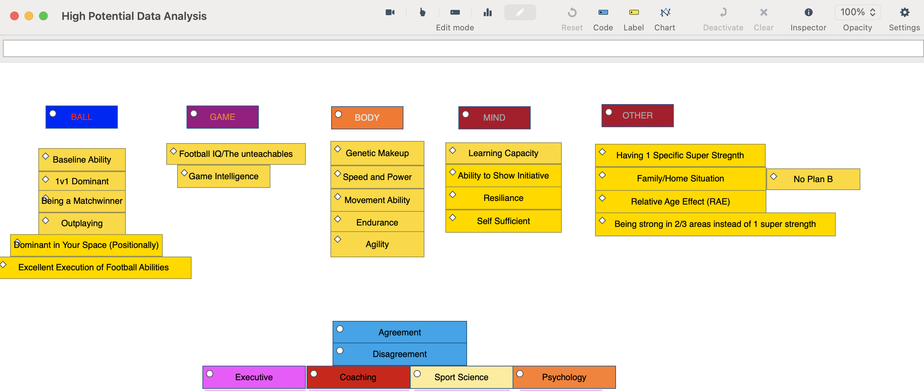
To tailor this process to the needs of the research question and utlise the software available to the researcher, SportsCode was used to generate the codes and establish themes across the focus group. This software is a data/coding system used in the performance analysis industry, creating data points from sporting footage, or in this case from an audio file. Following the initial listens and the context taken from the familiarisation process, a code window was created on SportsCode. The labels and codes included key discussion topics, which area within the 4 Corner model they fell under, and which participants were speaking (figure 2).

Figure 2: Code window
Following the familiarisation and generation of codes, some themes were starting to emerge. As previously discussed in 3.3.4, there was concerns raised about the participation imbalance due to the number of coaches in the focus group. While the conversation and theme outcomes remained balanced, the ‘Ball’ corner marginally has the most codes (themes) raised across the period. This suggests in the initial stages of the analysis that an emphasis was placed on the technical aspect, when judging a player’s potential. The use of the software created a simplistic process to organise the qualitative data into a systematically format, breaking down large amounts of text into manageable parts and making it easier to identify patterns and themes. Using this specific coding system helped create a clear documentation of how themes and insights were derived. This traceability was important for transparency and for justifying the conclusions drawn from the analysis.

Phase 3: Combination of Codes

Following the coding process, the software produced an output window. This allowed the most common and frequently reoccurring topics to be identified. The labelling system was helpful in providing context on who was saying which comment, and where agreements and disagreements among participants were present.

Figure 3: Combination of Codes
The output window consisted of only the key themes, followed by numbers in figure 3. The numbers account for the codes in which a key theme was emphasised or verbally spoken to suggest that it was a characteristic of a high potential player. For confidentiality purposes the participants names were cropped from the output window.
Assessing the combination of codes, in the form of the output window, it was seen that ‘Having 1 Super Strength’ and the ability to ‘Be Dominant in your Area (positionally)’ were the most reoccurring and topical themes in the discussion. While this can’t be a conclusion as the only important themes when assessing potential, it can however act as a data insight from the first round, as themes that created agreement within the group and were highlighted as important topic in determining ‘high potential’. The insights gained from the output window were beneficial in guiding the design of the next rounds questionnaire. These data insights guided the development of more targeted, relevant questions for the questionnaire phase.

3.6.2 Quantitative Analysis
Following the conclusion of the questionnaire, quantitative analysis was used as a process for making sense of the numerical data. The process of understanding the data in its relation to the topic and the research question is termed as ‘validity’ (Mellinger and Hanson, 2020).
Standard deviation was used at the statical analysis process to reflect consensus in the questionnaire, creating a consensus score. The mean and the median act as a process of reflecting central tendencies, while standard deviation is used to identify how much agreement there is among respondents in relation to a particular characteristic’s importance (Bhandari, 2020). If the standard deviation is low, then consensus is indicated, while higher standard deviation suggests disagreement is present. This is useful to highlight the areas of debate and uncertainty. The specific attribute with low standard deviation is useful in identifying topics of agreement and providing clarity in the areas to further delve into. Low standard deviation from the questionnaire suggests the specific topic is important and representative of the academy participants when determining potential.
SurveyMonkey provided statical analysis using standard deviation and participant response percentage for each question to accelerate and simplify the analysis process. The use of response percentage was beneficial in providing context for the questions where consensus was not required, such as the under/over-representation questions. Differing outputs of statical data ensured the quantitative analysis process was flexible in how conclusions and findings were analysed. The data was visualised on SurveyMonkey in graphic form which was simple to draw conclusions and pull relevant information for the results and findings.

3.7 Research Limitations
The limitations of this research can be split into two separate issues, time constraints, and methodological constraints.
Due to the researcher working in a full-time position within the academy, this limited the time available to research and collect data. This meant the study was conducted over a limited period, which may have impacted the breadth of the results and availability to explore central topics further. To explore the key issues further, the researcher recommends the use of a Delphi method, which is a structured, systematic forecasting and consensus-building technique used in research, particularly for decision-making and expert opinion gathering. Ziglio (1996) identified the Delphi method as an interactive communication process aimed at the collection of anonymous knowledge and judgements of expert to generate a consensus via the administration of repeated questionnaires with justified responses. Using a Delphi method with the option of extra repeated rounds of research and additional time to focus in on the key consensus topics, could identify more detailed responses and further solidify the consensus being met across the academy.
Methodological constraints were also limiting in the research process. One of the participants involved in the research left the academy in between the first and second round of data collection. As explained in the consent form (see appendix 2), the data from the focus group could still be used as part of the research but they did not participate in the questionnaire. This prevented the capturing of the full scope of that individual’s experiences or responses.

3.8 Concluding Remarks
The methodology section aims to outline and justify the research design and methods, explore the data collection phases, and analyse the techniques used in this research. The selected methodologies aligned closely with the study’s objectives, providing both qualitative and quantitative data to support the research questions while recognising the studies limitations. Overall, the methodology provided analysis for future research on the topic and producedx a wealth of data in relation to the research goals which will be further explored in the results and recommendations section. The following section will aim to analyse the findings and results from the selected methodologies, exploring the key themes and outcomes from the research.

4.0 Findings

4.0.1 Introduction
This section will present the findings from the focus group interview and questionnaire. A significant number of topics and themes emerged from the research, exploring different ways to measure potential, the key traits and attributes associated with ‘high potential’, external influences, and the challenges in talent selection. The findings are structured around the key themes drawn from the focus group research, followed by the questionnaire results.
The structure of the chapter reflects the natural flow of insights shared by participants. It begins with a focus on outplaying and game intelligence, highlighting how decision-making, perception, and the technical capacity of each player within their specific zone on the pitch underpin potential in the technical corner. The second theme explores speed and power, where both objective and subjective impressions influence decisions around the athletic potential. The third theme explores the psychosocial dimensions of player profiling, highlighting the importance of resilience and self-sufficiency, but how these traits can be measured accurately remains unclear. Finally, the chapter moves to the broader concept of high-potential identification, exploring the staff perceptions of current club processes and how these qualities are weighted within selection.
The observations drawn from the findings are tailored to the unique structure and procedures of this specific academy. Therefore, offering a detailed foundation for the discussion that follows, situating the academy’s talent selection approach within the wider landscape of research and practice.

4.1. Focus Group Results

4.2. Theme One: Outplaying and Game Intelligence
From the case study findings, two conclusions have been met for theme one:
- Outplaying your opponent is a crucial technical attribute to be considered a high potential player
- Game intelligence is a key contributing factor in understanding a player’s potential

4.2.1 Outplaying
The focus group discussion around the technical aspects that impact a player’s high potential ability sparked a wide range of insightful perspectives and dynamic dialogue. The initial discussion explored the need for a ‘required technical baseline’, and some emphasised the importance around ‘having consistent technical execution’. This early discussion was centred around the need for consistency and efficiency within the technical attributes and required players not to fall short of a specific technical required level. However, the term ‘outplaying’ was the attribute that created the most agreement within the group as a definitive technical factor in measuring potential. The term was consistently mentioned by various participants across different stages of the focus group. The data analysis flagged that the term was mentioned as an attribute for high potential players by three separate participants, with verbal agreement from other participants in the form of verbal communication. Based on the findings from the focus group, outplaying was categorised as being dominant within your area or specific position on the pitch, acting as an individual measurement of success within the context of a game.
Participants felt it was difficult to define a specific technical attribute that a player had to have but felt that ‘outplaying’ could be used as a broad term, as a way of creating an assessment. This point is highlighted by participant 5; “The execution of your own role in a 1v1 situation, or successful in your own space…it takes away the whole team dynamic and you’ll find that individuals who are top players generally find success in their own zone”. Participant 5 explored the use of analysing a player’s ability within their own position or space on the pitch to determine their success within the context of the game. This creates an opportunity for individual assessment of a player’s ability or potential, regardless of the structural and tactical success or failures of the team. Measuring players on an individual basis ensures that potential isn’t overlooked due to the dynamics of the team. In a high performing team, a less skilled individual can be carried; conversely, a highly skilled player may be overlooked due to the poor performing nature of the team.
Participant 1 expanded on the outplaying definition. They felt it was a useful way to judge a player’s ability, however, was keen to stress that it was more than just your ability in attacking or defending 1v1 duels. Ensuring a wide range of outplaying characteristics were relevant helped generate the idea that outplaying wasn’t position specific. However, it was clear that the characteristics to define outplaying were different depending on the players physical profile or the position that they found themselves on the pitch. Participant 1 explored this further:

“Everyone outplays differently and in a unique way, outplaying means you can beat your direct opponent or opponents. Someone do that with a pass…some with physicality, someone by outsmarting the opponent…Being successful in the mini games within the big game”

Similarly, from a coach’s perspective, Participant 3 examined key technical abilities that they hope to see from a high potential player, within the positional structure of the team:

“If I look at a full back for example and what I expect from them in and out of possession. I expect them to be able to serve well in passing from lower areas of the pitch and have a variation of passing techniques, while executing them well and consistently. I expect them to have the capabilities to get themselves into crossing positions and with a variation of how they get to those points. Out of possession, I want them to be able to go into a 1v1 scenario and physically be able to stay in the fight, while having the technical understanding of when to step into a tackle. Then you start looking at different positions and start to become streamlined to what the positional capabilities or attributes required to reach the top level”

Participant 3 provided a range of idealistic traits that are required from those who play in a full-back position. The use of both in possession and out of possession characteristics reinforces the importance of being dominant within your zone, regardless of whether your team is in possession of the ball. This further develops the idea that outplaying isn’t one specific trait that can be closely analysed but is individualistic and unique to the specific position on the pitch. Some traits will be more indicative of specific positions than others, especially in relation to the physical aspects. Wide players who are utilised in dribbling 1v1 positions may be required to be quicker and more agile, while central defenders may need to show greater levels of power, in relation to defensive or aerial duels.
During the focus group discussion on outplaying, the reoccurring language used was the player’s ability in spaces when they are 1v1 against their opponent - how they cope in their space both offensively and defensively against the direct opponent. While outplaying in this context appeared to be a subjective assessment. Participant 2 identified the presence of existing data and statistics generated from the academy’s performance analysis department, which is currently used to measure outplaying and its use within the talent selection process. A real-life example was presented to provide context on its importance on the predictions made on potential:

“The data on outplaying is important. Let’s take a specific player for example, he is a midfielder, whose outplaying data was 80% successful…You know that when he reaches a first team environment that data will naturally decrease due to physicality…but that success ratio is very rare in an academy. We must take that data seriously”

Participant 2, who identified a player who is a top performer in the outplaying data metric, urges that the data is used appropriately when selecting potential. While the participant understands that the data will naturally decrease when the player reaches a first team environment due to the physical disparity and the increasing standard, they believe that this data becomes very important in an academy setting when selecting players who have the most potential. If used correctly and accurately, data can provide another layer in the decision-making process to both support and oppose the opinion on a player’s potential. However, this specific case study example around the use of data focussed on a midfield player and only explored the success ratio of their ability in individual dribbling actions in 1v1 scenarios. While this remains useful data and highlights their ability in these specific actions, it runs the risk of only focussing on attacking-minded type players and leaving those who excel in defensive or out of possession actions behind.

4.2.2 Game Intelligence
Game intelligence, or a players tactical understanding within the game, offered a different perspective on the technical abilities required for high potential players. “I think there is a tactical part, some knowledge, a game intelligence that becomes so important for high potential players”. Participant 3 described a previous experience working with a player who at the time was regarded as having a high potential; “He has all the technical abilities in the world but sometimes looks like a ‘speed boat with no driver’. ‘A speedboat with no driver’ refers to the players lack of understanding and awareness of what is around them on the pitch. While they possess high potential traits in other areas, the lack of intelligence to the read the game effectively or assess situations limits their potential. While Participant 3 believes game intelligence may not be a standalone trait for measuring someone’s potential, they do believe the lack of game intelligence can act as a limiting factor which is stopping players fulfilling their full potential. Participants felt that the lack of one single trait such as ‘game intelligence’ had an overriding impact on the perception of the player and their potential. It was described in a way that suggested the intelligence of a player was a required piece of a puzzle which then ensures other characteristics can flourish. However, in contrast, Participant 3 suggested that players still reach the top level while lacking game intelligence. They went on to describe real life examples of players who are currently playing in the professional game who show outstanding abilities in some aspects of their game but lack total awareness and understanding on the pitch. Despite the examples of those playing at a high level in the professional game, game intelligence could be acting as a limiting factor in stopping them progressing even further in their career. Players with high levels of game intelligence can quicky assess options and make smart decisions under pressure within the game, leading to enhanced efficiency but also fewer errors. While most participants in the focus group agreed that game intelligence was an important trait for a ‘high potential’ player to attain, it created debate around the amount of game intelligence a player must have or not have when making a prediction on a player as participant 6 describes:

“We are talking about potential which is about making a prediction…if I am a gambling person I am not going to put my money on the one with an obvious limiting factor. They might have all the capabilities and the resources internally/externally but if they lack the game intelligence part then they are a high risk”

While participant 6 understands that a pathway remains open for those who lack game intelligence, they were keen to stress that the point in selecting those with the highest potential is about making the most accurate prediction with the information and beliefs that are present on specific players. Choosing a player who lacks an understanding or awareness’ on the pitch is a risk, as it’s an aspect which is difficulty to teach. Participant 6 went onto further discuss the importance of the cognitive attributes when selecting talent, and its importance when understanding potential.

“Potential lies in the unteachable aspects. You can teach the technical attributes or improve in a physical sense, but game intelligence and your positional awareness is harder to teach…so I think that’s where potential comes, the ones who can pick that up naturally”

This raises the importance of the technical traits related to game intelligence that are harder to coach and are often developed over time or through experience on the pitch. These technical traits include characteristics such as vision (ability to see the game develop around them), understanding of their tactical role (what their specific job is within the team’s structure) and anticipation or reaction to changes within the game or in a broader sense a players decision making. Attaining these traits ensures a player becomes easily coachable due to their understanding of the teams’ goals and their ability to problem solve. While these factors can be more difficult to identify, it was evident the group felt that they can play a significant role in a player reaching or failing to reach their expected potential. The discussion around a prediction of high potential players raises an interesting point, participant 6 believes if there is shared feeling around the ‘game intelligence’ aspect of the player it should be used in the selection process to avoid risking choosing those players with clear limiting factors toward their potential and technical ceiling within their development.

4.3 Theme Two: Speed and Power
From the case study findings, two conclusions have been identified for the second theme:
- Speed and power hold the most influence from a physical perspective when judging potential objectively

- Objective and subjective measurements are both important when assessing physical qualities.

4.3.1 Speed and Power
The conversation around the physical factors began with participant 5 discussing the base physical level that is required for all players. “I don’t think you can get away with having a low level of physical attributes, there is a standard level that everyone must achieve”. Similarly to the technical aspect, the need for a required baseline output was raised, creating an initial conversation around the requirements for elite academy players. If players fall short of the standard level, then they are in risk of being removed from the programme. As the conversation developed further, participant 5 further identified key objective measurements which were used in a broad sense to differentiate good players to the ones with the highest potential.

“The speed and power of a player is becoming more and more important. In the tests we do the ‘10m sprint’ is the most obvious one as it has the most validity, as it’s the one that looks the most like what they do on the pitch. Then there is the jump-based metrics, which explores the use of power and force…which gives us an insight into the players power and strength attributes. These both are the biggest standouts between good players and top players”

From a sport science perspective, participant 5 identified ‘speed and power’ as key physical traits due to its validity and the comparable nature to the physical components that are being displayed on the pitch. The objective data offers a key insight to compare players at specific age groups and stages, which can contribute towards the measurement of potential. The sport science representation believed that utilising the objective data from annual physical testing provides a reliable and quantifiable assessment of each academy players speed and strength capabilities. The testing scores can be used to compare academy players, creating benchmarks from those who are at the most advanced level of speed and power, or even a desired cut off requirement level. Objective testing can be used to measure an individual’s physical development, acting as a measurement of improvement or deterioration. Others in the focus group agreed on the topic of speed and power as characteristics of high potential players. Participant 1 emphasised the importance of selecting key defining traits in the selection process. They urged that to be impactful in setting players apart, there must be key metrics in place, especially from a physical perspective.

“it’s about compensation on the attributes from a physical level, we want a player to have varying physical traits that make them successful but if we are looking specifically at the high potential players, I also believe it is speed and power…A way to compare at each age group where they are physically compared to their peers”

Similarly, some focus group participants felt using speed and power as a determination of potential created challenges and it was something that needed improved within the academy. From a coach’s perspective, participant 5 introduced discussion around late developers:

“Talking about a player who is a late developer, who might see the pass or the opening to exploit but can’t execute it due to their current physical makeup. Measuring that in an official metric is difficult. So, then it becomes right everyone round the table agreeing, he did see it and he will be able to execute it in two years”

Participant 5 is referring to the technical skill that a player may possess but lacks the physical power to consistently execute in an effective manner. From a coach’s perspective, they suggest that if they can perform highly in technical and tactical moments at this stage, once they grow further to match their peers, they can continue to excel due to their experience of competing against bigger and stronger players. Late developing players need to find a way to cope and be effective in games due to their smaller physique, building physical and psychological resilience at a younger age. Once they grow themselves this can have positive impact on their performance on potential, showing a steep improvement curve once physically maturity is reached.
Participant 3 provided previous examples of academy players who were kept on due to their predicted late development but then failed to reach the stages which the club expected from them. Players had been previously recognised for their potential due to having top technical attributes but lacking the physical aspects, in which they had been predicted to improve following maturation and growth. Despite expectations of physical development, these improvements did not materialise as anticipated, which stagnated the players development and never allowed the player to reach their projected potential. This reinforced discussion of the recognition of the risk involved in making a prediction that a player will be stronger and more powerful based on their current physical attributes.

4.3.2 Objective and Subjective Physical Testing
While objective testing provides value and can be used as a metric to determine potential, those from a sport science background in the conversation were keen to emphasise the challenges with only using only objective testing as a measurement of physical performance. Participant 5 stated that “it is a mistake to completely objectify the physical aspects”. They believed that objective data does not reflect the players full physical ability and highlighted the importance of the players movement capacity, as a subjective alternative. In this instance, movement capacity is a reference to balance and coordination, the players ability to twist and turn, and the all-round smoothness in movement within key actions in the game. While testing can be used to measure some physical capabilities such as speed, power and strength, those in the discussion felt that the movement ability was often a feeling you got from watching the player and that it was often difficult to quantify within a game setting. Participant 5 reinforced this point with an example of an academy graduate, who is now playing first team football at the club:

“There are occasions that we do have these players that are not recognised by coaches or anyone in the building for their physical attributes…this specific first team player tested okay in physical testing but it’s actually when you look at him on the pitch, the way he moves, the way he changes direction…from the physical point of view that is his biggest weapon”

The sport science representation in the discussion stated they often felt ‘movement ability’ was overlooked in the talent selection process due to the desire for objective testing scores as a representation of physical performance. This example of a current first team player who was not recognised for his physical output in the academy but is now excelling at the top level due to his movement qualities, emphasises the need for subjective assessment in the sport science and talent selection domain. Disregarding subjective assessment within the physical component risks failing to recognise elite movement abilities as indicators of potential. The specific academy graduate’s movement abilities were described as ‘his biggest weapon’ referring to his outstanding and unique ability to demonstrate sharpness in his small movements, escape pressure through faints and turns, while using a low centre of gravity to stay balanced and smooth in his technical output. While this player may not perform as well as others in the power and speed testing, the ability to bring together all the other movement qualities makes him a challenging player to play against and is what physically separates him from the other players who remain in the academy.
Others in the discussion agreed with this point, and felt the all-round movement was an important aspect to consider when assessing potential. Efficient movement was identified by participant 4 as an important characteristic for those players aiming to reach the elite level in the game. “I think if we’re looking at producing real top elite players and creating a group for those players…I don’t think we’ll have bad movers within that group. I think it’s a key characteristic”. Coaches in the discussion agreed with the sport science perspective and felt that players in the ‘high potential’ bracket had to display efficient movement abilities. Reference was made to the development of the current game as it becomes continually quicker and those at the very top-level play at an extreme level of intensity. A player’s poor movement and lack of smoothness will be a limiting factor as the game continues to become slicker and faster.

4.4 Theme Three: Psychosocial Player Profiling
From the case study findings, two categories have been summarised within the third theme:
- Self-sufficiency and resilience are essential traits for a player to be considered as ‘high potential’

- Psychosocial factors are interconnected and contribute significant value when player profiling, but they are often challenging to measure

4.4.1 Self-Sufficiency and Resilience
A player’s ability to be self-sufficient and show resilience in moments of adversity were considered traits of a high potential player.
From a coach’s perspective, participant 4 gave their assessment on what a high potential player looked like for them, focussing on technical and physical attributes, but on top of that felt a player must demonstrate self-sufficiency.

“The big thing for me that separates good players with those in an elite category is the ability to show initiative…to take on information and learn and not wait to be lead, and taking ownership...that’s a high potential trait for me”

The psychosocial factors were discussed in a manner that appeared to be important to most of the participants. While it may not be the sole indicator of a young player’s current potential, participants felt it played a key role in whether a player could reach their highest potential. Those in the focus group felt that the players who show high levels of self-sufficiency give themselves a better opportunity to maximise and showcase their other footballing qualities at a higher level. It was described that understanding the mentality of young players and what they are willing and able to do to separate themselves from others in the academy is beneficial and can lead to a more efficient and accurate talent selection process. This helps ensure that the players who are willing to continue to push themselves are clearly identified in the process, along with their other recognisable high potential traits. Academies like the research case study continue to invest in providing players with psychological support as a form of player care, but also to maximise potential. The technical and physical components can become irrelevant if a player shows consistent difficulties in the psychosocial and behavioural areas of development. If a player is unable to take on necessary information from coaches or show initiative to learn, they will suffer both individually on their key personal development areas but also lack the tactical information to operate effectively within the team’s structure.
The broader social, economic and cultural factors also play a key role in a player’s ability to reach their highest potential. The social aspect of the 4 Corner model focuses on areas such as teamwork, communication, relationships, family life and other aspects which are not only important in a player’s football development but also in their everyday life. Many of the socialistic areas, like family and relationships are often uncontrollable factors but can have a significant impact both positively and negatively on their players mental well-being. Psychosocial representation in the study urged that support is in place to aid players with necessary guidance but those who can show resilience in the face of adversity and are willing to apply themselves with total dedication and concentration give themselves a better opportunity to fulfil their potential. The discussion on the psychosocial topics further delved into the specific psychological or social factors which drive behaviours and motivations. Family background and home life was raised as a key motivating factor in a player trying to reach their full potential through the examples of current players within the academy. Participant 2 explored an example of previous conversations that were held with a player in the academy about their purpose and motivation to graduate into the first team:

“I asked the question to players ‘what is the reason you want to be a professional player’, one of the responses was ‘I need to help my family’…that drive raises the chance to become professional footballers enormously…when a player becomes obsessed, that drive is so powerful”

However, others in the focus group didn’t agree that this could specifically be a means of judging someone’s potential as motivations and how they manifest themselves are different for players. The psychologist (participant 6) in the focus group also provided an example of a similar player who stated his key motivation was the improvement of his family’s life:

“What I would say to that argument, I can think of a player who family is his driving force, but he doesn’t present that in the way he trains or his body language, or attitude. So, if were looking at a specific attribute, it’s some form of being self-sufficient”

Following examples and feedback on the social backgrounds and mentality of players, ‘self-sufficiency’ was the loose term that generated the most agreement in being an important factor for a high potential player. The psychologist contribution to the discussion from participant 6 on potential and motivation emphasised strong support for the concept of ‘self-sufficiency’, with participants agreeing through both verbal and non-verbal communication. A central theme in the discussion was the emphasis on making informed decision on players, with value placed on the players who demonstrate proactivity and the ability to lead themselves. However, participant 4 suggested that there still had to be a pathway for the ‘maverick’ types who possess top qualities in other areas but lack the required psychological attributes:

“that’s why we have got to leave a space open for the maverick players who are a bit more difficult to handle but have that magic or ‘wow factor’ but then not stray too far out of line so it’s not detrimental to the rest of the group”

Participant 4 highlighted the risk of overlooking those players who have rare and exceptional abilities, simply because they do not yet demonstrate ‘self-sufficiency’. Adopting a selection process with excess focus on player behaviour, runs the risk of not picking the players who possess high potential technical or physical attributes, whose attitudes and behaviours may naturally evolve as they mature into young adults.
This creates an interesting argument around the behavioural profile of the player, exploring the examples of those players who produce consistent success on the pitch but don’t show themselves in the best light through their behaviour and attitude. Similarly, participant 1 believed that ‘self-sufficiency’ and having a strong inner drive was theoretically an asset but explained that they had seen so many players make it to the top who wouldn’t be described as that. Participant 1 used the example of previous Barcelona and Paris Saint Germain player Neymar, whom he felt he was a player who had reached the top level of the game but is “not elite driven” in the way he conducts himself. However, participant 5 was quick to responded on the example of Neymar, using the term “intrinsic motivation”. Participant 4 believed Neymar may not be a player who is viewed from the outside as a self-led role model, but other psychological areas such as mastery and the art of improvement could be the explanation for his elite status in the game. This suggests that ‘self-sufficiency’ can be demonstrated in different ways. Not all players must be the example setters or the ones who take responsibility to consistently show themselves in the best light. Although such players may give themselves a better opportunity in the selection process, this behaviour is not representative the full range of personalities within a group, each player has their own unique way of demonstrating self-sufficiency.
The discussion on talent selection for the maverick players centred on to what extend is the attitude issues were serving or inhibiting their potential. Selecting ‘maverick’ type refers to those highly skilled players who are independent and unconventional but often unpredictable in both their play and personality. Choosing this type of player runs the risk of distribution to other players or being a bad role model within the group which can negatively impact team dynamics. While this type of profile and personality is still encouraged to have a place in the development programme, the challenging part for academies is managing them and knowing when to cut them loose or reel them in.

4.4.2 Difficulty in Measuring Psychosocial Factors
The psychologist (participant 6) in the discussion felt that ‘resilience’ and ‘emotional regulation’ were the key high potential traits from the psychology corner, however raised concerns over how these were measured. They explored the danger in making psychological comparisons between players due to the varying loads that different players carry due to home life situations or previous experiences:

“Players backgrounds and family life play a huge influence. For example, player ‘A’ life is very straight forward, good family…while player ‘B’ has a volatile home life and has experienced trauma. So, in situations on the pitch player ‘B’ appears to be lacking resilience but is in fact carrying a much heavier psychological loads than others…so how can I create judgements and comparisons between two payers who’s lives and experiences are so different”

This raises an interesting point on ‘emotional regulation’ and that how a player handles their emotions is complex and demonstrative of wider issues impacting their development. With reference to the psychologists’ comments, it is evident that some players are demonstrating ‘resilience’ on a much more consistent basis through life outside of academy, which may create a tendency for them to show anger or be perceived incorrectly. Participant 6 felt the resilience they are building at home can impact them positively in a first team level as they build toughness but may currently reflect poorly at academy level, due to their emotional tendencies or perceived behaviours. This emphasises the importance of utlising the information in each corner in the 4 Corner model to further the holistic view and perception on each player.
Emotional regulation is linked to the previous topics of ‘self-sufficiency’ and ‘resilience’ regarding how players behave on and off the field. Some players may show the highest form of emotional regulation and professionalism off the pitch, but this may be in part due to their supportive home life. However, those who show distasteful behaviour on the pitch or struggle with organisation off the pitch may be deemed as ‘unprofessional’ but may be coping with an extremely heavy load due to external circumstances. This topic provided coaches and other non-psychology participants with a different perspective towards the discussion on player development, with information that appeared to be new and insightful to those participating in the focus group. “A really insightful point” said one of the coaches on the topic of emotional regulation. Emotional regulation adds another dimension to the challenging task of creating a measurement or metric for measuring potential from a psychological perspective. When asked about the possibility of a psychological measurement of a player’s potential, participant 6 responded:

“You cannot measure it and I know that’s not the answer you want… They are completely different human beings with completely different lives… You would almost need to do a perceived adversity score versus a perceived coping score to understand that ability to cope. So, some players will have a high potential because we have never put them in a situation where we have challenged their ability to cope”

Participant 6 once again refers to the challenging nature of psychologically comparing players in reference to potential. However, they do propose that academies adopt alternative assessment methods to better evaluate players mental resilience and their ability to cope with adversity in game or training situations. ‘We have never put them in a situation where we have challenged their ability to cope.’ While encouraging the need for clubs to create an environment for psychological safety, they suggest stretching players to face struggles and adversity on the pitch, to challenge them and overall improve their ‘ability to cope’.

4.5 Theme Four: High Potential Identification
From the case study findings, one outcome is concluded for theme four:
Players identified as having ‘high potential’ should demonstrate an exceptional strength in at least one specific area from ‘Ball, Game, Body, Mind’ or alternatively show a high level of performance and consistency in at least three of the four areas.
This theme examines the interconnectedness of the different components within the 4 Corner model, placing focus on the key requirements and relationships across the case study’s ‘Ball, Game, Body, Mind’ structure that are used to characterise a player being regarded as ‘high potential’. It is important to note that the insights gathered from this specific section are unique to the structure and processes of this academy’s processes and may not be reflective of other existing academies. This section examines the structural approach to identifying high potential, rather than exploring individual characteristics. Over the course of the focus group this process was often termed as the player having a specific ‘super strength’, as participant 1 describes:

“There is two layers for judging potential within the framework. Layer one is having an elite weapon, a ‘super strength’ in the skillset…Option two is performing highly in three out of the four pillars…with both layers being underpinned with mindset”

Participant 1 was keen to explain the methods currently used for the academy to categorise potential and the requirements that a player must attain within the club’s 4 Corner model. The two-option approach entails a process by which a player must either be a top performer within 1 specific sub section of the 4 Corner model or the alternative selection method, a player who demonstrates high performing qualities on a consistent level in at least 3 of the sub sections. Those in the first option must have an ‘elite weapon’, which is their specific strength that is clearly identifiable as a high potential quality. The required level in the second option for each corner doesn’t need to be as outstanding as a single ‘super-strength’ but these players are regarded as having high potential due to their all-round consistently strong performing traits across three corners of the model. The topic of one specific ‘super strength’ for defining potential was challenged by participant 5 who felt that it was a whole blend of traits that are often difficult to quantify, rather than a single strength. They believed there were top players in the professional game who have never held a ‘super strength’ but continue to perform at the highest level:

“There’s a broad range of weapons that may be important, maybe ‘consistency’ for example. Doing the basics correct on a consistent basis, but that will not be thrown in your face as a super-strength…when looking at elite first team players, there’s a combination of things which each of them have, it’s different for every player…it’s just like a recipe book with some of this and some of that”

Participant 5 believes this approach of requiring a player to possess a single ‘super strength’ presents a challenge as it risks excluding those who may represent well rounded qualities. This area of discrepancy reinforces the importance of having the second option which provides a pathway for those players who are strong and show consistency. Participant 2 however emphasised the importance of having a ‘super strength’ and why it should be taken seriously at an academy stage in a player’s career:

“I think we sometimes miss the super strength…it might not be the most attractive football trait…but we should be focussing on what can the player do really well because that will ultimately be what carries them to the first team”

Participant 2 was keen to stress that no matter what the specific ‘super-strength’ is, that should be the area of focus in the selection process and believes that when the player reaches first team level, the specific strength will remain the same. The unique nature of a players ‘super-strength’ is the aspect of their game which sets them apart from the rest. As a decision maker in the talent selection process participant 2 is comfortable taking ownership when identifying the super strength, suggesting that players unique strengths are often missed or overlooked within their own assessment in the selection process. The nature of some traits may not be the most eye-catching, such a player’s heading ability or how they react to key moments within the game, but they urge that these traits should be clearly identified and brought to player discussions. It was expressed that by the time a player reaches a first team environment, it will be the same strength that is the reason for the players continued upward trajectory.
However, it still raises questions around what makes a ‘super strength’ super. The term ‘super’ is subjective and relies on an expert opinion, with the help of objective data. Frameworks and process can be put in place to create reference points and increase the validity of decision making, but due to the reality of talent selection, it requires human choice and the best selections being made with all the relevant information available. Both layers offer an alternative entry point for players to be considered ‘high potential’ but how they are selected remains the challenge. The two-layer structure aims to minimise the subjective nature by using a framework but ultimately talent selection must have a subjective nature, as it requires human choice.

4.6 Questionnaire Results

4.6.1 Introduction to Questionnaire
The questionnaire aimed to capture individual responses on the key themes raised from the focus group, allowing a broader understanding of the attitudes towards high potential selection in the case study. 24 academy staff across varying roles took part in the study following a thematic analysis process after the case study research. A 5-point Likert scale was used to measure participants level of agreement, disagreement or other feelings toward a statement. For each of the ten questions, a five-point scale was used, ranging from responses such as “strongly agree” to “strongly disagree”, “always” to “never”, “extremely important” to “not at all important”, and “very unlikely” to “very likely”. The final two questions asked participants around the specifics of the 4 Corner model and representation/underrepresentation within the talent selection process and the case study context. While a five-point scale was retained, response options were framed around the model’s key components “ball, game, body, mind, or none”.
SurveyMonkey.com was used as the questionnaire provider, which also generated insights and analysis summaries upon completion of data collection. Standard deviation calculations were applied to assess the level of consensus among participants for each question. This was a simplified method to determine the extent to which the quantitative findings aligned or diverged from the themes identified in the focus group responses.
The questionnaire results are presented within the same four thematic categories identified from the focus group analysis, as the questionnaire served to provide a secondary, supporting layer of data within the overall research design. All responses were confidential so individual data could not be disclosed to differentiate between the differing roles of participants and the results that were present.

4.6.2 Theme One: Technical Characteristics Linked to High Potential Selection
Three questions were presented to the participants from the technical aspects of the model.
- Outplaying (being dominant in your zone) is a key high potential trait?
- How important does ‘game intelligence’ and the ‘unteachable aspects’ play in determining a high potential player?
- A high potential player must understand their specific role tactically within the team?

The first question around the technical characteristics, was angled with the statement: ‘Outplaying (being dominant in your zone) is a key high potential trait?’. Despite the lack of clarity on its definition (hence the simplified brackets), there appeared to be a consensus across the focus group participants on the meaning of outplaying and as a measurement of judging potential.
95.83% of the respondents on the survey felt that outplaying (being dominant in your zone) was a key high potential trait. The standard deviation score was 0.55, this low score emphasises the consensus and agreement on the importance of outplaying in the talent selection process. With the survey participants being a widespread range of academy technical staff, it is obvious that outplaying is a term which is well-understood and recognised across the different departments of case study staff. Each department plays a different role to ensure a player can outplay to the best of their ability. The level of agreement on this trait also references the academy’s identity and style; being dominant in your zone both in and out of possession is crucial if players wish to make the step into this first team setting.
In relation to the cognitive aspects of player selection, those in the focus group felt that game intelligence and the ‘unteachables’ play a significant role in determining someone as high potential. Similarly, 91.6% of the questionnaire participants deemed it either ‘extremely important’ or ‘very important’, while 8.4% of participants believed it was ‘somewhat important’. The standard deviation score was slightly higher than outplaying at 0.63. The tactical question, which explored the idea that a player ‘must understand their specific role within the team’ showed that no one disagreed, however 25% of the participants responded ‘sometimes’. While all three questions in this theme led to agreement overall, it can be concluded that from a technical perspective outplaying shared greater consensus across the study than game intelligence and the tactical aspects of potential. The results indicate that while participants continued to regard game intelligence as an important factor in evaluating a player’s potential, the ability to outplay was perceived as a more distinctive determinant when predicting future performance.

4.6.3 Theme Two: Physical Characteristics Linked to High Potential Selection
Participants were presented with two questions focusing on the physical dimension of the model.
- Speed and power are the most defining physical trait when measuring potential objectively?
- How important is it that high potential players are effective movers, in relation to ‘balance’, ‘agility’, and ‘co-ordination’?
During the focus group study, it was concluded that ‘speed and power’ was the most suitable and identifiable characterisation to objectively measure a player’s physical qualities. Participants also felt that due to the demanding nature of the elite men’s game, and the continued development of the games speed, intensity and aggression, that these physical components were important for academy players to progress to first team football and reach their potential. The responses for this specific question ranged from ‘strongly agree’ to ‘strongly disagree’. Although most participants from the questionnaire agreed speed and power were the most defining objective physical trait, 25% of the participants disagreed. Interestingly, this question generated the highest standard deviation score of 1.08, higher than any other question in the study. This higher score suggests that consensus on this topic wasn’t as clear as other questions and there was disagreement present. A reason for the higher consensus score may be in relation to the differing ranges of a player’s speed and power levels throughout their physical development. Some players develop earlier or later than their peers so the subjective testing scores can vary depending on their stage of physical maturation. However, 58.3% of participants either agreed or strongly agreed that ‘speed and power’ was the most defining physical trait that could be objectively measured. It can still be concluded that most questionnaire participants did agree but widespread consensus on this topic is not present.
The sport science representation in the study felt it was unjust to only measure the physical components of potential in an objective manner. Both sport science and coaching participants in the focus group urged that players who reach their highest potential also are expert movers on the pitch, which is often more difficult to quantify. Likewise, the questionnaire data also demonstrated that a player’s movement ability from a subjective viewpoint plays an influential role in determining high potential. 95.8% of participants felt it was either ‘extremely important’, ‘very important’, or ‘somewhat important’ that high potential players are effective movers in relation to balance, agility, and co-ordination. This suggests that in the physical selection process of high potential players, the subjective element is equally as important. According to the research, high potential players in the case study should represent attributes of speed and power but more importantly should be top movers in how they utilise their body on the pitch.

4.6.4 Theme Three: Psychological Characteristics Linked to High Potential Selection
Participants responded to two questions centered on the psychosocial aspects of the model, focusing on self-sufficiency and resilience.
- Can a player be regarded as high potential without being self-sufficient?
- High potential players must show some form of resilience?
In relation to the question around ‘self-sufficiency’ participants had to answer between five responses ranging from “very unlikely” to “very likely”. This created a numerical measurement to understand if high potential players could be identified without possessing a key psychological trait, or if such characteristic were essential within the selection process.
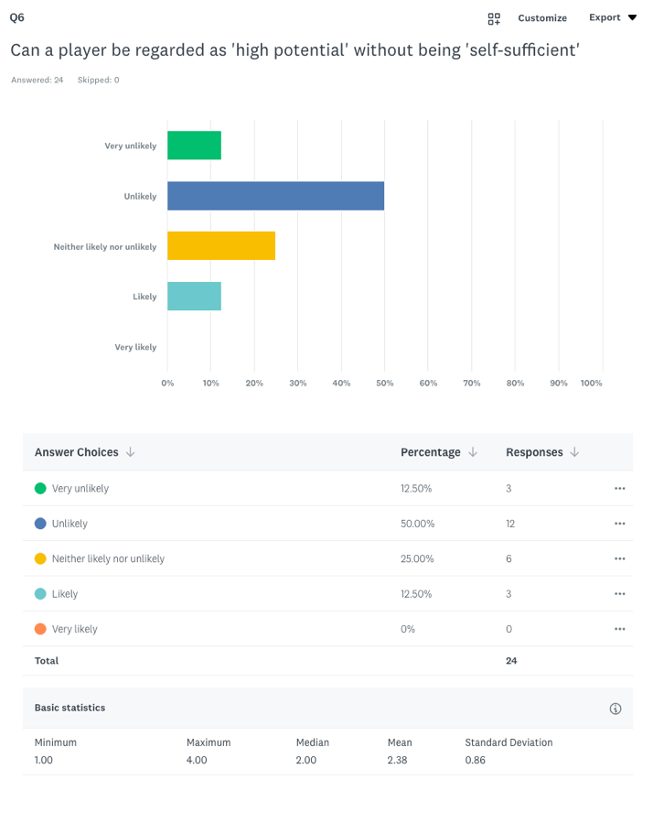

Question 6 responses
The focus group agreed on the importance of high potential players being some form of ‘self-led’ or ‘self-sufficient’ as a conclusive term for motivation and the inner desire to be better. The questionnaire results however were not as conclusive, with 25% of respondents selecting ‘neither likely nor unlikely’. Some participants may have been unsure on the use of the term in relation to potential, or the question layout may have encouraged indecision. A limitation of using a 5-point Likert scale is the option to be neutral or at the midpoint in a response, allowing respondents to choose an option that is undecided. Krosnick and Fabrigar (1997) suggest that respondents may select the middle option to avoid expressing strong opinion, reducing the scale’s ability to reveal clear attitudes or distinctions between views.
However, the second question in the topic of theme three produced much greater consensus when participants were asked around the importance of high potential players being ‘resilient’. A player’s ability to demonstrate resilience produced the lowest standard deviation score across the questionnaire, demonstrating the clearest measurement of consensus with 100% of participants ‘agreeing, or ‘strongly agreeing’ that a player must show some form of resilience. The questionnaire responses suggests that this is a non-negotiable psychological trait for a high potential player. Even players considered ‘mavericks’ – those who may lack self-leadership, can still viewed as high potential if they demonstrate resilience, respond positively to setbacks, and consistently show the ability to perform under pressure. However, measuring psychological traits such as ‘resilience’ and ‘self-sufficiency’ within the conversation of potential can be very challenging.

4.6.5 Theme Four: The Impact of a Standout Attribute in Identifying High-Potential Players
Participants responded to three questions centre around the use of the case studies selection process to identify high potential players and the over and underrepresentation of a specific corner in the current case study environment.
- Do you agree that a high potential player must have a ‘super-strength’, or if not, must be strong in three out of the four pillars?
- When assessing a player holistically in relation to potential, do you think there is an area which is underrepresented in the decision-making process?
- Similarly, when assessing a player holistically in relation to potential, do you think there is an area which is overrepresented in the decision-making process?

The pilot study with the club’s academy director identified that the case study used a two layered process to identify high-potential players. Layer one involved a player being selected due to having an elite weapon within the 4 Corner Model, or a ‘super-strength’ which was the terminology used by the academy director. This meant that the player could be identified as having a specific attribute which sets them apart from other players and gives them an increased chance of reaching their full potential. The second layer in the process offered a pathway for players who didn’t have a standout attribute but instead must perform to a consistent high standard in at least three corners of the model.
The questionnaire results concluded that only one person in the study disagreed on the two layered approach as a method for identifying high potential players, 95.8% of participants either agreed or strongly agreed on its use. Across the academy staff, the degree of alignment in the responses approached full consensus, highlighting a strong collective perspective that reinforces the reliability of the club’s selection processes.
During the pilot study the academy director also emphasised the psychosocial perspective in the selection process of players ‘with both layers being underpinned by mindset’. While there was no clear way for measuring such characteristics, the director was keen to highlight the importance of the mental characteristics in the selection process.
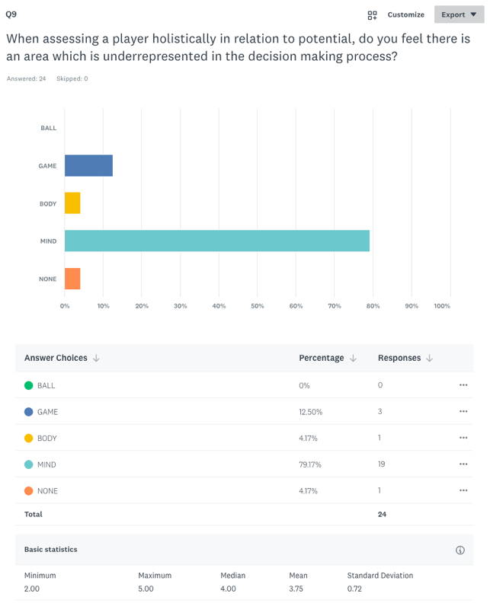

Question 9 responses

Interestingly as shown in the question 9 responses, the topic of under-representation across the 4 Corner Model in the high potential selection process was addressed. 79.2% of participants across the academy workforce believed the ‘Mind’ corner was the most under-represented area when assessing potential in the academy. The key academy figure heads in the focus group also support the use of the psychosocial characteristics when assessing potential, however most questionnaire respondents believe not enough attention is being paid towards these characteristics in the decision-making process. It is evident that psychosocial factors bear great importance in the intentions and belief systems of those working in an academy but finding a way to measure and incorporate them into the high potential decision-making process remains unclear and a challenge.
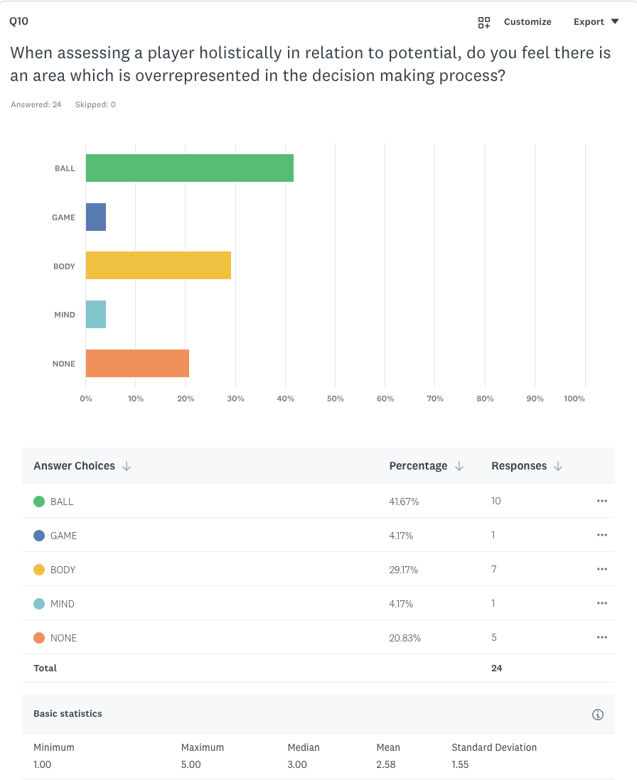

Question 10 responses

Overrepresentation in the high potential decision-making process generated a mix of responses. The ‘Ball’ corner which represents the technical aspect created the most amount of agreement on this topic. Similar opinions were shared indirectly from the focus group, participant 4 felt that there was too much emphasis placed on ‘technical players’ who were ‘late in their development’ when assessing the top talents in the academy. They felt that an over reliance on their technical qualities and a lack of focus on growth and maturation resulted in certain academy players not having the physical capacity to reach their potential. Also, the diversification of results and 20.83% of participants voting ‘none’ on these questions, suggests that the underrepresentation of the ‘Mind’ corner is more severe than any existing overrepresentation.

4.7 Conclusion
The findings of the study provide valuable insights into the academy’s perspective on the talent selection process, shedding light on the key characteristics and underlying beliefs held on the topic of potential within the specific case study academy.
The results emphasise the importance of working across different disciplines, as shown in the 4 Corner model, to fully evaluate a players high potential ability. Throughout the research it was evident that identifying high potential or talent will always be inherently complex due its subjective nature. While structured models and measurable criteria such as the case study’s model provide a foundation for player assessment, the interpretation of potential remains greatly influenced by the perspectives of individuals (Christensen 2009). After focus group discussion, widespread questionnaire and detailed analysis four concluding key themes were identified, unique to the case study and its practices.
From a technical and tactical perspective, ‘outplaying’ and ‘game intelligence’ were identified as the key attributes which could be used to identify a ‘high potential’ player. Outplaying was met with agreement across the academy participants as a high potential trait while game intelligence and the tactical aspect had greater relevance towards a player’s ability to reach their full potential, instead of a defining trait in the selection process. However, for both attributes there appeared to be an uncertainty as to how they could be best measured and best maximised in the decision-making process.
It was found that ‘speed and power’ held the most influence from a physical perspective when judging potential objectively, but the subjective physical components held an equal importance when assessing high potential players. Participants felt speed and power was the most reliable measurement due to its testing validity, but it raised disagreements around assessing potential in late developers. A players movement ability was identified as a key high potential trait; however, it was felt to be a ‘subjective feeling’ rather than an objective measurable. It can be concluded that the objective measurement of speed and power, combined with the subjective opinion in the way that players move about the pitch were the defining factors across the study for assessing potential across the physical component.
The research identified that while psychosocial factors have a significant impact on player development and potential, it is often difficult to measure in relation to potential. ‘Self-sufficiency’ and ‘resilience’ were categorised as the key psychosocial traits that were required from high potential players, however creating a measurement or judgement between players on these factors was described as extremely challenging and there remains a continued lack of understanding or clarity on how the desired characteristics could be incorporated into the selection process.
Participants across the study agreed that players who were identified as having ‘high potential’ should demonstrate an exceptional strength in at least one specific area of the 4 Corner model or alternatively be consistently strong in any three areas of the model. This two-option approach acts as a process for the case study decision makers to follow and to help guide the selection process. Although this selection process is generally valued within the academy, participants felt that psychosocial factors receive too little attention in decision-making. In contrast, the technical corner was seen as carrying more weight than it perhaps should, though views on that were less unanimous.

5.0 Discussion

5.1 Context
This section provides context by comparing the research findings with the existing literature in the field of talent selection and wider practices to identify potential. The discussion section is organised around the four main themes identified in the research findings. The research findings both align and diverge from existing studies, offering a deeper understanding of talent selection practices.

5.1.1 Technical/Tactical
From the technical and tactical perspective, the research concluded that ‘outplaying’ and ‘game intelligence’ were key traits that could be used to differentiate those players of a higher potential. Kelly et al., (2021) explored the key technical characteristics used in talent selection. This study found that average dribble completion (taken from match analysis statistics) was a key indicator in the talent selection process. While this is different to outplaying, it holds key similarities that can be comparable. Both are assessing a player’s ability to operate in a space from once they receive the ball to when the ball is no longer with them. Outplaying in the context of the research however acts as a broader term that explores a variation of technical traits, which can be applicable in any position and not just analysing a dribbling ability. However, the data being used in the academy to measure this attribute was solely focussed on attacking duels. Using data is extremely important and helps enhance the validity of results or the decisions made within an academy. It is important however to ensure that the term used for ‘outplaying’ in the focus group, is consistent with the data output being used in the academy. The use of “success in their own zone” and “everyone outplays differently” enforces the idea that outplaying isn’t position specific. No matter where you are on the pitch there is an opportunity to outplay, ensuring a widespread judgement or assessment across the full team can be created from this. While the data provides interesting discussion around attacking duels and first team progression, a widespread tool that can be used for each position would act as an effective way to make comparisons and judgements for all players who may be regarded as high potential.
Similarly, Steiner et al., (2019) explored passing to outplay opponents as a performance-relevant parameter in football. While the research didn’t offer a definitive conclusion in relation to potential or performance with the passing metric, it provided a different perspective on the players positional ability to take risks or successfully play through pressure. The findings concluded that 52% of passes from the middle third of the pitch were played by defenders, emphasising the importance of progressive passes as a determination of success within the context of the game but also as an assessment of individual performance. Implementing a passing like metric in the context of outplaying provides flexibility in technical assessments, allowing evaluators to focus on specific pitch areas and technical attributes that are unique to the position but showcase a player’s potential. While there were similarities in the technical attributes used within selection practices within existing research, this specific study is unique in its assessment of ‘outplaying’ as a key trait to differentiate players with ‘high potential’. To be dominant in your zone and ‘outplay’ regardless of the technical trait or position on the pitch, creates a measurement of success that could be used regardless of contextual situations within the game.
The findings on game intelligence and its importance within the context of talent selection were consistent with the existing research. Participants agreed that ‘game intelligence’ was a crucial characteristic for a high potential player and should be closely evaluated due to its ‘unteachable’ nature. Similarly, findings from Dugdale et al., (2021) examining coach ratings, found the greatest difference between reselected and deselected players from an academy was ‘game understanding’ and ‘game awareness’. These terms come under the ‘Game’ corner of the case study model, which explores the players tactical understanding. Both tactical characteristics had the most significant impact between players being kept or disregarded from the academy programme in Scotland. While Dugdale et al., (2021) explored talent selection from an entry to exit point within an academy, the attitudes and beliefs toward the tactical aspect of the game are similar with this case study. Participants in the focus group saw ‘game intelligence’ as a potential mitigating factor in enabling players to reach their potential. It can be concluded from both studies that ‘game intelligence’ is a necessary and desirable trait required in talent selection at all levels and particularly significant when identifying high potential.
Williams (2023) explained that the term ‘game intelligence’ refers to the ‘ability to process information, anticipate what is about to happen, and react accordingly’. Williams also suggested that expert players also seem to be better than non-expert players at recognising patterns from experience and using their visual sense to gather specific information they can exploit during matches. This makes similar reference to the ‘unteachable’ nature that was raised in the study. Participant 6 said “positional awareness’ is harder to teach…so I think that’s where potential comes”. Both studies refer to the desirable trait of having skills that are both cognitive and reactionary.
Furthermore, this raises an interesting debate from the literature regarding potential and performance-based models. Performance based models focus solely on current performing traits, while potential based models place focus on the attributes that may be harder to detect but are often important for the future of a player’s success. As the 4 Corner model amalgamates both performance and potential based methods, it is important that factors such as ‘game intelligence’ are being accounted for in the process of identifying high potential.

5.1.2 Physical
The physical component of potential concluded: ‘speed and power’ is a clear objective differentiator for high potential players and the importance of including subjective component when measuring potential.
The findings around ‘speed and power’ are consistent with existing literature in the physical research field. Dugdale et al., (2021) found the biggest difference in talent selection outcomes between re-selected and de-selected players on physical testing was the ‘5m sprint’ and the ‘20m sprint’. This specific test type identifies the explosive and powerful nature of players, creating judgements of their physical capabilities over short distances. While the Dugdale et al., (2021) study has differing intentions to the research question, measuring talent selection from the entry/exit point of the academy, it concludes that decision makers place the largest amount of emphasis towards explosive physical traits, such as ‘speed and power’. The participants in the case study referred to ‘speed and power’ and ‘movement ability’ as objective standouts between good and elite level players. While agreement was still met, the use of speed and power as an objective measurement of high potential raised the greatest amount of disagreement, compared to the rest of the studies themes. A reason for the higher standard deviation score may be in relation to the physical assessment of younger players who are not fully developed in comparison to their peers. Using a specific metric such as speed and power to define potential has its challenges, especially with younger players. Speed and power as a desirable physical trait favours players who have developed quicker compared to later maturing players. This often leads to uncertainty on a young players physical capacity, late developing players may not represent high levels of speed and power at this current stage in their development but once they have fully developed, a physical assessment is fairer and more contextual.
However, in reference to the case studies’ objective testing, such as the 10m sprint, its validity was emphasised as the test ‘that looks the most like what they do on the pitch’. Comparisons were made within the focus group to the English Premier League, referencing the high physical attributes that are required to reach the top level and the desire for increased levels of speed and power, combined with efficient movement capabilities. Similarly, a study by the University of South Wales (2024) on the evolution of football, found that the total stoppage time, ball speed and passing rates increased significantly for men between the 2014-2022 World Cup competitions. The key findings state that “speed is increasingly an advantage in football, which means all teams are looking to sign up faster players, and in turn they need to be skilful while moving fast”.
Both the outcomes from this study and the current research within the physical testing field are aligned. As the game continues to develop and change, its intensity, speed and all-round flow of the game is being enhanced. Players who want to reach a World Cup level are required to be quicker, stronger and demonstrate clean and coordinated movement capabilities when in control of the ball.

5.1.3 Psychosocial
When exploring the psychosocial factors in relation to talent selection, the research from the study concluded that ‘self-sufficiency’ and ‘resilience’ were essential traits that a player must attain to be considered ‘high potential’, however it was recognised that they were often difficult to assess or quantify.
In a widely populated study on the psychological factors associated with talent development in football, it was found that ‘self-regulation, resilience, commitment, and discipline’ were the more influential factors on a player’s development (Gledhill et al., 2017). The study examines the application of psychosocial concepts within the context of football; “social influences (such as parents or peers) interact with individual psychological characteristics (such as discipline or commitment) to shape or guide behaviours (such as lifestyle choices) which may then influence talent development in football” (p. 1). While ‘self-sufficiency’ and ‘resilience’ are referred to as influential across both Gledhill and the case study, the Gledhill study discusses the psychological factors in relation to talent development and not as a process of talent selection. It could be suggested that due to the challenging nature of measuring psychosocial factors, there should be a greater focus on ongoing psychological development for players rather than just a process of high potential selection.
Ivarsson et al., (2020) however did explore the psychosocial factors in relation to the future performance of football players. This study included perceptual-cognitive testing functions, measured task orientation, ego orientations and coping strategies. Throughout the study it was found that many of the results were at high risk of performance bias and other mitigating factors which impact the findings. The study concluded that the psychological factors that were measured had a small effect on the future football performance. The psychologist in the study’s focus group discussed the use of using a similar coping score as the Ivarsson et al., (2020) study; ‘You would almost need to do a perceived adversity score versus a perceived coping score to understand that ability to cope’, while also stating ‘that you cannot measure it’. Both the case study and exiting studies are aligned in their results: psychosocial profiling of players is important but creating clear testing strategies for judgement in the talent selection process is extremely difficult. Musculus and Lobinger (2018) also concluded that accurately measuring psychological traits is challenging due to their complex nature. The research and existing studies suggest a shared recognition of the challenges involved in assessing potential from a psychosocial perspective.

5.1.4 High Potential Identification
Participants in the case study were asked to comment on the current practices used by the academy to select high potential. There was widespread agreement on how potential was selected in the academy, while recognising that it was a multifactorial process unique to each player. There is little existing information on how other academies are currently selecting potential as academy-specific frameworks generally remain undocumented or unpublished. It must be recognised therefore while there will be alternative high potential selection practices used by other academies; comparisons are not possible.
However, Vaeyens et al., (2008) found that in wider elite sport, performance indicators are often domain-specific and highlight that a unique talent trait may distinguish those athletes at the top level. While the selection processes in place to measure potential or talent in sport was often vague and unclear, the identification of the athletes unique ‘super-strength’ can be an indication for high potential ability in both this football context and in the wider sporting context explored by Vaeyens et al., (2008).

5.1.5 Broader Elite Sport Context
The findings of this research represent a diverse range of results which are representative of a small context within academy football and are specific to the case study in question. However, it introduces a unique set of results which can be compared with other findings in elite sports.
Firstly, Davids et al., (2008) emphasise that the technical aspects are vital across all sports, as they underpin consistent skill execution and are essential for consistent, adaptable, and pressure-resistant performance. A study assessing talent detriments in young racquet sport players found that intellectual and perceptual abilities, along with coordinative skills, differentiate elite from non-elite players (Faber et al., 2015). Similarly to the case study results, the reference to intellectual and perceptual abilities references the athlete’s ability to problem solve or demonstrate ‘game intelligence’, which can be seen to be an elite trait in both football and racquet sport contexts. In racquet sports there appears to be a greater desire for coordinative skills due to the hand eye coordination required in the process of striking a ball with a racquet.
The physical characteristics naturally held importance on player selection and identification across other sports but what varied between results was discussion around maturation, testing and performance factors. When looking directly at performance factors in basketball, significant differences between elite and non-elite players were found in height, body mass, T-test agility, 20m sprint times, and jumping ability (Han et al., 2023).While both this study and the case study are aligned on the importance of the athletes level of speed and power, the factors in basketball are much more test focussed, with less significance placed on the subjective elements such as game intelligence or movement qualities. This could be due to the nature of basketball and how it is played; more transitions, smaller court, less players, and a physical requirement of tall, athletic profiles who can dribble, shoot and make quick court movements. The case study highlighted the importance of additional subjective reasoning around how the player utilised their body and the all-round movement qualities. It could be concluded that both sports require strong, physical players but how the physical capacities are measured and assessed differ.
From a psychosocial perspective, Foan’s (2021) study explored the role of character in rugby union talent selection and identification. The psychosocial characteristics that held the most significance in the selection process included ‘industriousness’, ‘resilience’, and ‘perseverance’. The study’s results also concluded that there is no unified understanding of what ‘character’ in rugby union represents, highlighting the need for clearer definitions in the selection processes. Both contexts recognise that players are resilient and have the mental capacity to face the challenges that are presented to them. The findings are consistent as there appears to be uncertainty in how these psychosocial traits are defined and measured. Both cases emphasise the importance of psychological strength but face significant challenges in objectively measuring it or establishing definitive evaluation criteria.

6.0 Conclusion

6.1 Summary of Key Findings
The study set out to explore the factors that contribute to a player being regarded as ‘high potential’ while using the 4 Corner model as a method of talent selection. It was evident throughout the existing research and the study that potential was challenging to identify. However, to create some sort of consensus across the case study and group of participants, the focus group and questionnaire was designed and analysed to identify the key and reoccurring topics that matter most to the participants the most in reference to potential. A consensus score was created following the completion of the questionnaire. The findings identified the most valuable traits for a player to attain when assessing potential across the technical/tactical, physical and psychosocial subcomponents.
The key characteristics for a high potential player across the 4 Corner model were:
- Technical: Outplaying & game intelligence
- Physical: Speed & power, combined with elite movement qualities (agility, balance, coordination)
- Psychosocial: Resilience and self-sufficiency

6.2 High Potential Characteristics
From a technical and tactical perspective, a player’s ‘ability to outplay’ and their ‘game intelligence’ were considered the most influential factors. It was recognised that outplaying had the potential to be measured objectively but finding an accurate way to achieve this would require further development within the academy. A player’s intelligence and understanding of the game was a requirement for a high potential player but not considered a standalone super-strength. It was clear in both the case study and questionnaire that there was clear consensus around ‘game intelligence’ and its importance as a high potential characteristic.
From the physical perspective the objective evaluation of ‘speed and power’ was highlighted as the most distinguishable indicator of high potential players due to its game related testing strategies and the increasing physical requirements to play at the very top level. Agility, balance and co-ordination (movement qualities) were considered of equal importance, although potentially more difficult to assess due to the subjective nature. The case study research highlights that the assessment of both objective and subjective element are vital when assessing the physical potential of a player. This approach ensures that decisions are informed by robust data, helping to highlight standout physical qualities, while also allowing for holistic judgement to recognise that traits and game related athletic behaviours that standardised tests cannot capture. Using both methods of assessment can be useful for the late-maturing athletes where the physical testing data may not capture their true ability.
‘Self-sufficiency’ and ‘resilience’ were identified as essential psychosocial traits to be considered as ‘high potential’. Participants felt if players didn’t embody these psychological characteristics they would struggle to reach their full potential. However, it was recognised that these were challenging to measure and difficult to quantify due to the social influences that are unique to each player. Emotional regulation and the effect of a player’s individual psychological load make it difficult to compare the mental performances of young players.
The results of the study represent similarities across the technical, physical and sociological subcomponents when assessing potential. It is clear there are factors that case study participants believe are important when selecting potential, such as ‘game intelligence’ (technical), ‘movement qualities’ (physical) and ‘resilience’ (psychosocial), however developing a reliable numerical testing framework and scoring strategy to quantify these characteristics remains to be undertaken.

6.3 The Role of the 4 Corner Model in High Potential Identification
The case study explored the current two layered process in selecting high potential. A two layered approach provide a structured framework for evaluating players against set criteria. This type of approach generated clear consensus between participants on the study who were aligned with the current practices of the case study academy. However, there was limited existing studies that explored similar selection strategies. If used appropriately this strategical method of selecting potential offers transparency and accountability in the decision-making process when selecting players of ‘high potential’. Identifying which layer each high potential player falls under can enhance the precision of the selection process, while further identifying the players key development areas.

6.4 Implications for Practice
Although this study is centred in the context of academy football, its findings have wider application across a range of sports that involve talent selection processes, and other practices across the further football landscape.
The research contributes to existing studies, by offering actionable insights for academies who are similarly operating with talent groups or HPPP, who are aiming to refine and enhance their talent selection processes to better understand potential. Although the results are only directly applicable to this case study, the research provides tangible, real-life data which can be applied to findings in a similar setting. By focusing on the identifiable attributes for high potential players in this context; outplaying, game intelligence, speed and power, movement ability, resilience and self-sufficiency, academies can choose to develop targeted talent development programmes that align with these or similar priorities.
Using a holistic evaluation such as the 4 Corner model provides a framework for academies to structure the talent selection process, ensuring players are evaluated not only for their current abilities but also for their potential to succeed longer term. Further developments of findings could help produce a framework of measurable outcomes to identify high potential. Despite its challenges, objective scoring systems on themes such as outplaying, movement qualities and resilience could be measured to compliment the framework to provide data that is tangible and useful in the selection process.

6.5 Limitations
The primary limitations of the research included its focused scope, relying exclusively on the 4 Corner model as the framework for identifying potential, as well as the absence of comparable case studies for cross-referencing and validation.
Existing talent selection studies examined additional areas which were beyond the scope of the model, such as the Relative Age Effect (RAE) and medical considerations (King et al., 2024). Including these external factors could have contributed to a more comprehensive and holistic set of results. The RAE is an external influence which creates a bias on performances, whereby athletes born in, or close to, a critical age-cut off period may have a sporting advantage compared to their peers (Cobley et al., 2019). In research designed to examine the characteristics of selected and deselected under-18 academy players, it was found that the RAE played an important role in influencing player review ratings from coaches (Kelly et al., 2022). The consistent presence of this topic within existing talent selection research highlights the important role the RAE plays in the selection process. Incorporating external factors, such as the RAE, to assess its influence on potential could have further enhanced the study’s outcome, to create a clearer reflection of the case study in discussion.
Due to the closed nature of talent selection processes, it was challenging to gauge the current strategic methods used by other academies to understand potential. The research results were being compared with existing talent selection literature, which focused on talent selection as a process of ‘selection’ or ‘non-selection’ from external researchers. While these comparisons created interesting discussion, it was challenging to identify what processes alternative clubs were using to distinguish their ‘highest potential’ players from the rest, hindering the ability to further refine the results and assess the reliability of the case study’s conclusions. Aligning the results from the case study with previous research conducted by other top clubs in the UK could establish comparative benchmarks to evaluate effectiveness and identify areas for improving within the process. This would also offer an opportunity to help reveal trends or patterns in the talent selection field that might not be apparent in a single study. However, we must recognise that each academy will have a unique overarching football strategy and therefore elements of the process may vary depending on this

6.6 Recommendations for Future Research
While this study explored potential across players from age U13-U21, it may be of interest to understand the attributes required to be considered a ‘high potential’ player within each different phase from FP, YDP, and PDP. A potential follow up study could include separate studies that explore potential between different age groups in an academy setting. This would provide data that is unique to the specific age group and comparable between phases. From a physical assessment perspective, it creates an opportunity for clearer detail and understanding around topics of maturation and growth and its relationship to potential. Due to the varying rates that players bodies develop across the phases, having comparative data at each phase could create a talent development process that is more streamlined and bespoke to the specific age group. Using separate age studies could provide coaches, decision makers and other technical staff with more concise characteristics of measurement, creating further clarity and structure around the talent selection process.
An additional follow up study could also investigate the use of bias or the factors that motivate someone to select a player as ‘high potential’. The participant’s role within the academy may impact the decision on why they believe a player should be selected, for example, coaches may select a specific player due to his consistent strong performances in training and relentless work rate, while someone from an executive or recruitment position may select a player as ‘high potential’ due to their physical profile and the potential for an increased market value in the player. Those in recruitment positions may over prioritise the potential sell on value for the club if the player has traits that are attractive to the future market. For example, a left-footed centre back is often a player that can cost clubs more to buy at a first team level, so bringing through this type of profile can increase the potential revenue generated for the club. To provide some context, just an estimated 20% of players at the top end of the game are naturally left-footed, so the underrepresentation of top-quality left footed centre-backs is also a matter of mathematic, simple economics, and supply and demand too (Karlsen, 2022). Exploring the factors that drive decisions on potential could create understanding around the belief system of those making decisions and uncover unconscious biases in the process, to further improve the selection process.
The research could broaden its scope to include external influences that may impact player potential, such as the RAE and bias in decision making. This, in turn, could foster a more reasoned and transparent discussion around potential.

6.7 Recommendations to Include Wider Sporting Practices
It was evident in the study there was challenges when measuring high potential characteristics, especially psychosocial attributes. It was clear that many participants in the focus group were unfamiliar with the issues being raised by the psychologist about the emotional challenges that players experience and this offered a different perspective on talent selection. A recommendation for future practice is to invest in enhanced psychosocial education for coaching and support staff, allowing them to better understand their young people and the underlying reasons behind variations in behaviour and responses. This could not only help young person’s development but also enhance the detail and context around the athlete in the talent selection process. The interconnection between the phycological and social corner in the 4 Corner model is relevant across all sports, exploring the broader societal challenges that young people encounter in their everyday lives.
A challenge in the study was the risk in making future assessments on the potential of late developing players. A recommendation for football and wider sporting practices is to create flexible pathways for late developing athletes, avoiding a selection process that is rigid and excludes the athletes who are yet to develop the required physical traits. However, it is equally important to cautiously assess the early developing athletes who are over-performing at their specific stage in comparison to their peers. Combining testing data and coaches’ opinions, provides a richer insight into a player’s long-term potential. Including objective assessment into the process, alongside informed interpretation and discussion on the importance of movement abilities, and maturation and growth, offers actionable insight on the talent selection process which can be transferrable to other sports, not just football.

Bibliography
Abbott, A. and Collins, D. (2004) Eliminating the dichotomy between theory and practice in talent identification and development: considering the role of psychology. Journal of Sports Sciences, 22 (5), pp. 395–408.
Adler, M. and Ziglio, E. (1996) Gazing into the oracle: The Delphi method and its application to social policy and public health. Jessica Kingsley Publishers. .
Ajay Smith (2019) Talent ID in Youth Football. Available: https://playerdevelopmentproject.com/talent-id-in-youth-football/#:~:text=Talent%20ID%20is%20the%20process,youth%20pathways%20to%20elite%20environments. [Accessed: 17/12/25].
Arain, M., Campbell, M.J., Cooper, C.L. and Lancaster, G.A. (2010) What is a pilot or feasibility study? A review of current practice and editorial policy. BMC Medical Research Methodology, 10, pp. 1–7.
Arksey, H. and O'Malley, L. (2005) Scoping studies: towards a methodological framework. International Journal of Social Research Methodology, 8 (1), pp. 19–32.
Austin, S. (2023) Liverpool’s ‘Talent Group’ and a commitment to youth. Available: https://archive.trainingground.guru/articles/liverpools-talent-group-and-a-commitment-to-youth [Accessed: 04/10/24].
Baker, J. and Young, B. (2014) 20 years later: deliberate practice and the development of expertise in sport. International Review of Sport and Exercise Psychology, 7 (1), pp. 135–157.
Balyi, I. and Hamilton, A. (2004) Long-term athlete development: Trainability in childhood and adolescence. Olympic Coach, 16 (1), pp. 4–9.
Bhandari, P. (2020) Central Tendency | Understanding the Mean, Median & Mode. Available: https://www.scribbr.com/statistics/central-tendency/?utm_source=chatgpt.com [Accessed: 12/08/24].
Boone Jr, H.N. and Boone, D.A. (2012) Analyzing likert data. The Journal of Extension, 50 (2), pp. 48.
Boynton, P.M. and Greenhalgh, T. (2004) Selecting, designing, and developing your questionnaire. Bmj, 328 (7451), pp. 1312–1315.
Braun, V. and Clarke, V. (2006) Using thematic analysis in psychology. Qualitative Research in Psychology, 3 (2), pp. 77–101.
Braun, V. and Clarke, V. (2024) Thematic analysis. In: Encyclopedia of quality of life and well-being research. Springer, pp. 7187–7193.
Christensen, M.K. (2009) “An eye for talent”: Talent identification and the “practical sense” of top-level soccer coaches. Sociology of Sport Journal, 26 (3), pp. 365–382.
Clarke, V. Gareth Terry, Nikki Hayfield, Victoria Clarke and Virginia Braun. Editorial Advisory Board, , pp. 17.
Clarke, V., Braun, V., Hayfield, N. and Smith, J.A. (2015) Qualitative psychology. A Practical Guide to Research Methods, 222, pp. 248.
Cobley, S., Abbott, S., Eisenhuth, J., Salter, J., McGregor, D. and Romann, M. (2019) Removing relative age effects from youth swimming: The development and testing of corrective adjustment procedures. Journal of Science and Medicine in Sport, 22 (6), pp. 735–740.
Collins, D. and MacNamara, A. (2012) The rocky road to the top: why talent needs trauma. Sports Medicine (Auckland, N.Z.), 42 (11), pp. 907–914.
Cresswell, J. (2013) Qualitative inquiry & research design: Choosing among five approaches.
Crowe, S., Cresswell, K., Robertson, A., Huby, G., Avery, A. and Sheikh, A. (2011) The case study approach. BMC Medical Research Methodology, 11, pp. 100–100.
Davids, K., Button, C. and Bennett, S. (2008) Dynamics of skill acquisition: A constraints-led approach. Human kinetics. .
Deci, E.L. and Ryan, R.M. (2013) Intrinsic motivation and self-determination in human behavior. Springer Science & Business Media. .
Diouf, M., Miller, J. and Rothwell, M. (2024) Professional soccer players perceptions of the English Football Association 4 corner model in supporting first team transitions. Journal of Sports Sciences, 42 (2), pp. 103–108.
The Football Association (2016) Discover the Coaching Pathway from Grassroots to Elite Level. Available: https://www.thefa.com/news/2016/oct/07/discover-the-coaching-pathway [Accessed: 12/08/24].
Dugdale, J.H., McRobert, A.P. and Unnithan, V.B. (2021) Selected, deselected, and reselected: A case study analysis of attributes associated with player reselection following closure of a youth soccer academy. Frontiers in Sports and Active Living, 3, pp. 633124.
The Football Association (2020) The FA 4 Corner Model. Available: https://learn.englandfootball.com/articles-and-resources/coaching/resources/2022/the-fa-4-corner-model [Accessed: 12/08/24].
Faber, I.R., Bustin, P.M., Oosterveld, F.G., Elferink-Gemser, M.T. and Nijhuis-Van der Sanden, M.W. (2016) Assessing personal talent determinants in young racquet sport players: a systematic review. Journal of Sports Sciences, 34 (5), pp. 395–410.
Figueiredo, A.J., Gonçalves, C.E., Coelho e Silva, M.J. and Malina, R.M. (2009) Characteristics of youth soccer players who drop out, persist or move up. Journal of Sports Sciences, 27 (9), pp. 883–891.
Finlay, L. (2002) “Outing” the researcher: The provenance, process, and practice of reflexivity. Qualitative Health Research, 12 (4), pp. 531–545.
Foan, N. (2021) " Better people make better players": exploring the role of character in rugby union talent identification.
Ford, P.R., Carling, C., Garces, M., Marques, M., Miguel, C., Farrant, A., Stenling, A., Moreno, J., Le Gall, F. and Holmström, S. (2012) The developmental activities of elite soccer players aged under-16 years from Brazil, England, France, Ghana, Mexico, Portugal and Sweden. Journal of Sports Sciences, 30 (15), pp. 1653–1663.
Ford, P., Yates, I. and Williams, A. (2010) An analysis of practice activities and instructional behaviours used by youth soccer coaches during practice: Exploring the link between science and application. Journal of Sports Sciences, 28, pp. 483–95.
Gill, P., Stewart, K., Treasure, E. and Chadwick, B. (2008) Methods of data collection in qualitative research: interviews and focus groups. British Dental Journal, 204 (6), pp. 291–295.
Gledhill, A., Harwood, C. and Forsdyke, D. (2017) Psychosocial factors associated with talent development in football: A systematic review. Psychology of Sport and Exercise, 31, pp. 93–112.
Goto, H., Morris, J.G. and Nevill, M.E. (2015) Match analysis of U9 and U10 English premier league academy soccer players using a global positioning system: Relevance for talent identification and development. The Journal of Strength & Conditioning Research, 29 (4), pp. 954–963.
Gould, A. and Docherty, C. (2024) Scottish FA
Report on the ‘Transition Phase’. Scottish Football Association. Available: https://www.scottishfa.co.uk/media/12066/scottish-fa-transition-phase-report-190824.pdf [Accessed: 12/09/24].
Graeme McDowall (2023) The System: What We Can Learn When Science and Reason Collide with Scottish Football. Pitch Publishing Ltd. .
Greene, J.C., Caracelli, V.J. and Graham, W.F. (1989) Toward a conceptual framework for mixed-method evaluation designs. Educational Evaluation and Policy Analysis, 11 (3), pp. 255–274.
Gustavson, K., Von Soest, T., Karevold, E. and Røysamb, E. (2012) Attrition and generalizability in longitudinal studies: findings from a 15-year population-based study and a Monte Carlo simulation study. BMC Public Health, 12 (1), pp. 918.
Han, M., Gómez-Ruano, M., Calvo, A.L. and Calvo, J.L. (2023) Basketball talent identification: a systematic review and meta-analysis of the anthropometric, physiological and physical performance factors. Frontiers in Sports and Active Living, 5, pp. 1264872.
Huijgen, B.C., Elferink-Gemser, M.T., Lemmink, K.A. and Visscher, C. (2014) Multidimensional performance characteristics in selected and deselected talented soccer players. European Journal of Sport Science, 14 (1), pp. 2–10.
Hult, G.T.M., Mena, J.A., Ferrell, O.C. and Ferrell, L. (2011) Stakeholder marketing: a definition and conceptual framework. AMS Review, 1, pp. 44–65.
Ivarsson, A., Kilhage-Persson, A., Martindale, R., Priestley, D., Huijgen, B., Ardern, C. and McCall, A. (2020) Psychological factors and future performance of football players: A systematic review with meta-analysis. Journal of Science and Medicine in Sport, 23 (4), pp. 415–420.
Karlsen, T. (2022) Why does every club want a left-footed centre-back, and who is the best around? Available: https://www.espn.co.uk/football/story/_/id/37633113/why-does-every-club-want-sign-left-footed-centre-back [Accessed: 17/01/25].
Kelly, A.L. (2018) A multidisciplinary investigation into the talent identification and development process in an English football academy. University of Exeter (United Kingdom). .
Kelly, A., Williams, C., Cook, R., Saiz, S. and Wilson, M. (2022) A Multidisciplinary Investigation into the Talent Development Processes at an English Football Academy: A Machine Learning Approach. Sports, 10, pp. 159.
Kelly, A., Wilson, M.R., Jackson, D.T., Goldman, D.E., Turnnidge, J., Côté, J. and Williams, C.A. (2021) A multidisciplinary investigation into "playing-up" in academy football according to age phase. Journal of Sports Sciences, 39 (8), pp. 854–864.
Kemple, T.M. (2008) Norbert Elias, Involvement and Detachment. Canadian Journal of Sociology, 33 (1), pp. 198–203.
King, M., Brown, M., Cox, J., McLellan, R., Towlson, C. and Barrett, S. (2024) Talent identification in soccer: The influence of technical, physical and maturity-related characteristics on a national selection process. Plos One, 19 (3), pp. e0298359.
Kite, R.J., Ashford, M., Noon, M., Morris, R. and Clarke, N. (2024) Talking a Good Game: Identifying the Discrepancies of Football Coaches’ Beliefs and Actions in Player Selection. Journal of Expertise, 7 (1), pp. 352–368.
Kitzinger, J. (1995) Qualitative Research: Introducing focus groups. 311. England: BMJ. Available: https://www.bmj.com/content/311/7000/299 [Accessed: 01/12/24].
Koopmann, T., Faber, I.R., Lath, F., Loffing, F. and Schorer, J. (2023) Exploring the subjective beliefs of expert coaches on ‘talent’and player selection in German table tennis. International Journal of Sports Science & Coaching, 18 (6), pp. 1952–1963.
Krosnick, J.A. and Fabrigar, L.R. (1997) Designing rating scales for effective measurement in surveys. Survey Measurement and Process Quality, , pp. 141–164.
Lane, A.M., Beedie, C.J., Jones, M.V., Uphill, M. and Devonport, T.J. (2012) The BASES expert statement on emotion regulation in sport. Journal of Sports Sciences, 30 (11), pp. 1189–1195.
Larkin, P. and O’Connor, D. (2017) Talent identification and recruitment in youth soccer: Recruiter’s perceptions of the key attributes for player recruitment. PLOS One, 12 (4), pp. e0175716.
Lath, F., Koopmann, T., Faber, I., Baker, J. and Schorer, J. (2021) Focusing on the coach’s eye; towards a working model of coach decision-making in talent selection. Psychology of Sport and Exercise, 56, pp. 102011.
le Gall, F., Carling, C., Williams, M. and Reilly, T. (2010) Anthropometric and fitness characteristics of international, professional and amateur male graduate soccer players from an elite youth academy. Journal of Science and Medicine in Sport, 13 (1), pp. 90–95.
Likert, R. (1932) A technique for the measurement of attitudes. Archives of Psychology, .
Lovell, R., Towlson, C., Parkin, G., Portas, M., Vaeyens, R. and Cobley, S. (2015) Soccer player characteristics in English lower-league development programmes: The relationships between relative age, maturation, anthropometry and physical fitness. PloS One, 10 (9), pp. e0137238.
Lyberg, L., Biemer, P., Collins, M., de Leeuw, E., Dippo, C., Schwarz, N. and Trewin, D. (1998) Book and Software Reviews. Journal of Official Statistics, 15 (1), pp. 115–124.
MacNamara, Á and Collins, D. (2015) Second chances: investigating athletes’ experiences of talent transfer. PloS One, 10 (11).
Malina, R.M. (2014) Top 10 research questions related to growth and maturation of relevance to physical activity, performance, and fitness. Research Quarterly for Exercise and Sport, 85 (2), pp. 157–173.
Maxwell, J.A. (2012) A realist approach for qualitative research. Sage. .
McGarry, A. and Kieburtz, K. (2023) Adaptive clinical trials and master protocols. In: Handbook of Clinical Neurology. Elsevier, pp. 313–323.
Mellinger, C.D. and Hanson, T.A. (2020) Methodological considerations for survey research: Validity, reliability, and quantitative analysis. Linguistica Antverpiensia, New Series–Themes in Translation Studies, 19.
Messick, S. (1994) The interplay of evidence and consequences in the validation of performance assessments. Educational Researcher, 23 (2), pp. 13–23.
Mohr, M., Krustrup, P. and Bangsbo, J. (2003) Match performance of high-standard soccer players with special reference to development of fatigue. Journal of Sports Sciences, 21 (7), pp. 519–528.
Morgan, D.L. (1997) Qualitative research methods: Focus groups as qualitative research. Thousand Oaks, CA: SAGE Publications, Inc.Doi, 10, pp. 9781412984287.
Murr, D., Feichtinger, P., Larkin, P., O ‘Connor, D. and Hoener, O. (2018) Psychological talent predictors in youth soccer: A systematic review of the prognostic relevance of psychomotor, perceptual-cognitive and personality-related factors. PloS One, 13 (10), pp. e0205337.
Musculus, L. and Lobinger, B.H. (2018) Psychological characteristics in talented soccer players–recommendations on how to improve coaches’ assessment. Frontiers in Psychology, 9, pp. 41.
O. Nyumba, T., Wilson, K., Derrick, C.J. and Mukherjee, N. (2018) The use of focus group discussion methodology: Insights from two decades of application in conservation. Methods in Ecology and Evolution, 9 (1), pp. 20–32.
Cambridge Dictionary (2022) Outplaying. Available: https://dictionary.cambridge.org/dictionary/english/outplaying [Accessed: 14/12/24].
Pandey, R., Faiyaz, M.S., Singh, G. and Uddin, Z. (2023) Functional analysis of blockchain consensus algorithms. In: Distributed Computing to Blockchain. Elsevier, pp. 207–233.
Patton, M.Q. (2002) Qualitative research and evaluation methods. Sage. .
Patton, M.Q. (2014) Qualitative research & evaluation methods: Integrating theory and practice. Sage publications. .
The Training Ground Guru (b) Pep Lijinders Liverpool's intensity identity. Available: https://trainingground.guru/podcast/pep-lijnders-liverpools-intensity-identity/ [Accessed: 12/08/24].
Pham, M.T., Rajić, A., Greig, J.D., Sargeant, J.M., Papadopoulos, A. and McEwen, S.A. (2014) A scoping review of scoping reviews: advancing the approach and enhancing the consistency. Research Synthesis Methods, 5 (4), pp. 371–385.
Premier League (2022) Elite Player Performance Plan. Available: https://www.premierleague.com/youth/eppp [Accessed: 12/08/24].
Raab, M., Lobinger, B., Hoffmann, S., Pizzera, A. and Laborde, S. (2015) Performance psychology: Perception, action, cognition, and emotion. Academic press. .
Reilly, T., Williams, A.M., Nevill, A. and Franks, A. (2000) A multidisciplinary approach to talent identification in soccer. Journal of Sports Sciences, 18 (9), pp. 695–702.
(2018) Report on Youth Academies in Europe. Nyon: European Club Association. Available: https://www.ecaeurope.com/media/2730/eca-report-on-youth-academies.pdf [Accessed: 14/12/24].
Richardson, D., Gilbourne, D. and Littlewood, M. (2004) Developing support mechanisms for elite young players in a professional soccer academy: Creative reflections in action research. European Sport Management Quarterly, 4 (4), pp. 195–214.
Roberts, A.H., Greenwood, D.A., Stanley, M., Humberstone, C., Iredale, F. and Raynor, A. (2019) Coach knowledge in talent identification: A systematic review and meta-synthesis. Journal of Science and Medicine in Sport, 22 (10), pp. 1163–1172.
Ryan Blackwell, G. (2018) Introduction to positivism, interpretivism and critical theory. Nurse Researcher, 25, pp. 14–20.
The Scottish Football Association (2024) Scotland to host 2024 edition of Victory Shield. Available: https://www.scottishfa.co.uk/news/scotland-to-host-2024-edition-of-victory-shield/ [Accessed: 14/09/24].
Smith, J. and Noble, H. (2014) Bias in research. Evidence-Based Nursing, 17 (4), pp. 100–101.
Sousa, V.D., Driessnack, M. and Mendes, I.A.C. (2007) An overview of research designs relevant to nursing: Part 1: quantitative research designs. Revista Latino-Americana De Enfermagem, 15, pp. 502–507.
Transfermarkt (2010) Squad Scotland U16 - Season 09/10. Available: https://www.transfermarkt.co.uk/schottland-u16/kader/verein/30136/saison_id/2009/sort/marketValueRaw [Accessed: 14/09/24].
Steiner, S., Rauh, S., Rumo, M., Sonderegger, K. and Seiler, R. (2019) Outplaying opponents—a differential perspective on passes using position data. German Journal of Exercise and Sport Research, 49 (2), pp. 140–149.
Sukamolson, S. (2007) Fundamentals of quantitative research. Language Institute Chulalongkorn University, 1 (3), pp. 1–20.
Taylor, J. and Collins, D. (2019) Shoulda, coulda, didnae—Why don’t high-potential players make it? The Sport Psychologist, 33 (2), pp. 85–96.
Tenny, S., Brannan, J.M. and Brannan, G.D. (2025) Qualitative Study. In: StatPearls. Treasure Island (FL): StatPearls Publishing LLCJan.
Terry, G., Hayfield, N., Clarke, V. and Braun, V. (2017) Thematic analysis. The SAGE Handbook of Qualitative Research in Psychology, 2 (17-37), pp. 25.
The FA (2014) England DNA philosophy unveiled at St. George's Park. Available: https://www.thefa.com/news/2014/dec/04/england-dna-launch [Accessed: 12/08/24].
Thomas Duncan (2024) Scottish football failing young players, says SFA. Available: https://www.bbc.co.uk/sport/football/articles/cx2e957vdnwo [Accessed: 12/08/24].
University of New South Wales (2024) World Cup soccer is getting faster for men and women alike. Science Daily. Available: https://www.sciencedaily.com/releases/2024/12/241217131553.htm [Accessed: 04/01/25].
Vaeyens, R., Lenoir, M., Williams, A.M. and Philippaerts, R.M. (2008) Talent identification and development programmes in sport : current models and future directions. Sports Medicine (Auckland, N.Z.), 38 (9), pp. 703–714.
Williams, A.M. and Drust, B. (2012) Contemporary perspectives on talent identification and development in soccer. Journal of Sports Sciences, 30 (15), pp. 1571–1572.
Williams, A., Ford, P. and Drust, B. (2020) Talent identification and development in soccer since the millennium. Journal of Sports Sciences, 38, pp. 1–12.
Williams, M. (2023) Mark Williams on game intelligence. Available: https://www.fifatrainingcentre.com/en/community/science-explained/play/mark-williams-on-game-intelligence.php [Accessed: 04/01/25].
Zuber, C., Zibung, M. and Conzelmann, A. (2016) Holistic patterns as an instrument for predicting the performance of promising young soccer players–A 3-years longitudinal study. Frontiers in Psychology, 7, pp. 1088.

Tables and Figures

Figure 1: Key parts of the identification, selection and development process in soccer (Williams et al., 2020)

Figure 2: Code window

Figure 3: Combination of Codes

Table 2:1 Technical/Tactical Research Sources

Source | Subjective/Objective Data | Academy/Age Group Involved in Research | Technical Characteristics Used for Player Assessment
A Multidsciplinary Investigation into the Talent Identification and Development Process in an English Football Academy  (Kelly et al,. 2021) | Objective | English Professional Football Academy  98 players across:  FDP (U9-U11)  YDP (U12-U16) | Technical Tests:  Ball Juggling  Slalom Dribble  Shooting Accuracy  Lob Pass  Match Analysis Stats:  Reliability in Possession  Pass Completion  Tackle Completion  Block Completion  Loose Ball Received  Dribble Completion  Total Touches  Goals Scored
Selected, Deselected, and Reselected: A Case Study Analysis of Attributes Associated with Player Reselection Following Closure of a Youth Soccer Academy  (Dugdale et al,. 2012) | Subjective | Scottish Professional Academy  79 players:  (U11-U17) | Coach Rating Criteria:  First Touch  Striking the Ball  1v1  Decision Making  Technique Under Pressure  Running with the Ball  X-Factor  General Game Understanding  Game Sense/Awareness  Anticipation  Consistent Execution  Vision  Team Understanding  Defensive Ability
Multidimensional Performance Characteristics in Selected and De-Selected Talented Soccer Players  (Hujgen et al,. 2014) | Objective & Subjective | Dutch Professional Academy: Development Groups | Technical Tests:  Peak Shuttle Dribble  Repeated Shuttle Dribble  Slalom Dribble Performance  Tactical Characteristics:  Knowing about Ball Actions  Positioning and Decisions  Acting in Changing Situations

Table 3.1: Literature Review Research Findings

Research Topic | Authors | Approach | Applied Methods | Main Findings
Analysis of attributes associated with player re-selection  (Dugdale et al,. 2021) | Exploratory Case Study | Quantitative  Fitness tests  Coach ratings | Players who were re-selected by coaches all rated higher for all ‘skill’ and ‘psychological’ attributes.
Talent identification and recruitment perceptions of the key attributes  (Larkin and O’Connor 2017) | Modified Delphi method | Qualitative:  Interview  Quantitative:  Questionnaire | Coaches consider technical, tactical, and psychological factors (important), while physiological, anthropometrical and sociological (less important).
Match analysis of U9 and U10 English Premier League academy players using Global Positioning System (GPS) data  (Goto et al,. 2015) | Experimental Approach | Quantitative:  GPS data  Physical testing data | Players who were retained in the English premier League academy covered greater total distance and covered more distance at lower speeds.
The subjective beliefs of expert coaches on talent selection in German table tennis  (Koopmann et al,. 2023) | Interview Study | Qualitative | Coaches see talent as dependent on various factors including relative age, maturation as well as practice and pervious experiences.
Multidisciplinary investigation into the talent development processes at an English football academy  (Kelly et al,. 2022) | Two-Fold Study | Quantitative:  Coach rating scores | Predicted adult height, greater lob pass, average dribble completion and total match play hours were the most important features that contribute towards player review ratings.

Table 3.2: Focus Group Participants

Name | Job Title | Years Being Employed by Club | Years Working in Elite Football | Related Qualifications Gained
Participant 1 | Academy Director | 2.5 | 7 | UEFA A Coaching License
Participant 2 | Head of Academy Football | 0.4 | 12 | UEFA A Coaching License
Participant 3 | Professional Development Phase Manager / B Team Coach | 8.8 | 14 | UEFA Pro Coaching License  UEFA Elite Youth License
Participant 4 | Lead Youth Development Phase Coach | 2 | 26 | UEFA Pro Coaching License
Participant 5 | Head of Academy Performance | 17 | 25 | MSc Physiology & Sport Science  Certified S&C Specialist
Participant 6 | Consultant Sport Psychologist | 2 | 8 | Doctorate Psychology In Sport & Exercise Psychology  SVQ3 in Social Services for Children & Young People  BPS Chartered Psychologist

Appendices

Appendix A: Participant Information Sheet

- Research Project Title: Evaluating Talent Selection in a Scottish Football Academy: The Role of the FA 4 Corner Model in Identifying High Potential Players
- Background, aims of project
I would like to invite you to take part in my dissertation research which will explore the decision-making process in selecting ‘high potential’ players in an elite academy setting. The club has recently introduced the High Potential Player Programme (HPPP). Using the FA 4 Corner model, the research aims to help identify what ‘high potential’ looks like in our academy and what methods we are using to identify and select. Your input will be useful to understand what the key pillars of ‘high potential’ are that represent our academy.
- Why have I been invited to take part?
You have been invited because I believe you will be able to contribute massively to the importance of this topic.
- Do I have to take part?
No. You do not have to take part.
If you do decide to take part, you can withdraw your participation at any time without needing to explain and without penalty by advising the researcher of this decision.
If you withdraw, we will not collect any more data from you. However, any data collected up until the point that you withdraw will be kept and used in the data analysis.
You will be given this information sheet to keep and be asked to complete an electronic consent form.
- What will happen if I take part?
You will need to participate in a 30–45-minute focus group, with other members of staff from the academy. This will then be followed by an online questionnaire which will be sent out in the coming months.
- Are there any potential risks in taking part?
The following risks are involved in taking part, is that there is a small chance that participants identities could be accessed and leaked due to hacking and technical issues that are always a risk with online video conferencing software.
To help prevent these risks, data will be destroyed 6 months after graduation.
- Are there any benefits in taking part?
There will be no payment for taking part in this project.
- What happens to the data I provide?
I am carrying out this study as part of my personal studies towards the completion of my degree.
As part of the project, I will be recording personal data relating to you.
Personal/confidential information will be stored anonymously using my personal laptop which is password protected.
My supervisor will have access to research data
Your personal data will be kept for 6 months on personal OneDrive and then will be securely destroyed.
We will ask all participants for their permission to use direct quotes.
- Recorded media
Participation permission will be obtained to record the interview session to allow researcher to transcribe the session later. Session will be recorded on MS teams and will also be voice recorded on my personal mobile device, as a backup method.

- Will the research be published?
This research will be used for my MPhil Sport Studies project.
I am happy to provide copy of my results to participants, once my project has been marked and returned.
- Who has reviewed this research project?
The ethical approaches of this project have been approved via The University of Stirling [General University Ethics Panel/NHS, Invasive & Clinical Research Ethics Committee/ Animal Welfare and Ethics Review Body].
- Who do I contact if I have concerns about this study or wish to complain?
If you would like to discuss the research with someone you can contact myself at roi2@stir.ac.uk, or contact my dissertation supervisor, Ross Walker. His email address is ross.walker1@stir.ac.uk.

You will be given a copy of this information sheet to keep.
Thank you for your participation.

Appendix B: Consent Form

Please tick box
I confirm that I have read and understood the information sheet explaining the research project and I have had the opportunity to ask questions about the project.
I understand that my participation is voluntary and that I am free to withdraw at any time during the study without giving a reason, and without any penalty. I understand that if I withdraw no more data will be collected from me. However, any data collected up until the point that I withdraw may be kept and used in the data analysis.
I have been given an email address and know whom to contact should I wish to withdraw my data.
I understand that my responses will be kept anonymous and I give permission for members of the research team to have access to my anonymised responses.
I agree to take part in this study

Date:

Signed:

Appendix C: Focus Group Outline and Questions

Bulleted Outline

Welcome

Introduce myself and explain the plan for the session

Our topic is….

The results will be used for…

You were selected because…

Explain a follow up questionnaire which will act a second round of refined questions from the outcome of the focus group…

Finally, explain importance of confidentiality and the importance of answers remaining anonymous. Everyone is kindly asked to fill in consent form and participant information sheet before beginning.

Guidelines

No right or wrong answers, only differing points of view

We're recording, one person speaking at a time

You don't need to agree with others, but you must listen respectfully as others share their views

My role as moderator will be to guide the discussion, I will not be giving my own opinion.

Some data may be used from existing research to help guide the discussion.

The topic is on how we identify potential for the HPPP, important we stay on topic and this does not become a discussion about your opinion on the programme and whether it is a benefit or not.

Introduce for context who the ‘high potential’ players currently are at the club.

Explain use of 3 main questions and then singular department led questions.

Semi-Structured Question Guideline

- When you think of ‘high potential’ in our current academy setting, what is the first thing that comes to mind?

- What sets apart players with ‘high potential’ compared to those who are continually selected to stay on at the club?

- In your opinion what are the metrics/defining factors that differentiates ‘high performance’ and ‘high potential’.

Coach led question:

Research shows that coaches often rank players on a subjective and objective basis, with technical tests and coach rating criteria. If focusing only on the technical and tactical characteristics, which do you believe are the most important to be considered ‘high potential’?

Sport Science led question:

In your opinion how much of the testing data is being used to determine potential, and what physical data do you believe bares the greatest importance for those in the ‘high potential’ category?

Psychology led question:

Which psychological factors play the biggest impact in being selected as ‘high potential’ and do you believe enough emphases is placed on these factors?

Executive led question:

How influential is the 4 Corner model as a process for selecting potential and how is this used within the selection process within the academy?

Appendix D: Segment from Focus Group Transcript

Researcher
When you think of ‘high potential’ in our current academy setting, what is the first thing that comes to mind?

Participant 1
The learning capacity or willingness to take on information. So, I also think you need to have a genetic starting point, what comes out of your fast fibers or be the top level in your skillset and the level of skills. I see it almost like a formula.

Researcher
Ok great. Does anyone having to follow up with that or anything that you want to share?

Participant 4
Self-sufficiency and ownership are a massive part for me. Also, a players movement capacity. Because we've got lots of players that have got all those good technical execution skills. I think top movement is a key thing to reach the top, the top level. So combined with all the execution and the movement then then I should have shown initiative being self-led, taking ownership of things.
Participant 1
Yesterday I was speaking to someone and another thing I want to talk about is like I think everyone has one super strength why you would make it and everyone also has one barrier or reason you wouldn't make it. So ultimately, I think the Super strength is the reason why you would reach the top level.
Participant 4

Well yeah, I'm thinking because say you've got two players who both have brilliant super strengths, but they also have barriers. The one that shows initiative and the one that's a bit more self-led; it would reduce the barrier. So, I think its talent and mentality combined.
Researcher
So, does everyone agree on that point that the player must be self-led or self-sufficient to reach that high potential or be considered high potential? Is that something that rest of you agree with?
Participant 6
As a key part in terms of reaching the potential yes. But I do think the key thing is potential here. So, we're judging this and not current performance of the player. So, you have to have some something in the 1st place, but then there has to be a sign of that there is going to be continuous growth and improvement.
Participant 1

One thing in football that is a real challenge when discussing mentality is that inner drive sounds theoretically right? But I’ve seen so many players also making it who are not self-led or totally driven. Think of someone like Neymar Jr. He's not a driven. He's not. He's not someone who's elite driven.
Participant 5
I think if you look at it, if you are looking at intrinsic motivation, if you're curious, OK, maybe look at autonomy in terms of you could question some of his behaviors around that. But if you look at the other themes in motivation like mastery and the desire for improvement, he wants to get better. He wouldn’t be where he is without the constant practice and striving for perfection.

Participant 1
I think what I'm trying to say is when it comes down to a barrier, I think self-driven that might be someone’s barrier to some people, but I think you can still make it if you're super-strength is that strong in another department.

Participant 3
I think when looking at the definition of high potential, it's important that you don't say it’s the well-behaved players and talk about all the good stuff about them because it is not necessary those players that have the highest potential. The player who are positive in the mentality aspect might have a better chance of reaching their potential, but it may not be a high potential, or a lower ceiling of potential. So that's why it's almost possessing that talent is the part that’s very important.

Participant 4
So, if we if we identify all the best attitudes in the Academy, right, and bring them into high potential group, we obviously can't do that because a lot of those players, they will put more effort into their attitude because they know they're limited ability wise. On the flip side, we can't move the Academy round those one or two players who have just got unbelievable ability but are not driven. That’s why we have got to leave a space open for the maverick players who are a bit more difficult to handle but have that magic or ‘wow factor’ but then not stray too far out of line so it’s not detrimental to the rest of the group.
Participant 6
But on the topic of the maverick players, if we as a club say that you can still make it so then you're not looking at player that has for me high potential then. We are talking about potential which is about making a prediction…if I am a gambling person I am not going to put my money on the one with an obvious limiting factor. They might have all the capabilities and the resources internally/externally but if they lack the game intelligence part then they are a high risk

Researcher
As you say, it's like a gamble. It's a, it's a prediction we're making here for, for a player to be described as having high potential because we don't know what's going to happen with them. What would you guys say? Like the metrics or defining factors which differ player who has high potential compared to the ones who are high performing at this moment?...

Appendix E: Questionnaire Questions and Responses

Question and Response 1
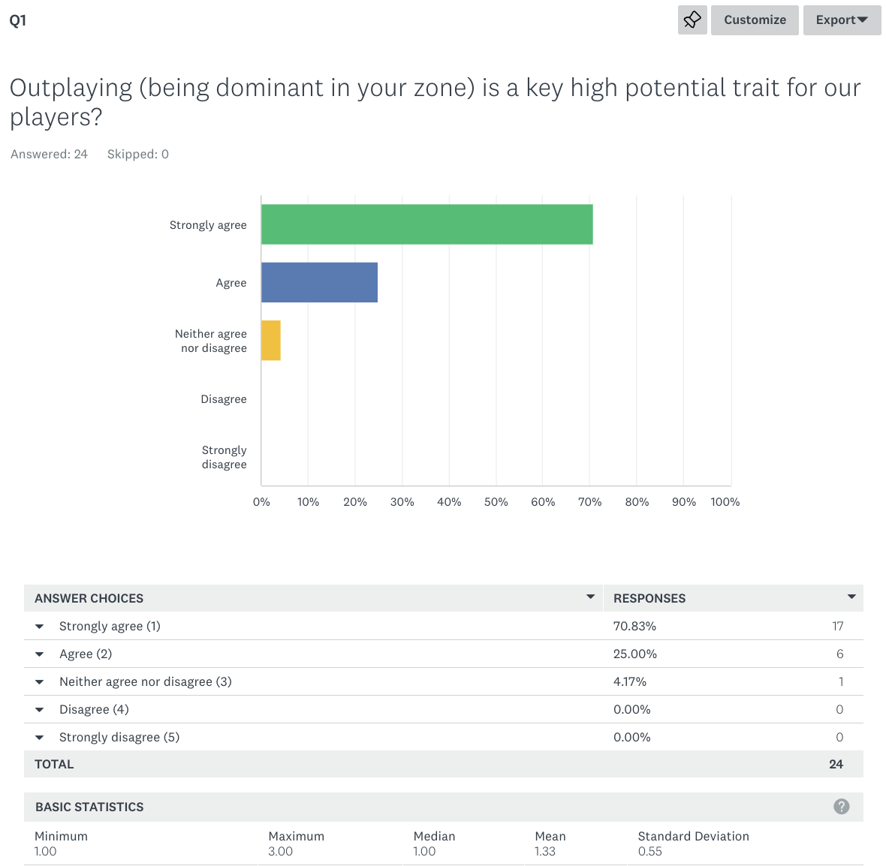

Question and Response 2
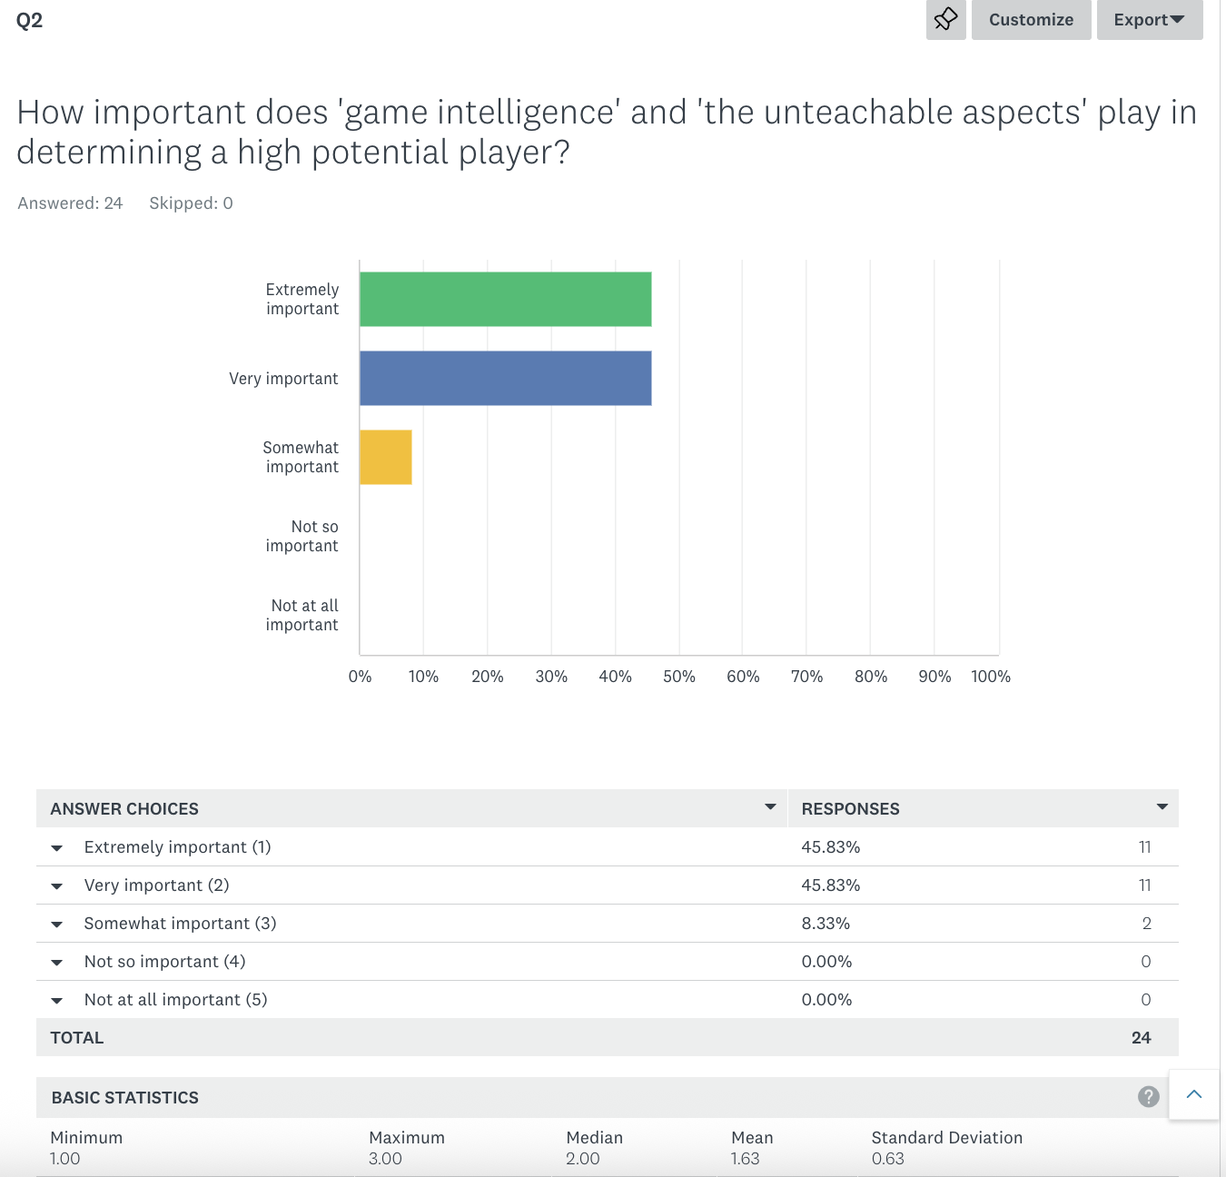

Question and Response 3
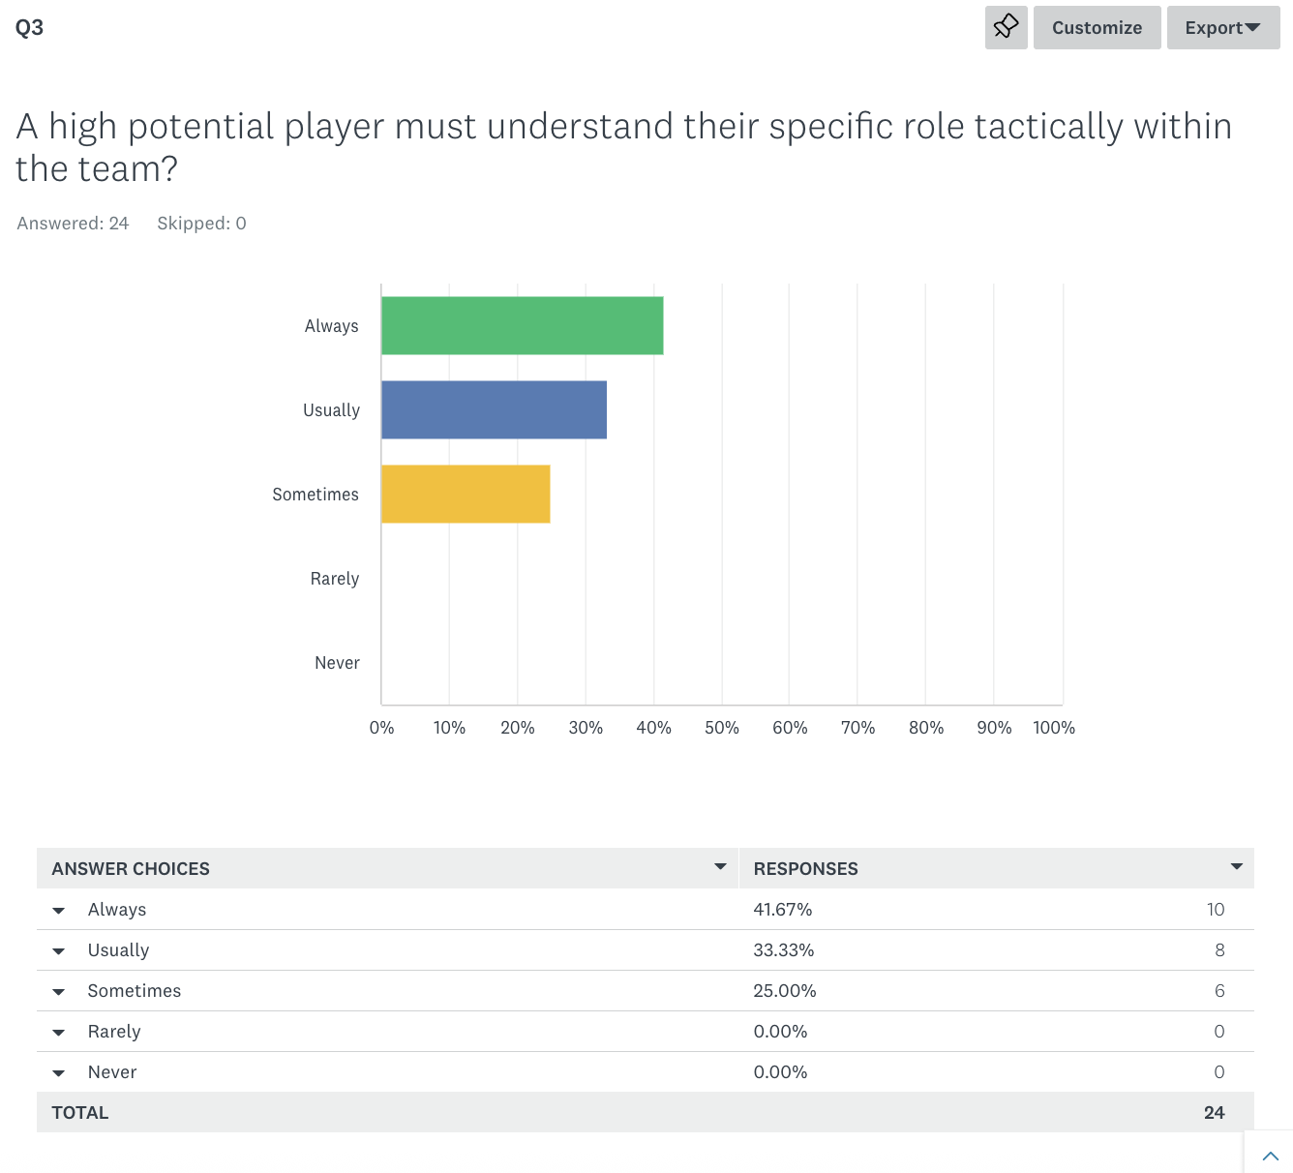

Question and Response 4
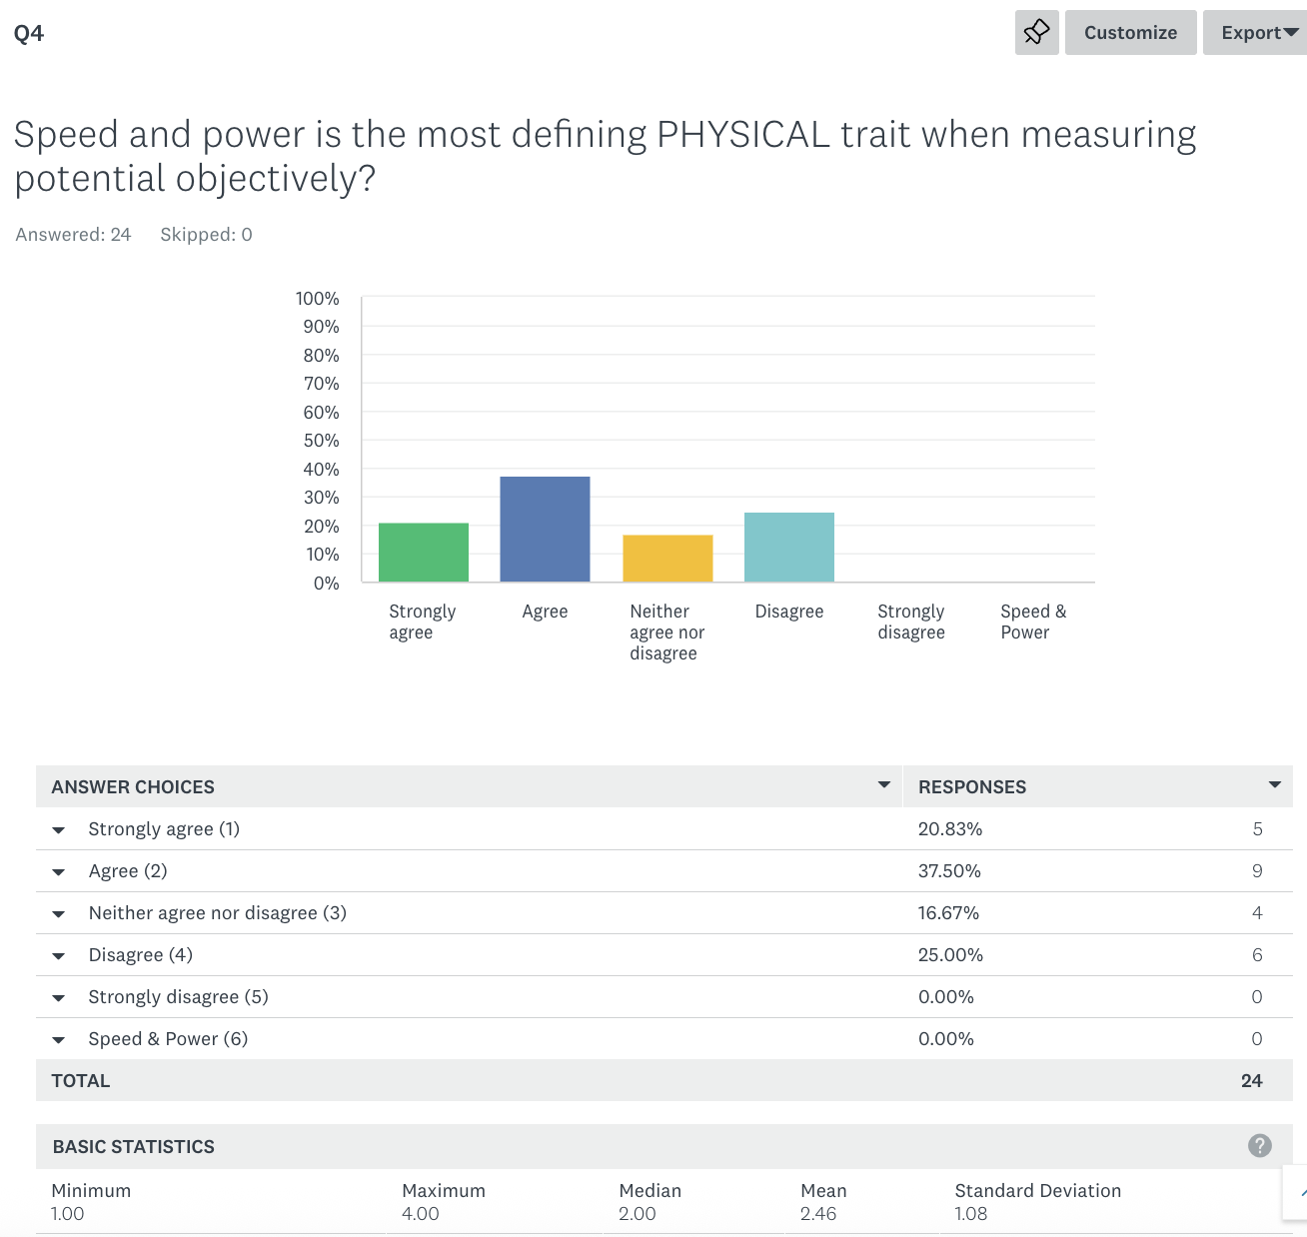

Question and Response 5

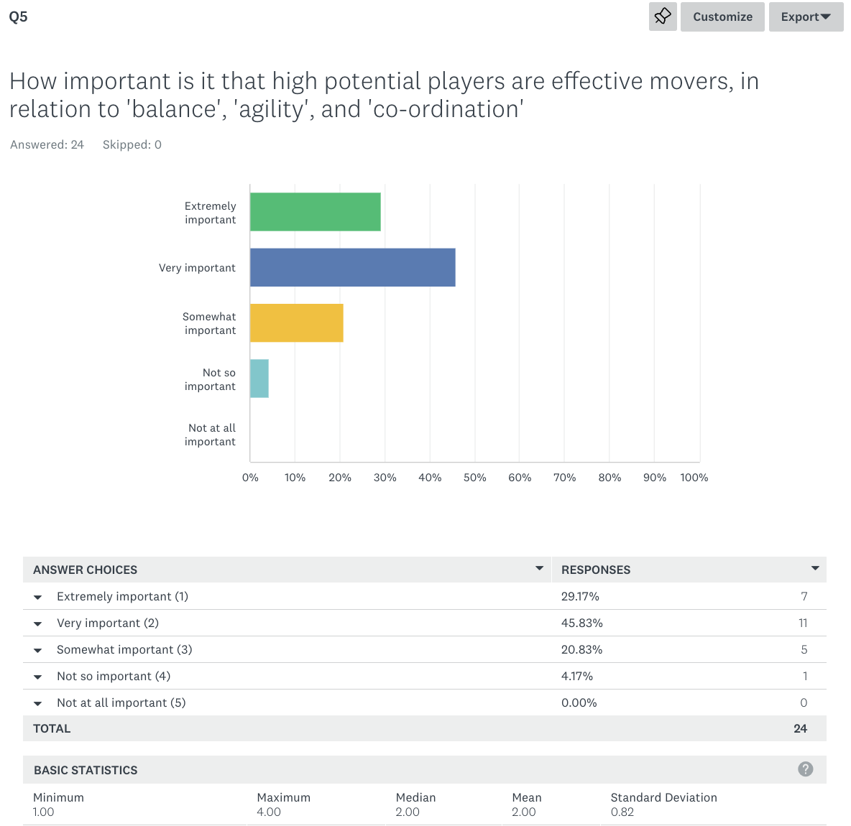

Question and Response 6
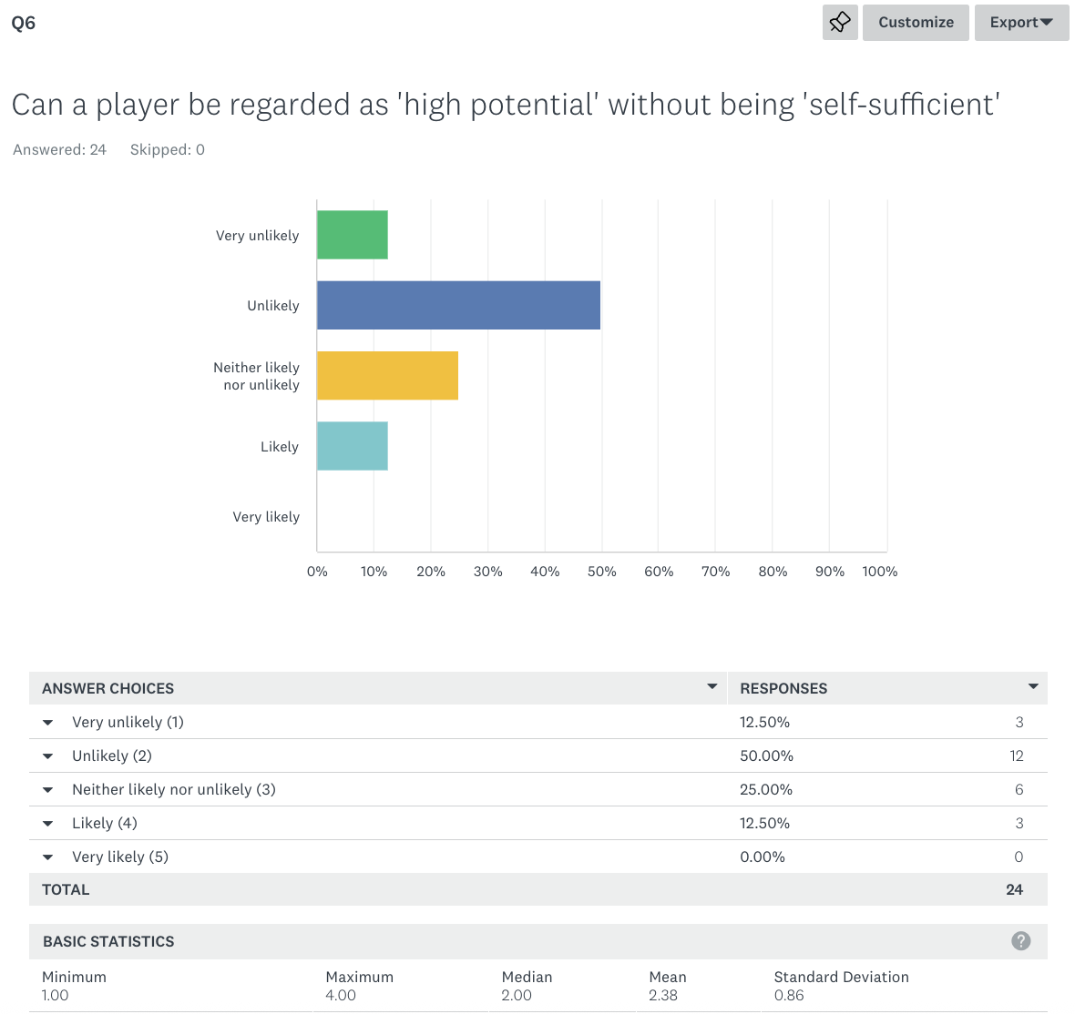

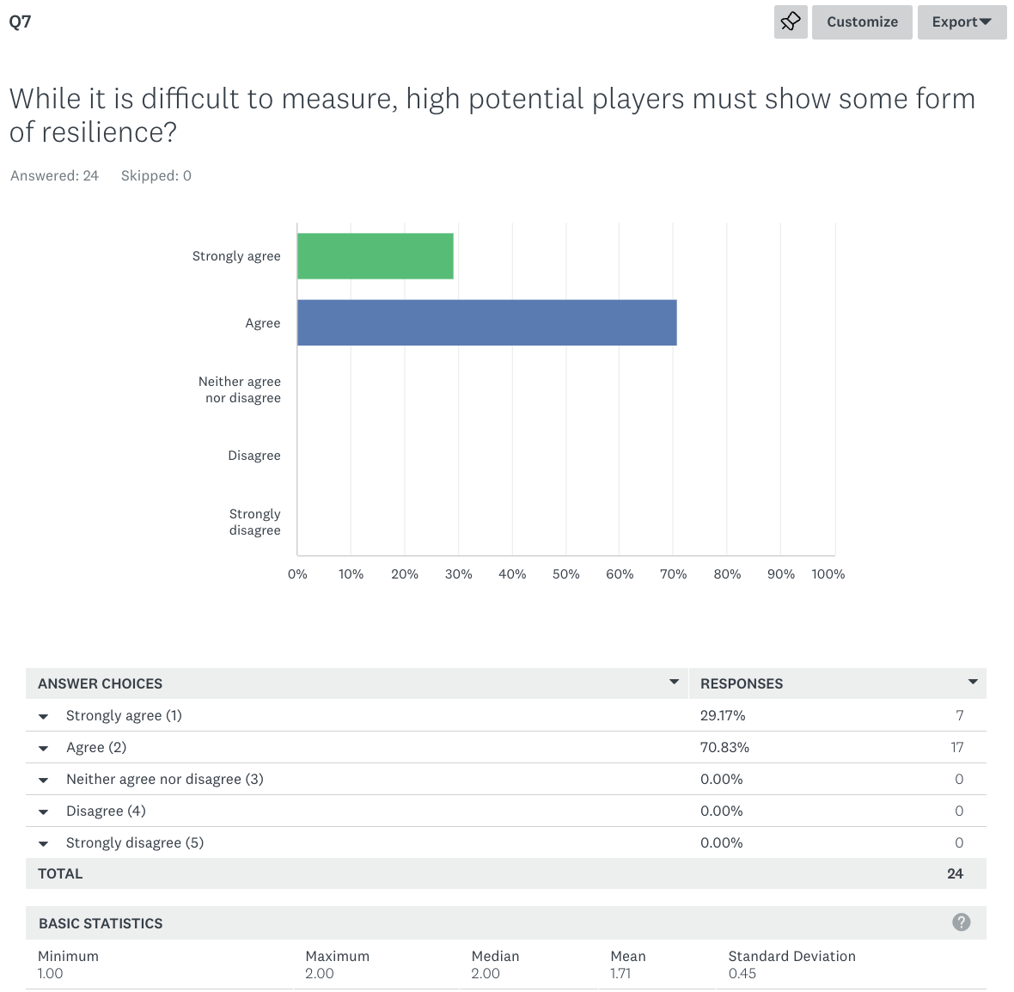
Question and Response 7

Question and Response 8
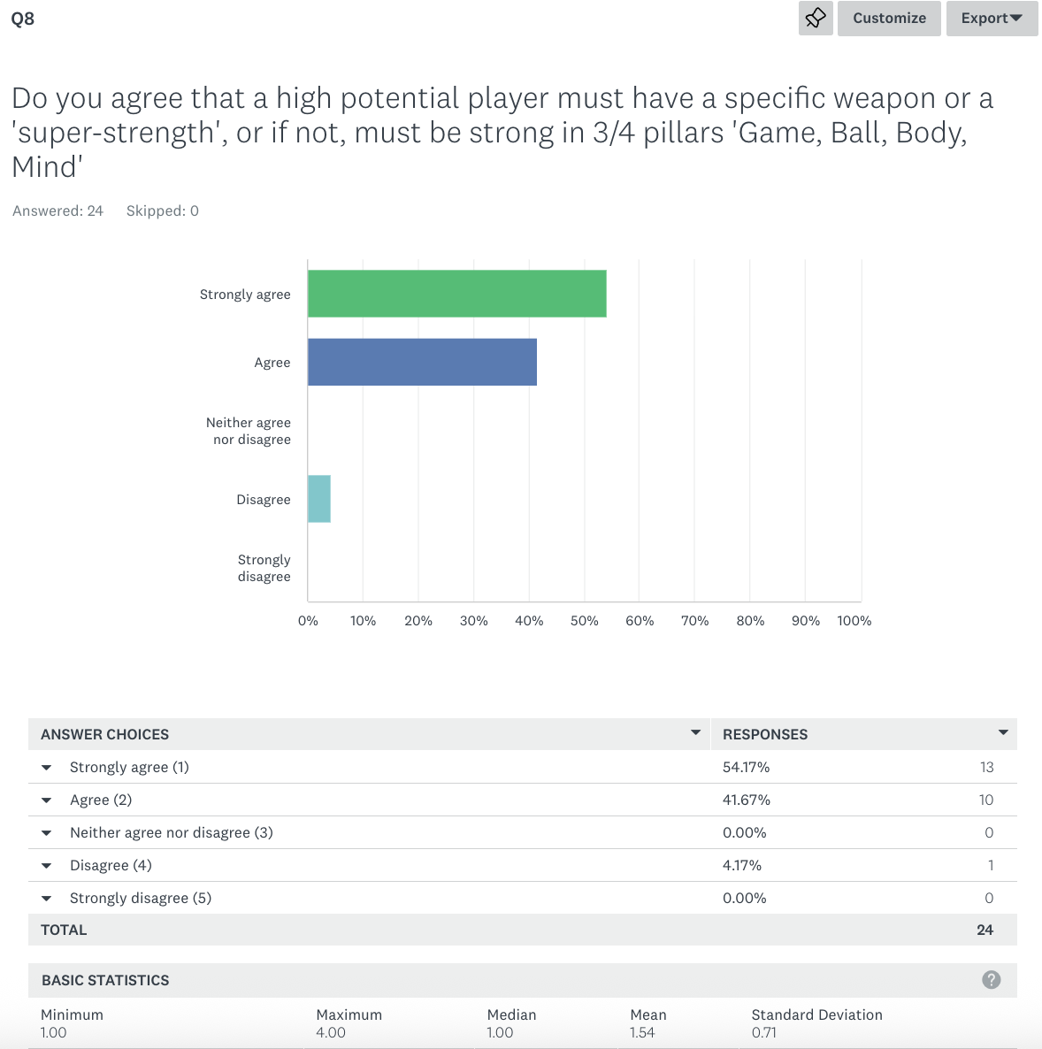

Question and Response 9
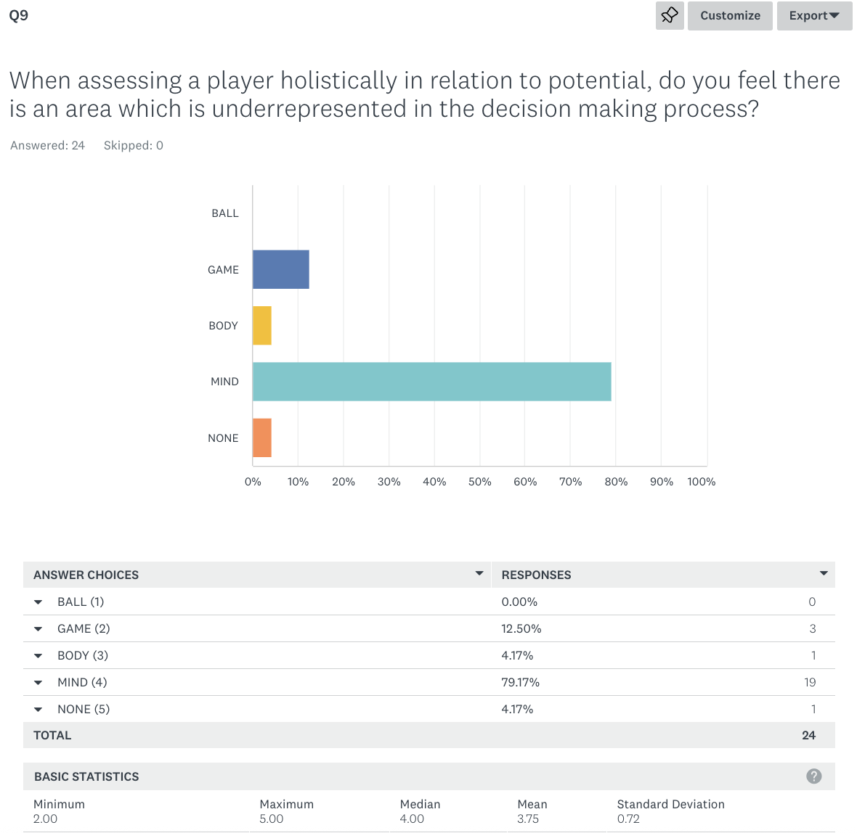

Question and Response 10
