This is the accepted manuscript version of the article, accepted for publication in Sports Medicine Volume 55, pages 655–673 (2025). The final authenticated version is available online at Springer via https://doi.org/10.1007/s40279-024-02149-3

Title
Which training intensity distribution intervention model will produce the greatest improvements in maximal oxygen uptake and time-trial performance? A systematic review and network meta-analysis of individual participant data

Author Information
Michael A. Rosenblat, PT, PhD^{1*} michael@evidencebasedcoaching.ca
Jennifer A. Watt, MD, PhD^{2,3,4} jennifer.watt@utoronto.ca
Jem I. Arnold, PT, PhD(c)⁵ jem.arnold@ubc.ca
Gunnar Treff, PhD⁶ gunnar.treff@pmu.ac.at
Øyvind B. Sandbakk, PhD⁷ oyvind.sandbakk@ntnu.no
Jonathan Esteve-Lanao, PhD⁷ jonathan.esteve@allinyourmind.es
Luca Festa, PhD⁸ luca.festa@me.com
Luca Filipas, PhD^{9,10} luca.filipas@unimi.it
Stuart Galloway, PhD¹¹ s.d.r.galloway@stir.ac.uk
Iker Muñoz, PhD¹² iker.munoz@deusto.es
Domingo J. Ramos-Campo, PhD¹³ domingojesusramos@gmail.com
Patrick Schneeweiss, PhD^{14,15} patrick.schneeweiss@med.uni-tuebingen.de
Sergio Sellés-Pérez, PhD¹⁶ sergio.selles@ua.es
Thomas Stöggl, PhD¹⁷ thomas.stoeggl@sbg.ac.at
Rune K. Talsnes, PhD⁷ rune.talsnes@ntnu.no
Christoph Zinner, PhD¹⁸ christoph.zinner@hoems.hessen.de
Stephen Seiler, PhD¹⁹ stephen.seiler@uia.no

Contact Details
¹Evidence-Based Coaching, www.evidencebasedcoaching.ca, Toronto, Ontario, Canada
²Knowledge Translation Program, Li Ka Shing Knowledge Institute, St Michael’s Hospital, Toronto, Ontario, Canada
³Division of Geriatric Medicine, Department of Medicine, University of Toronto, Toronto, Ontario, Canada
⁴Institute of Health Policy, Management and Evaluation, Dalla Lana School of Public Health, University of Toronto, Toronto, Ontario, Canada
⁵School of Kinesiology, University of British Columbia, British Columbia, Canada
⁶Paracelsus Medical University, Institute for Molecular Sports and Rehabilitation Medicine, Salzburg, Austria
⁷Centre for Elite Sports Research, Department of Neuromedicine and Movement Science, Norwegian University of Science and Technology, 7491 Trondheim, Norway
⁸Italian Cycling Federation FCI, Italy
⁹Department of Biomedical Sciences for Health, Università degli Studi di Milano, Milan, Italy
¹⁰TotalEnergies Pro Cycling Team, Essarts-en-Bocage, France
¹¹Physiology, Exercise and Nutrition Research Group, Faculty of Health Sciences and Sport, University of Stirling, Scotland, United Kingdom
¹²Department of Physical Activity and Sports, Faculty of Education and Sports, University of Deusto, Bilbao, Spain
¹³LFE Research Group, Department of Health and Human Performance, Faculty of Physical Activity and Sport Science-INEF, Universidad Politécnica de Madrid, Madrid, Spain
¹⁴Medical Clinic, Department of Sports Medicine, University of Tübingen, 72076 Tübingen, Germany
¹⁵Interfaculty Research Institute for Sports and Physical Activity, University of Tübingen, 72074 Tübingen, Germany
¹⁶General Didactic and Specific Didactics Department, Faculty of education, University of Alicante, Spain
¹⁷Red Bull Athlete Performance Center, Salzburg, Austria
¹⁸Department of Sport, University of Applied Sciences for Police and Administration of Hesse, Wiesbaden, Germany
¹⁹Department of Sport Science and Physical Education, Faculty of Health and Sport Sciences, University of Agder, Kristiansand, Norway

*Corresponding Author
Michael A. Rosenblat, PT, PhD
Evidence-Based Coaching,
www.evidencebasedcoaching.ca
Toronto, Ontario, Canada
ORCID: 0000-0002-3045-2177

Acknowledgements

We would like to thank Andrew J. Carnes, Paulina Hebisz, Rafał Hebisz and Stephen A. Ingham for sharing and discussing their data with us. However, during the process it became apparent that the studies in question did not fulfil the eligibility criteria for the present study and were therefore not included.

Abstract

Background

Endurance athletes tend to accumulate large training volumes with the majority of which is performed at a low intensity and a smaller portion at moderate and high intensity. However, different training intensity distributions (TID) are employed to maximize the physiological adaptations and endurance performance.

Objective

The objective of this systematic review and network meta-analysis of individual participant data was to compare the effect of different TID models on maximal oxygen uptake (V̇O_{2max}) and time-trial (TT) performance in endurance-trained athletes.

Methods

Studies were included if they were: 1. published in peer reviewed academic journals, 2. in English, 3. experimental or quasi-experimental studies, 4. included trained endurance athletes, 5. compared a polarized (POL) TID intervention to a comparator group that utilized different TID model, 6. the duration in each intensity domain could be quantified, and 7. reporting V̇O_{2max} or TT performance. Medline and SPORTDiscus were searched from inception until February 11, 2024.

Results

We included 13 studies with 348 (n = 296 male, n = 52 female) recreational (n = 150) and competitive (n = 198) endurance athletes. Mean age ranged from 17.6 to 41.5 years and V̇O_{2peak} ranged from 46.6 to 68.3 mL⋅kg⁻¹⋅min⁻¹. There were no differences in V̇O_{2max} or TT performance between POL and any of the other TID models when training load was quantified by using a time in heart rate zone approach. Subgroup analysis showed a significant difference (SMD = -0.63, p < 0.05) in the response of V̇O_{2peak} between recreational and competitive athletes. Competitive athletes may have greater improvements to V̇O_{2max} with POL, while recreational athletes may improve more with a pyramidal (PYR) TID.

Conclusion

We did not find general differences in the changes in V̇O_{2max} or TT performance between TID models. However, athletes at higher performance levels seem to benefit more from a POL TID model.

Key Points

- Although no general differences in the changes in V̇O_{2max} or TT performance was found between training intensity distribution (TID) models, when training load is quantified by time in heart rate zone, our data indicate that athletes at a higher performance level may respond better to a polarized TID, while recreational athletes may respond better to a pyramidal TID.

- Small sample size studies continue to be a major issue in sport science research. Even with pooling data we were not able to overcome this limitation for several intervention groups and therefore were unable to provide valid conclusions regarding the effects of threshold, low, and high training intensity distribution models. The direction and magnitude of the effect for these interventions may be as a result of sampling error.

- A high degree of collaboration, communication, and transparency between laboratories made this study achievable and we strongly encourage multi-centre collaboration among sport science researchers to improve statistical power to detect small but important effects of training interventions on performance outcomes.

Introduction

Observational studies have shown that endurance athletes following a structured training program tend to accumulate large training volumes, the majority of which is accumulated at a low intensity, with a smaller portion at higher intensity [1, 2]. There are several methods used to describe the different intensity zones/domains [2-5]. The Three-Intensity Zone model is commonly used in scientific literature to describe training intensity distribution (TID: with Z1 demarcated below the first lactate threshold (LT₁) or ventilatory threshold (VT₁); Z2 between LT₁/VT₁ and the second lactate (LT₂) or ventilatory (VT₂) threshold; and Z3 above LT₂/VT₂) [2, 6]. The Three-Intensity Zone model will be used to describe intensity moving forward in this review.

The term ‘polarized’ (POL) training was introduced to describe a commonly observed TID in elite endurance athletes by using a session-goal approach to determine training load. POL consists of approximately 75 to 80% of training sessions performed in Z1, <10% in Z2, and 15% to 20% in Z3 [2]. Alternatively, the term ‘threshold’ (THR) TID is used to describe training programs which incorporated a greater portion of training sessions in Z2 (e.g., 40-50-10%) [7-10]. This TID may be more common in untrained and/or recreational athletes [11].

Several early experimental studies were conducted to determine the effectiveness of POL compared to THR on endurance performance [7-10]. These studies found mixed results, partially explained by small sample sizes (6 to 15 participants per group). A meta-analysis of these early experimental studies was conducted to increase the ability to detect a significant effect, and showed that a POL model was superior to a THR model for improving time-trial (TT) performance [12].

Further examination into the approaches used to determine TID led to the addition of a pyramidal (PYR) model [11]. PYR consists of the same relative emphasis on Z1, but with the next largest intensity component in Z2, and the smallest component in Z3 (e.g., 75-15-10%). A PYR model has been observed as the primary TID model in several programs of endurance athletes [2, 13-16]. An important note, however, TID has been shown to vary depending on training phase [6, 11, 13-16], and across sports [6].

It is necessary to consider the method for which TID is determined when comparing TID across studies. For example, an intervention executed as a POL TID (75-8-17%) using a session-goal approach, can be quantified as a PYR TID (91-6-3%) using HR based time-in-zone (TIZ) [2]. In addition, there are several methods to determine TIZ including internal load measurements such as heart rate (HR) [2, 13, 16], blood lactate concentration [2], and training impulse (TRIMP) [14, 15], external load such as running pace [17, 18] and mechanical power output in cycling and rowing [19], and qualitative metrics such as rate of perceived exertion (RPE) [20]. Internal and external load measurements may not entirely align with each other and with the prescribed or intended TID target [21].

Since the earlier meta-analysis comparing POL to THR [12], there have been several experimental studies published that compared POL to other TID models. Therefore, a more up-to-date synthesis of the evidence is possible. A recent meta-analysis was conducted to compare POL versus all other interventions [22]. However, the authors conducted a pairwise analysis by combining interventions that differed in TID as well as exercise type (i.e., aerobic vs strength), which can be misleading. A network meta-analysis (NMA) allows for a comparison of multiple interventions simultaneously to determine the effect of TID on improvement in endurance sport performance in greater precision and provides the ability to rank all the interventions in a coherent way..

One limitation to synthesizing aggregate data from exercise intervention studies is the inability to account for individual alterations in the training program, as results are based on the original group allocation, not necessarily the completed program [8, 23]. Furthermore, differences in individual participant characteristics such as age and baseline fitness are subject to regression to the mean. Therefore, conducting a NMA of individual participant data (IPD) would allow for improved accuracy, as covariate analyses would not be subjected to these limitations [24]. Accordingly, the objective of this study was to conduct a NMA of IPD to compare the effect of different TID models on V̇O_{2max} and TT performance in endurance-trained athletes.

Methods

The Preferred Reporting Items for Systematic Reviews and Meta-Analyses (PRISMA) extension statement for reporting systematic reviews incorporating NMAs was used as a guideline to structure this review and ensure transparency [25].

Eligibility Criteria

Study eligibility criteria was based on the PICOS framework. Studies were included if they met the following criteria: 1. published in peer reviewed academic journals, 2. in the English language, 3. were experimental or quasi-experimental studies, 4. included recreational or competitive trained endurance athletes, 5. compared a POL TID intervention to a comparator group that utilized different TID model, 6. the duration completed in each intensity domain could be quantified, and 7. the study reported results for V̇O_{2max} or TT performance, pre- and post-intervention. Participants were considered trained endurance athletes if they participated in a structured training program that was specific to a mode of exercise, as previously described [26].

Studies were excluded for the following reasons: 1. the study was a companion report for an article that was included in the review, 2. the IPD was unavailable, 3. the study contained nutritional interventions (supplements, hydration, fed state, etc.), 4. participants were subject to changes in environmental conditions (heat, cold, altitude, hypoxia, hyperoxia, etc.), 5. the study included potential ergogenic devices/modalities (cooling vests, compression garments, etc.), or 6. included pharmacological agents.

Information Sources

Two electronic databases, Medline (Ovid) and SPORTDiscus (EBSCOhost), were used to conduct the literature search. The original search was conducted on March 28, 2023. An updated search was performed on February 11, 2024.

Search

The full line-by-line search strategy for each database is available in tables 1 and 2 of the Electronic Supplementary Material Appendix S1 (S1). The search strategy included commonly used terms to describe the different TID models and endurance sports. In addition, several different tenses and synonyms were used to further broaden the search. Search limits included the following: titles, abstracts, academic journal articles, and the English language.

Selection Process

Two reviewers (MR and GT) conducted two levels of screening (1. titles and abstracts, and 2. full-text articles). Disagreements were resolved by a third reviewer (JA). Studies were included in the NMA only if IPD were available. Study groups were compared at baseline using a one-way ANOVA to confirm that there were no significant differences in the primary outcomes (V̇O_{2peak} and/or TT performance) within studies. If there were significant differences, then the comparisons were excluded from the analyses.

Data Collection Process

The corresponding authors for each study was contacted by one of the reviewers (MR) to obtain IPD for participant characteristics, intervention results, and the results for the outcome variables. Two reviewers (MR and JA) conducted a separate data collection from each report to obtain relevant information regarding the study design and outcome characteristics. The corresponding authors for the respective studies were contacted via email to review the extracted IPD and correct potential errors.

When multiple studies reported data from the same participant sample, the publication with the most complete outcome data was considered the primary publication; otherwise, the publication with the largest sample size was considered the primary publication. If a companion publication reported data for an additional outcome of interest, then the data was extracted, but publication details (e.g., sample size) were abstracted from the primary publication only.

Data Items

All data are presented as a mean (and standard deviations [SD]). Study characteristics were extracted for the following components: participant allocation method (i.e., randomization and stratification), wash-in duration (weeks), and intervention duration (weeks).

IPD were requested and obtained for the following participant characteristics: age (years), sex, sport, performance level, baseline and follow up body mass (kg), and height (cm). Performance level was classified as competitive if participants competed at a high-performance level at Tier 3 or above (i.e., university/college, provincial/state, national, international, or professional) otherwise they were classified as recreational [27, 28].

Intervention characteristics were extracted for the following components: the method by which exercise intensity zones were determined, the intended TID model, the intended relative TID distribution, periodization model, mesocycle structure, inclusion of resistance training, and the duration of a taper period (weeks) if included. IPD were requested for the total time completed in the different exercise intensity zones. The duration (minutes) within each intensity zone was determined from the heart rate (HR) values corresponding to the respective zone borders.

Exercise intensity zones were determined using the Three Intensity-Zone Model described by Seiler et al. [2] as it is the most common method used in the TID literature. To facilitate data aggregation across multiple studies, the first lactate turn-point/threshold (LT₁), the gas exchange threshold (GET), and the first ventilatory threshold (VT₁) were all accepted to define the transition between Zone 1 (Z1) and Zone 2 (Z2). Similarly, the second ventilatory threshold (VT₂), respiratory compensation point (RCP), critical power (CP), second lactate turn-point/threshold (LT₂), and maximal lactate steady state (MLSS), were all accepted as methods to define the transition between the Z2 and Zone 3 (Z3).

TID models were classified by the relative proportion of total time spent in each zone: POL, Z1 > Z3 > Z2 and the Polarization-Index >2.0; PYR, Z1 > Z2 > Z3; THR, Z2 > Z1 > Z3; HIGH, Z3 > Z1 and Z3 > Z2; LOW, Z1 = 100%. The Polarization-Index was used to distinguish between POL and non-POL TID using Equation 1 when Z2 ≠ 0 and Equation 2 when Z2 = 0 [29]. The equations are provided in S1.

The following outcome characteristics were extracted for V̇O_{2max} or peak oxygen uptake (V̇O_{2peak}) (mL⋅kg⁻¹⋅min⁻¹): metabolic gas analysis system, exercise equipment and mode, initial stage intensity, stage duration, increment intensity, and measurement criteria. The terms V̇O_{2max} and V̇O_{2peak} will be referred to exclusively as V̇O_{2peak} moving forward, unless otherwise specified. For TT performance (seconds): exercise mode, TT distance, TT location, inclusion of familiarization, and inclusion of competition during the TT test. IPD were requested for the time-points including pre-wash in, baseline, mid-intervention, and follow up.

Geometry of Network

Network connectivity was visually assessed using network graphs for interventions that included V̇O_{2peak} and TT performance.

Risk of Bias of Individual Studies

The Cochrane Collaboration Risk of Bias 2.0 Tool [30] was used to assess the degree of bias across studies included in the review. Two reviewers (MR and JA) independently assessed the individual articles with a third reviewer (GT) to resolve discrepancies.

Summary Measures

V̇O_{2peak} was evaluated as a mean difference (MD) with associated 95% confidence intervals and prediction intervals between groups at follow up in its original units (mL⋅kg⁻¹⋅min⁻¹). TT performance was evaluated by using the standardized mean difference (SMD) between intervention groups at follow up. The SMD with associated 95% confidence intervals and prediction intervals were used in place of expressing TT performance as MD in seconds as each study used different distance events (e.g., 2 km versus 40 km). Hedges g was used to account for small sample size bias [31].

Planned Methods of Analysis

Data were aggregated in two different ways to conduct separate analyses. First, participants were placed in the groups for which they were originally allocated (intention-to-treat analysis). The second method involved placing participants into groups based on the completed TID model described in section 2.6 determined by HR TIZ (per-protocol analysis).

All statistical analyses were performed using R (version 4.3.3) [32]. The network meta-analysis for the MD for V̇O_{2peak}, and the SMD for V̇O_{2peak} and TT performance were conducted using the NETMETA package [33], which uses a frequentist approach. A two-stage approach was used to combine the results of the individual studies [24, 34]. The analyses were completed using a random effects model and the DerSimonian-Laird estimator [35].

Tables were used to describe the study characteristics, risk of bias, and results for V̇O_{2peak} and TT performance from the individual studies. A flow diagram was used to describe the article screening and selection process. A figure that contained forest plots was used to describe the pooled analysis of the results for V̇O_{2peak} and TT performance.

Assessment of Inconsistency

Global inconsistency was assessed using a design-by-treatment interaction model [36]. Local inconsistency was assessed using the back-calculation method (separate indirect from direct evidence [SIDE]) [37].

Risk of Bias Across Studies

A comparison adjusted funnel plot was used to visually assess small study effects for the NMA [38].

Additional Analysis

The METAFOR package [39], which conducts pairwise analyses, was used to determine the effect of covariates on V̇O_{2peak} and TT performance for comparisons with sufficient sample size. Participant level covariates included age and baseline V̇O_{2peak}. Study level covariates that were included sport, performance level, weeks, weekly training duration, polarization index, and TT distance.

Results

Study Selection

The electronic databases Medline (Ovid) and SPORTDiscus (EBSCOhost) produced a total of 559 results. Following the removal of 94 duplicates, 465 titles and abstracts were screened. A total of 29 full-text articles were identified, retrieved, and screened for eligibility. Thirteen studies were included in the study (Figure 1). The final literature search, which was performed on February 11, 2024, found 45 additional studies from the initial search; however, none were included in the study. The results of the line-by-line literature search and the explanations for study selection can be found in tables 1-3 of S1.

INSERT FIGURE 1 HERE

Identification of studies via databases and registers

Records removed before screening:
Duplicate records removed (n = 94)
Records marked as ineligible by automation tools (n = 0)
Records removed for other reasons (n = 0)
Records identified from*:
Databases (n = 559)
Registers (n = 0)

Identification

Records screened
(n = 465)
Records excluded**
(n = 436)

Reports sought for retrieval
(n = 29)
Reports not retrieved
(n = 0)

Screening

Reports excluded:
-Companion report (n = 3)
-Did not include recreational or competitively trained endurance athletes (n = 1)
-Did not report results for outcomes of interest (n = 3)
-Individual participant data unavailable (n = 4)
-Did not compare polarized TID to a group that utilized different TID model (n = 5)

Reports assessed for eligibility
(n = 29)

Studies included in review
(n = 13)
Reports of included studies
(n = 13)
Included

Figure 1. PRISMA flow diagram.

Summary of Network Geometry

There were 16 pairwise comparisons for V̇O_{2peak} and 12 for TT performance included in the intention-to-treat analysis. The graphs for both V̇O_{2peak} and TT performance demonstrated a non-star shaped network (Figure 2-A, 2-C). The number of pairwise comparisons increased to 26 for the per-protocol analysis for V̇O_{2peak} and 27 for TT performance. The graphs for the per-protocol analysis for both V̇O_{2peak} and TT performance revealed a star-shaped network (Figure 2-B, 2-D).

INSERT FIGURE 2 HERE

A B
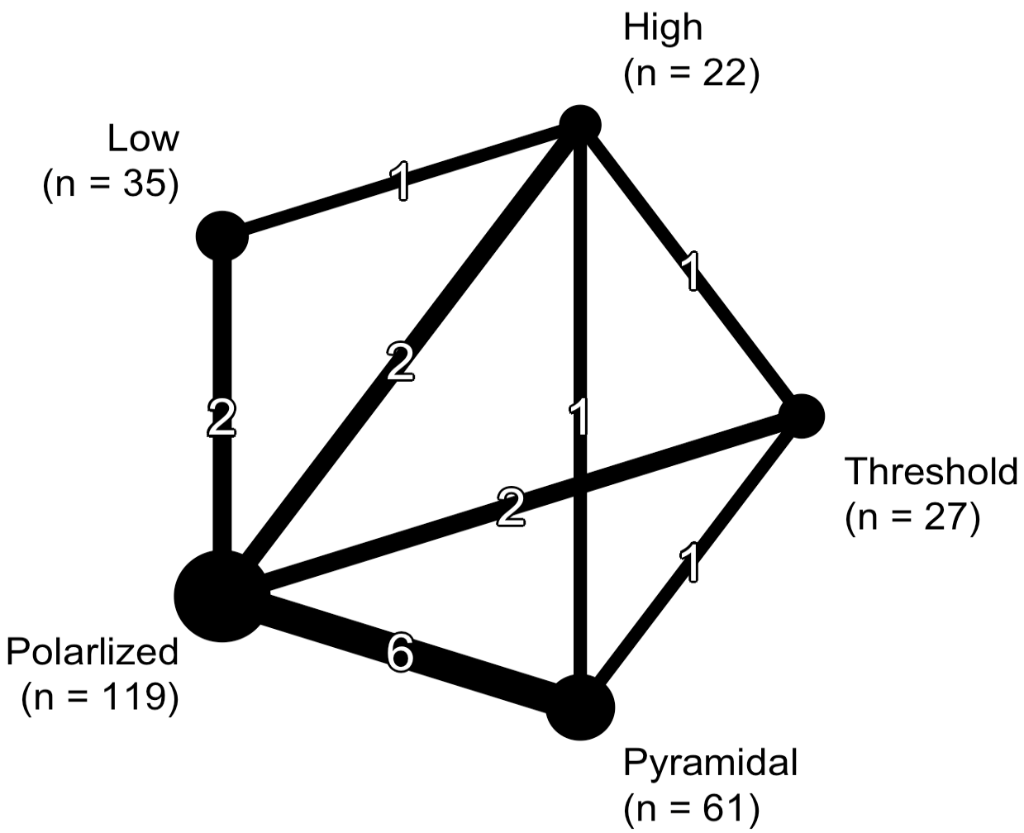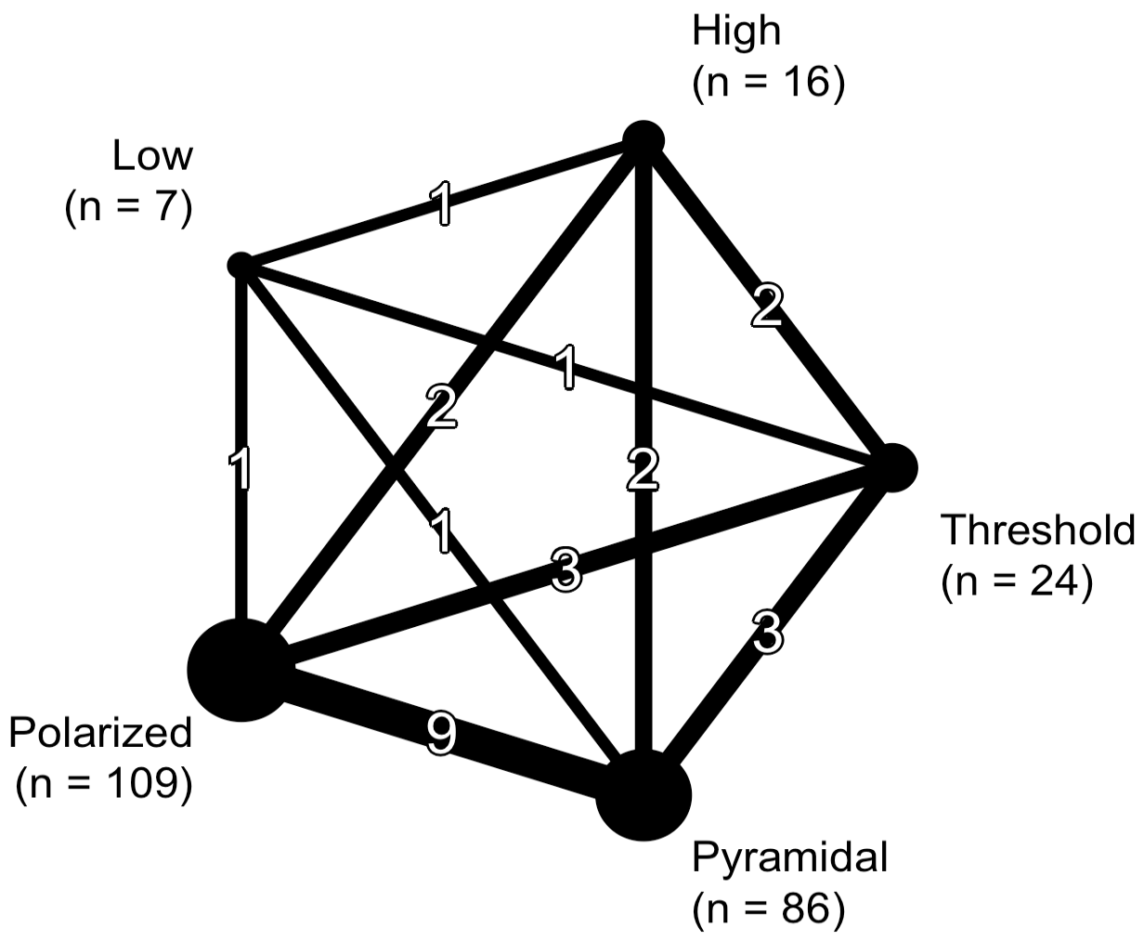

C D
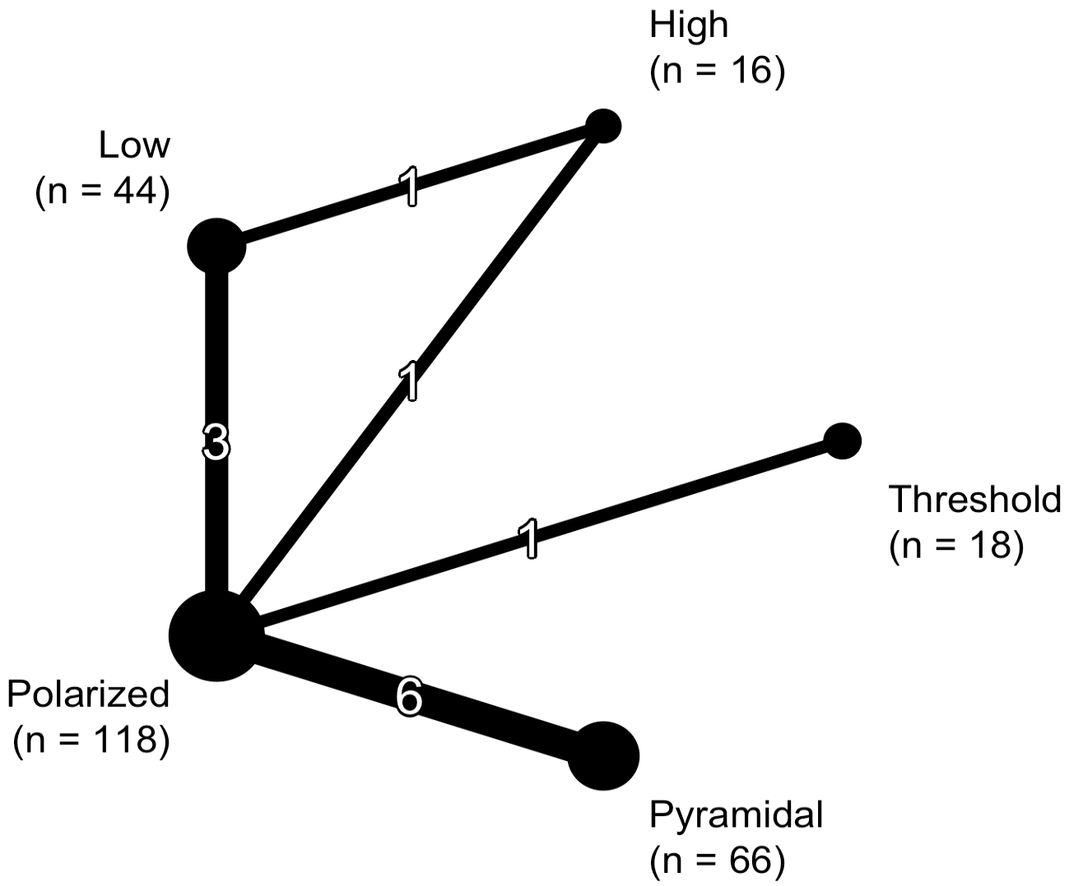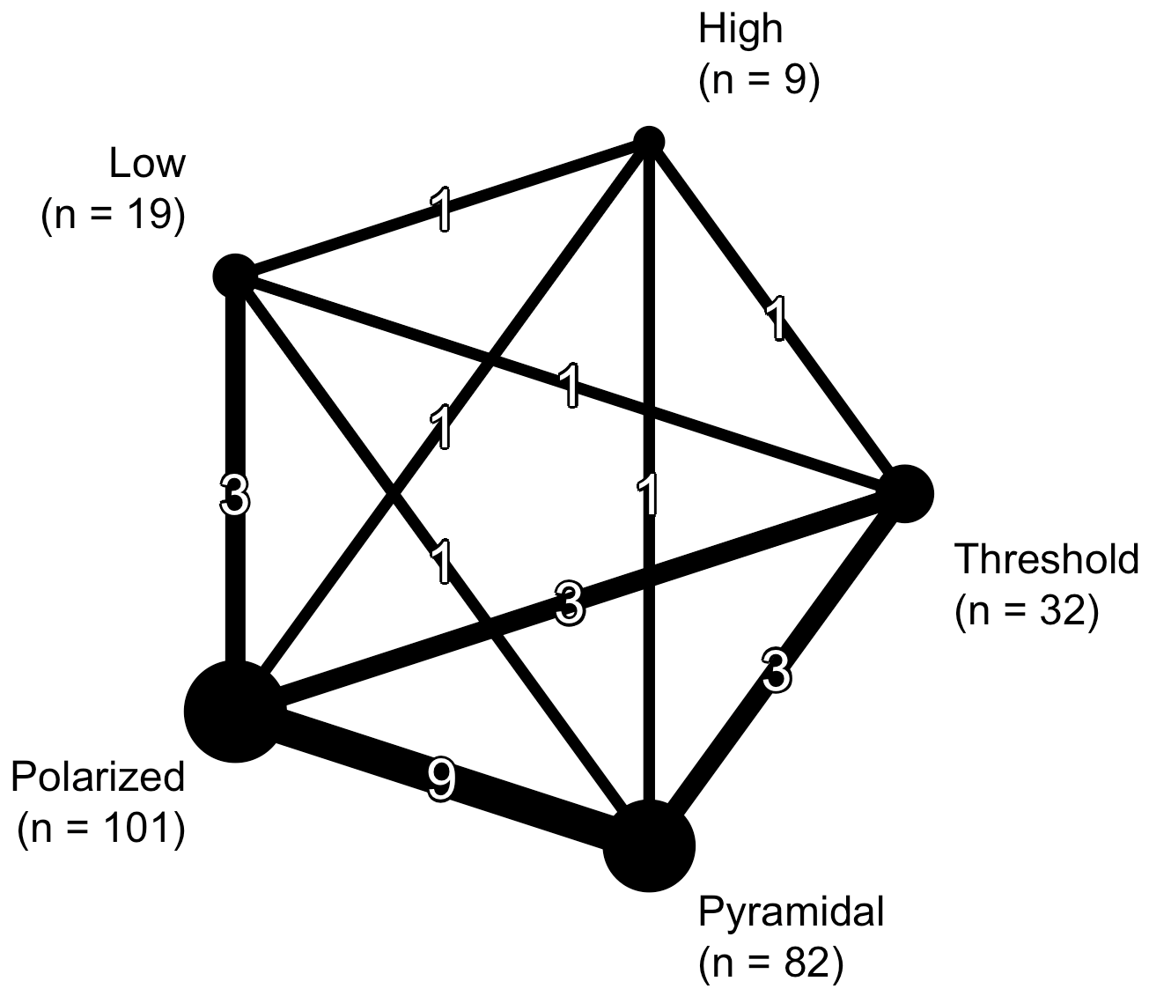

Figure 2. Network graphs for interventions: A, maximal oxygen uptake (V̇O_{2peak}) (mL⋅kg⁻¹⋅min⁻¹) for the intention-to-treat analysis; B, V̇O_{2peak} (mL⋅kg⁻¹⋅min⁻¹) for the per-protocol analysis; C, time-trial (TT) performance for the intention-to-treat analysis; D, TT performance for the per-protocol analysis. Line widths are proportional to the number of studies directly comparing treatments. Point sizes are proportional to the number of observations in treatment arms. The numbers on the connection lines indicates the number of direct pairwise comparisons between interventions.

Study Characteristics

A description of the study design characteristics for all included studies can be found in Table 1. Additional details of the study characteristics, participant characteristics, intervention characteristics, and outcome characteristics are located in tables 4-8 of S1.

One of the studies [9] included a crossover design. Therefore, only the results following the initial intervention for each group in this study were included. The studies ranged from 4 to 21 weeks in duration, including the wash-in and intervention periods.

There was a total of 348 (n = 296 male, n = 52 female) recreational (n = 150) and competitive (n = 198) endurance athletes across five sports (cross-country skiing, cycling, rowing, running, triathlon) included in the quantitative analysis. The range for mean age, BMI, and V̇O_{2peak} was 17.6 to 41.5 years, 19.8 to 24.9 kg⋅m⁻², and 46.6 to 68.3 mL⋅kg⁻¹⋅min⁻¹ respectively, across the studies respectively.

One study [7] prescribed a relative distribution of 80%, 10%, 10%, which did not fit any of the TID models described in section 2.6. This study was included in the review as careful analysis of the IPD revealed a completed distribution of 78(5)%, 7(3)%, 14(4)%, consistent with a POL TID. The comparator groups included PYR (k = 9), THR (k = 2), HIGH (k = 2), and LOW (k = 3) TID models.

Eleven of the 13 studies included V̇O_{2peak} (n = 264) and 10 included TT performance (n = 260). Regarding the TT tests, 2 studies [8, 40] included competitors, 1 study [8] used a different courses at follow-up, and in 1 study [40] the environmental conditions at follow up resulted in slower TT times.

INSERT TABLE 1 HERE

Table 1. Study characteristics
Study | Study characteristics |  | Participant characteristics |  |  |  |  |  | Intervention characteristics | Outcome characteristics
 | Design | Duration (weeks) | Sample size | Sport |  | Performance level | Age (years) | V̇O_{2peak}  (mL⋅kg⁻¹⋅min⁻¹) | Groups
Esteve-Lano et al. [7] | RCT | 21 | 15 | Running |  | Competitive | 26.4 (5.4) | 67.0 (6.1) | Z1 (polarized) | V̇O_{2max}, 10.4 km TT
 |  |  |  |  |  |  |  |  | Z2 (pyramidal)
Festa et al. [41] | RCT | 8 | 35 | Running |  | Recreational | 41.5 (8.6) | 53.3 (6.5) | PET (polarized) | V̇O_{2max}, 2.0 km TT
 |  |  |  |  |  |  |  |  | FOC (threshold)
Filipas et al. [42] | RCT | 22 | 30 | Running |  | Competitive | 36.6 (5.6) | 68.3 (3.8) | POL (polarized) | V̇O_{2peak}, 5.0 km TT
 |  |  |  |  |  |  |  |  | PYR (pyramidal)
Filipas et al. [43] | RCT | 12 | 30 | Running |  | Competitive | 34.4 (6.3) | 68.1 (2.8) | POL (polarized) | V̇O_{2peak}, 5.0 km TT
 |  |  |  |  |  |  |  |  | PYR (pyramidal)
Muñoz et al. [8] | RCT | 18 | 35 | Running |  | Recreational | 34.3 (7.4) | 61.6 (7.9) | PET (polarized) | V̇O_{2max}, 10.0 km TT
 |  |  |  |  |  |  |  |  | BThET (pyramidal)
Neal et al. [9] | RCT-X | 10 | 11 | Cycling |  | Competitive | 37.5 (6.2) | - | POL (polarized) | 40.0 km TT
 |  |  |  |  |  |  |  |  | PYR (pyramidal)
Pérez et al. [44] | RCT | 12 | 20 | Running |  | Recreational | 37.9 (8.9) | 56.8 (5.2) | POL (polarized) | V̇O_{2max}
 |  |  |  |  |  |  |  |  | PYR (pyramidal)
Schneeweiss et al. [40] | RCT | 3 | 18 | Cycling |  | Competitive | 17.9 (3.6) | - | POL (polarized) | 8.4 km (U/F), 12.6 km (M)
 |  |  |  |  |  |  |  |  | LIT (low)
Sellés-Pérez et al. [45] | NRCT | 23 | 15 | Triathlon |  | Recreational | 29.1 (6.7) | 55.7 (4.5) | POL (polarized) | V̇O_{2max}
 |  |  |  |  |  |  |  |  | PYR (pyramidal)
Stöggl et al. [46] | RCT | 9 | 41 | Combined |  | Competitive | 31.4 (6.7) | 62.0 (7.5) | POL (polarized) | V̇O_{2peak}
 |  |  |  |  |  |  |  |  | HVT (pyramidal)
 |  |  |  |  |  |  |  |  | THR (threshold)
 |  |  |  |  |  |  |  |  | HIIT (high)
Talsnes et al. [47] | RCT | 13 | 39 | XC-skiing |  | Competitive | 17.6 (0.7) | 66.7 (7.1) | HITG (polarized) | V̇O_{2peak}, 4.5 (F), 6.4 (M)
 |  |  |  |  |  |  |  |  | LOWG (low)
Treff et al. [23] | NRCT | 11 | 14 | Rowing |  | Competitive | 20.1 (2.0) | 65.6 (5.2) | POL (polarized) | V̇O_{2max}, 2.0 km TT
 |  |  |  |  |  |  |  |  | PYR (pyramidal)
Zinner et al. [48] | NRCT | 7 | 45 | Running |  | Recreational | 27.6 (6.9) | 46.6 (6.6) | POL (polarized) | V̇O_{2peak}, 5.0 km TT
 |  |  |  |  |  |  |  |  | HIIT (high)
 |  |  |  |  |  |  |  |  | HVT (low)
All data is expressed as a mean (SD). Body mass index (BMI), combined (cross-country skiing, cycling, running, triathlon), competitive (COMP), cross-country skiing (XC-skiing), female (F), male (M), maximal oxygen uptake (V̇O_{2max}), non-randomized controlled trial (NRCT), peak oxygen uptake (V̇O_{2peak}), randomized controlled trial (RCT), randomized controlled trial with crossover (RCT-X), recreational (REC), under 17 (U). Group names: between thresholds endurance training (BThET), focused endurance training (FOC), high-intensity interval training (HIIT), high-intensity training group (HITG), high volume training (HVT), low intensity training (LIT), low intensity training group (LITG), polarized (PET, POL), pyramidal (PYR), threshold hold training (THR), zone 1 (Z1), zone 2 (Z2).

Risk of Bias within Studies

Four of the 11 studies that included V̇O_{2peak} and 3 of the 10 studies that included TT performance were considered to have a high risk of bias. The full risk of bias results can be found in tables 9 and 10 of S1.

Results of Individual Studies

The results for the weekly TID as determined by heart rate for the groups as initially allocated (intention-to-treat) and the retrospective group re-allocation (per-protocol) are in tables 11 and 12 of S1. Group adherence was maintained in 5 of the 13 studies [40, 42-45] with a total of 67 (19%) participants altering their TID model during their training programs.

There were no differences between the intervention and comparator groups at baseline for V̇O_{2peak} and TT performance across studies. Following group re-allocation, there was a significant difference between groups for V̇O_{2peak} at baseline for 1 study [8], which was subsequently excluded from the per-protocol analysis.

The results for V̇O_{2peak} and TT performance with the participants in their original groups can be found in tables 13 and 14 of S1. The results for V̇O_{2peak} and TT performance following a retrospective group re-allocation based on the completed TID using the IPD are presented in Tables 2 and 3. Two studies [40, 47] combined participants that completed TT tests that differed in distance into a single analysis. In the retrospective group re-allocation, the participants in both studies, respectively, were placed into groups based on TT distance (i.e., outcome measure).

INSERT TABLE 2 HERE

INSERT TABLE 3 HERE

Table 2. Results for peak oxygen uptake (per-protocol analysis)
Study | Group | Group size | Completed  TID model | Baseline  (mL⋅kg⁻¹⋅min⁻¹) | Follow-up  (mL⋅kg⁻¹⋅min⁻¹) | Delta  (mL⋅kg⁻¹⋅min⁻¹) | Delta  (%)
Festa et al. [41] | 1 | 19 | Polarized | 53.0 (5.9) | 53.6 (4.8) | 0.6 (2.9) | 1.5 (5.7)
 | 2 | 4 | Pyramidal | 56.7 (6.5) | 56.6 (6.7) | -0.0 (1.2) | -0.1 (2.0)
 | 3 | 12 | Threshold | 52.7 (7.7) | 52.1 (7.9) | -0.6 (3.2) | -1.1 (7.2)
Filipas et al. [42] | 1 | 15 | Polarized | 68.5 (3.3) | 69.9 (3.6) | 1.4 (2.0) | 2.1 (3.0)
 | 2 | 15 | Pyramidal | 68.1 (4.3) | 68.9 (3.5) | 0.8 (1.5) | 1.3 (2.2)
Filipas et al. [43] | 1 | 15 | Polarized | 68.1 (2.9) | 68.1 (3.9) | 0.1 (1.4) | 0.1 (2.1)
 | 2 | 15 | Pyramidal | 68.2 (2.8) | 68.8 (2.6) | 0.6 (1.3) | 0.9 (1.9)
Pérez et al. [44] | 1 | 11 | Polarized | 56.7 (5.5) | 56.1 (6.3) | -0.6 (3.0) | -1.1 (5.3)
 | 2 | 9 | Pyramidal | 56.8 (5.0) | 58.4 (4.7) | 1.7 (2.9) | 3.1 (5.2)
Sellés-Pérez et al. [45] | 1 | 7 | Polarized | 54.7 (4.3) | 55.1 (5.5) | 0.4 (6.0) | 1.2 (11.4)
 | 2 | 8 | Pyramidal | 56.5 (4.8) | 57.6 (4.9) | 1.1 (2.9) | 2.1 (5.6)
Stöggl et al. [46] | 1 | 9 | Polarized | 61.7 (8.1) | 67.0 (8.5) | 5.3 (1.8) | 8.8 (3.1)
 | 2 | 10 | Pyramidal | 60.9 (8.4) | 61.9 (9.1) | 0.9 (3.2) | 1.6 (5.1)
 | 3 | 8 | Threshold | 63.3 (5.2) | 60.5 (7.9) | -2.8 (4.4) | -4.7 (7.5)
 | 4 | 9 | High | 63.7 (7.1) | 66.6 (5.8) | 2.8 (3.5) | 4.8 (5.9)
Talsnes et al. [47] | 1a | 9 | Polarized | 57.1 (3.9) | 59.1 (4.0) | 2.1 (2.7) | 3.7 (4.9)
 | 2a | 1 | Pyramidal | 60.1 (0.0) | 58.6 (0.0) | -1.5 (0.0) | -2.5 (0.0)
 | 1b | 19 | Polarized | 70.7 (4.9) | 70.3 (3.6) | -0.4 (3.7) | -0.4 (5.5)
 | 2b | 4 | Pyramidal | 68.7 (4.5) | 65.8 (5.6) | -2.9 (1.6) | -4.3 (2.5)
Treff et al. [23] | 1 | 5 | Polarized | 67.7 (7.9) | 67.4 (7.1) | -0.3 (1.4) | -0.3 (1.8)
 | 2 | 5 | Pyramidal | 63.5 (3.0) | 65.1 (0.8) | 1.6 (3.5) | 2.7 (5.6)
Zinner et al. [48] | 1 | 9 | Polarized | 45.7 (5.8) | 46.0 (5.2) | 0.3 (2.8) | 1.0 (6.1)
 | 2 | 16 | Pyramidal | 44.5 (7.0) | 46.3 (7.5) | 1.8 (2.5) | 4.1 (5.7)
 | 3 | 4 | Threshold | 43.2 (2.3) | 45.7 (2.9) | 2.5 (1.3) | 5.7 (2.8)
 | 4 | 7 | High | 47.5 (3.2) | 48.7 (5.0) | 1.2 (4.6) | 2.7 (9.4)
 | 5 | 7 | Low | 50.7 (7.7) | 51.2 (9.9) | 0.5 (3.1) | 0.6 (5.0)
All data is expressed as a mean (SD). Schneeweiss et al. [40] groups 1a and 2a include junior and female athletes who completed an 8.4 km time-trial, and groups 1b and 2b include senior athletes who completed a 12.6 km time-trial. Talsnes et al. [47] groups 1a and 2a include female athletes who completed a 4.6 km time-trial, and groups 1b and 2b include male athletes who completed a 6.4 km time-trial.

Table 3. Results for time-trial performance (per-protocol analysis)
Study | Group | Group size | Completed  TID model | Baseline  (sec) | Follow-up  (sec) | Delta  (sec) | Delta  (%)
Esteve-Lano et al. [7] | 1 | 3 | Polarized | 2203.7 (131.5) | 2082.0 (96.4) | -121.7 (35.2) | -5.5 (1.3)
 | 2 | 11 | Pyramidal | 2257.9 (138.0) | 2116.3 (128.8) | -141.6 (58.4) | -6.2 (2.4)
Festa et al. [41] | 1 | 18 | Polarized | 532.9 (79.7) | 513.2 (70.9) | -19.8 (34.7) | -3.4 (5.5)
 | 2 | 4 | Pyramidal | 543.2 (69.8) | 512.5 (70.1) | -30.8 (13.0) | -5.7 (2.4)
 | 3 | 12 | Threshold | 520.7 (65.9) | 510.1 (60.3) | -10.6 (13.4) | -1.9 (2.4)
Filipas et al. [42] | 1 | 15 | Polarized | 997.7 (47.9) | 986.3 (47.0) | -11.5 (11.0) | -1.1 (1.1)
 | 2 | 15 | Pyramidal | 992.8 (56.6) | 986.7 (55.7) | -6.1 (5.8) | -0.6 (0.6)
Filipas et al. [43] | 1 | 15 | Polarized | 997.1 (34.5) | 989.7 (37.5) | -7.5 (5.9) | -0.8 (0.6)
 | 2 | 15 | Pyramidal | 992.9 (31.8) | 983.5 (32.6) | -9.3 (7.0) | -0.9 (0.7)
Muñoz et al. [8] | 1 | 5 | Polarized | 2346.4 (312.8) | 2235.0 (350.3) | -111.4 (51.4) | -5.0 (2.6)
 | 2 | 20 | Pyramidal | 2373.4 (309.6) | 2242.4 (274.0) | -131.1 (76.4) | -5.4 (2.6)
 | 3 | 7 | Threshold | 2600.4 (247.0) | 2536.4 (228.8) | -64.0 (109.8) | -2.4 (4.1)
Neal et al. [9] | 1 | 6 | Polarized | 3891.8 (151.3) | 3764.7 (146.2) | -127.2 (78.6) | -3.3 (2.0)
 | 2 | 4 | Pyramidal | 3830.0 (325.0) | 3896.5 (394.7) | 66.5 (248.8) | 1.8 (6.8)
 | 3 | 1 | Threshold | 3761.0 (0.0) | 3780.0 (0.0) | 19.0 (0.0) | 0.5 (0.0)
Schneeweiss et al. [40] | 1a | 5 | Polarized | 2481.6 (213.1) | 2571.6 (343.9) | 90.0 (141.1) | 3.3 (5.1)
 | 2a | 3 | Low | 2718.7 (352.8) | 2855.7 (464.6) | 137.0 (167.6) | 4.8 (6.2)
 | 1b | 5 | Polarized | 3239.0 (85.3) | 3334.0 (222.1) | 95.0 (139.9) | 2.8 (4.3)
 | 2b | 5 | Low | 3262.0 (145.4) | 3217.2 (109.2) | -44.8 (108.8) | -1.3 (3.3)
Talsnes et al. [47] | 1a | 9 | Polarized | 1450.8 (59.5) | 1429.6 (81.8) | -21.2 (43.0) | -1.5 (3.0)
 | 2a | 1 | Pyramidal | 1410.0 (0.0) | 1353.0 (0.0) | -57.0 (0.0) | -4.0 (0.0)
 | 1b | 15 | Polarized | 1756.5 (139.6) | 1719.9 (145.8) | -36.6 (50.7) | -2.1 (2.8)
 | 2b | 2 | Pyramidal | 1814.5 (149.2) | 1827.5 (201.5) | 13.0 (52.3) | 0.6 (2.8)
Treff et al. [23] | 1 | 5 | Polarized | 371.9 (11.5) | 370.1 (9.4) | -1.8 (3.5) | -0.5 (1.0)
 | 2 | 6 | Pyramidal | 368.6 (8.3) | 367.2 (7.0) | -1.4 (2.0) | -0.4 (0.5)
Zinner et al. [48] | 1 | 9 | Polarized | 1576.6 (196.5) | 1514.4 (188.6) | -62.1 (31.0) | -3.9 (1.9)
 | 2 | 16 | Pyramidal | 1681.4 (339.4) | 1616.5 (329.7) | -64.9 (199.0) | -3.3 (10.2)
 | 3 | 4 | Threshold | 1717.2 (195.5) | 1573.5 (231.6) | -143.8 (213.9) | -8.1 (12.2)
 | 4 | 7 | High | 1538.4 (153.3) | 1502.4 (154.4) | -36.0 (66.6) | -2.3 (4.5)
 | 5 | 5 | Low | 1511.2 (394.2) | 1381.6 (311.1) | -129.6 (85.1) | -8.0 (2.9)
All data is expressed as a mean (SD). Schneeweiss et al. [40] groups 1a and 2a include junior and female athletes who completed an 8.4 km time-trial, and groups 1b and 2b include senior athletes who completed a 12.6 km time-trial. Talsnes et al. [47] groups 1a and 2a include female athletes who completed a 4.6 km time-trial, and groups 1b and 2b include male athletes who completed a 6.4 km time-trial.

Synthesis of Results

V̇O_{2peak}

The synthesized results for the MD and SMD for V̇O_{2peak} for the original group allocation and following group re-allocation can be found in Figure 2. There were 9 studies (n = 264) that were included in the analyses based on the original group allocation for V̇O_{2peak} [10, 41-45, 47]. The NMA consisted of POL (n = 119), PYR (n = 61), THR (n = 27), HIGH (n = 22), and LOW (n = 35) TID models. When compared to a POL TID model, there were no significant differences in the SMD for PYR (p = 0.81), THR (p = 0.27), HIGH (p = 0.25), or LOW (p = 0.15).

Following group re-allocation there was a change in sample size for each intervention (POL: n = 109, PYR: n = 86, THR: n = 24, HIGH: n = 16, LOW: n = 7). As in the analyses for the original group allocation, there were no significant differences between POL and PYR (p = 0.68), THR (0.17), HIGH (p = 0.33), LOW (p = 0.13).

TT Performance

The synthesized results for the SMD for V̇O_{2peak} for the original group allocation and following group re-allocation can be found in Figure 2. There were 10 studies (n = 262) that were included in the analyses based on the original group allocation for V̇O_{2peak} [7-9, 23, 40-43, 47, 48]. The NMA consisted of POL (n = 118), PYR (n = 66), THR (n = 18), HIGH (n = 16), and LOW (n = 44) TID models. When compared to a POL TID model, there were no significant differences in the SMD for PYR (p = 0.34), THR (p = 0.91), HIGH (p = 0.52), or LOW (p = 0.75).

Following group re-allocation there was a change in sample size for each intervention (POL: n = 101, PYR: n = 82, THR: n = 32, HIGH: n = 9, LOW: n = 19). As in the analyses for the original group allocation, there were no significant differences between POL and PYR (p = 0.75), THR (0.19), HIGH (p = 0.70), LOW (p = 0.30).

INSERT FIGURE 3 HERE

A B
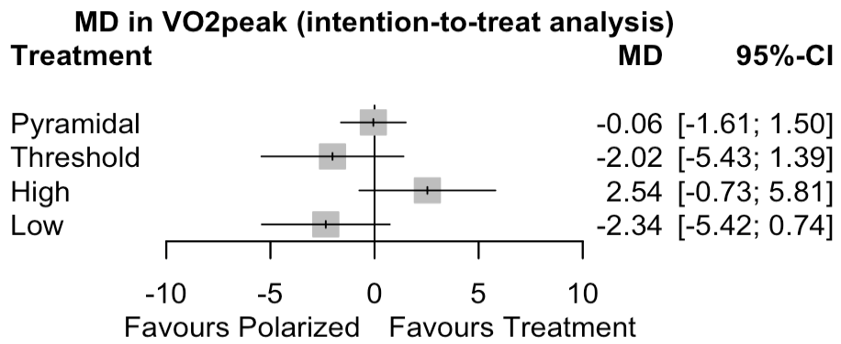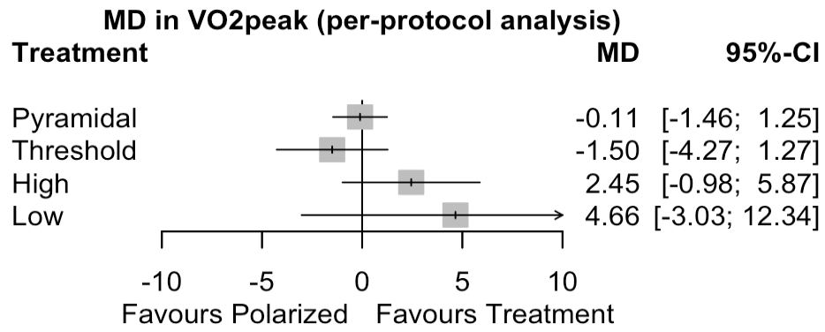

C D
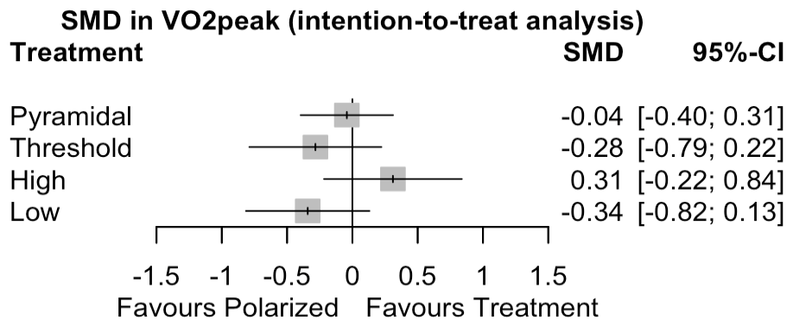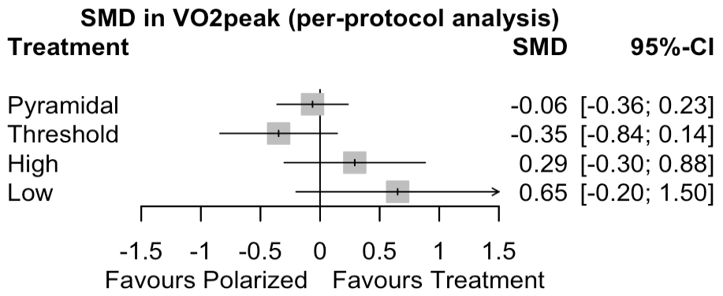

E F
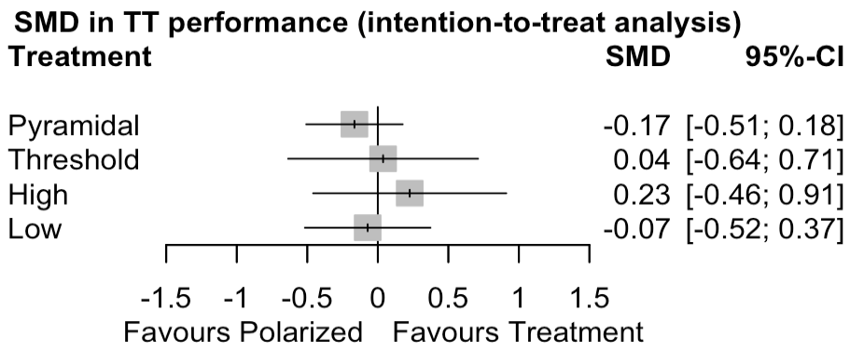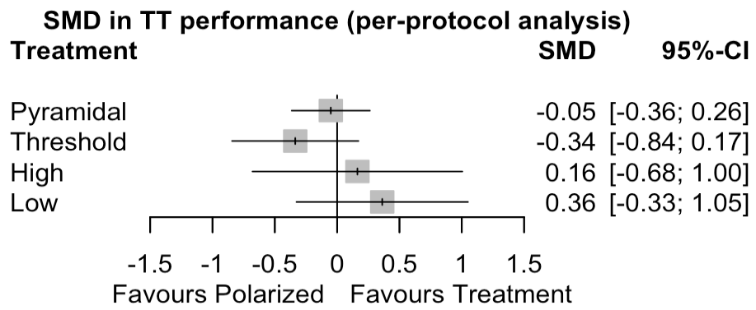

Figure 3. Forest plots of: A, mean difference (MD) in maximal oxygen uptake (V̇O_{2peak}) (mL⋅kg⁻¹⋅min⁻¹) for the intention-to-treat analysis; B, MD in V̇O_{2peak} (mL⋅kg⁻¹⋅min⁻¹) for the per-protocol analysis; C, standardized mean difference (SMD) in V̇O_{2peak} for the intention-to-treat analysis; D, SMD in V̇O_{2peak} for the per-protocol analysis; E, SMD in time-trial (TT) performance for the intention-to-treat analysis; F, SMD in TT performance for the per-protocol analysis.

Exploration of Inconsistency

There was no indication of global inconsistency for the intention-to-treat analyses for the MD in V̇O_{2peak} (Q = 3.51, p = 0.48), the SMD for V̇O_{2peak} (Q = 3.57, p = 0.47), or for the SMD for TT performance (Q = 0.12, p = 0.73). There was also no indication of global inconsistency for the per-protocol analyses for the MD in V̇O_{2peak} (Q = 3.16, p = 0.79), the SMD for V̇O_{2peak} (Q = 2.20, p = 0.90), or for the SMD for TT performance (Q = 2.47, p = 0.65). Furthermore, there was also no indication of local inconsistency for any of the analyses. The results can be found in tables 15-20 in S1.

Risk of Bias Across Studies

Visual inspection of funnel plot asymmetry did not indicate the presence of small sample size bias in the results for any of the pooled analyses. A figure that contains the funnel plots for each of the analyses are in figure 1 of S1.

Results of Additional Analysis

V̇O_{2peak}

Stratified meta-analysis showed a significant difference of between recreational and competitive athletes (SMD = -0.63, 95% CI = -1.24 to -0.02, p < 0.05; MD of approximately 2.7 mL⋅kg⁻¹⋅min⁻¹), with recreational athletes favouring PYR and competitive athletes favouring POL (Figure 3). There was a significant difference (p < 0.001) in baseline V̇O_{2peak} between recreational (53.0, 95% CI = 49.7 to 56.3) and competitive athletes (67.0, 95% CI = 64.0 to 69.8). An additional subgroup analysis was conducted to determine if the difference in V̇O_{2peak} was because of sex-based differences between the recreational and competitive subgroups; however, this was not found to be the case. There was no significant difference in other covariates including age (p = 0.45), sport (p = 0.16), weekly training duration (min) (p = 0.22), weeks (p = 0.83), or Polarization-Index (p = 0.98).

TT Performance

There was no significant difference in covariates including age (p = 0.19), baseline V̇O_{2peak} (p = 0.10), sport (p = 0.71), performance level (p = 0.72), weekly training duration (min) (p = 0.95), weeks (p = 0.64), Polarization-Index (p = 0.65), or TT distance (p = 0.48).

INSERT FIGURE 4 HERE

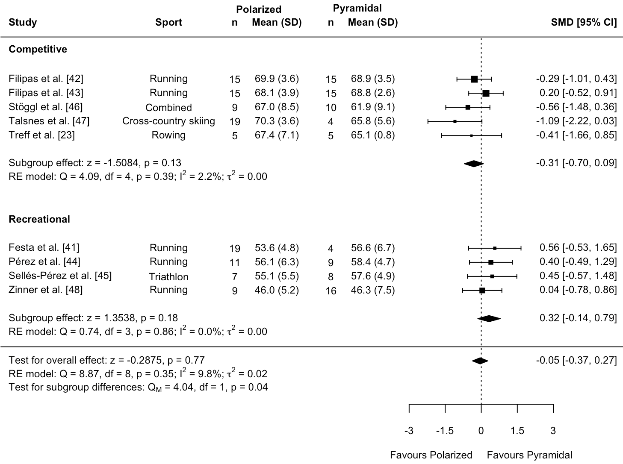

Figure 4. Standardized mean difference (SMD) in maximal oxygen uptake (V̇O_{2peak}) (mL⋅kg⁻¹⋅min⁻¹) between polarized and pyramidal training intensity distribution (TID) models (per-protocol analysis). Mean (SD) values are results for V̇O_{2peak} at follow up. Combined (cross-country skiing, cycling, running, triathlon).

Discussion

General Interpretation of the Results

We performed the first IPD NMA on the effects of different TID models on V̇O_{2peak} and endurance performance. Our main results showed no differences in V̇O_{2peak} or TT performance between POL and any of the other TID models (PYR, THR, HIGH, and LOW). However, we found a significant difference in the response of V̇O_{2peak} between recreational and competitive athletes when quantifying training load by HR TIZ. Competitive athletes may have greater improvements to V̇O_{2peak} with POL, whereas recreational athletes may benefit more from PYR.

The per-protocol analysis of SMD for V̇O_{2peak} and TT performance (Figure 2, D and F) showed greater similarities than for the intention-to-treat results (Figure 2, C and E), suggesting that these results may have been related. V̇O_{2peak} is one of the key determinants of endurance performance [49], although it is often observed that change in V̇O_{2peak} alone is poorly correlated with change in TT performance during short-term training intervention studies or when monitored across a competitive season [50-53]. Using the per-protocol dataset, a linear mixed effect model analysis with random effects for study found no significant effect of the percent change in V̇O_{2peak} on percent change in TT performance (beta = 0.004, 95% CI = -0.16 to 0.17, p = 0.96). Thus, while the per-protocol analysis of V̇O_{2peak} and TT performance did show similar results at the group level (Figure 2, D and F), those changes were not well correlated at the individual level. Longitudinal change in endurance performance can be driven by a number of interrelated factors, including fractional utilization of V̇O_{2peak} at the maximal metabolic steady state (MMSS), gross mechanical efficiency (economy), and peripheral muscle oxidative capacity [54, 55]. Therefore, to obtain a valid indicator that considers these factors, TT performance should be included as an outcome measure to evaluate the effectiveness of endurance training interventions.

When considering performance level, there was a significant difference in the response of V̇O_{2peak} between recreational and competitive athletes. Competitive athletes directionally but non-significantly saw greater improvements to V̇O_{2peak} with POL, while recreational athletes directionally but non-significantly saw greater improvements with PYR (Figure 3). While all participants were endurance-trained, only those who were reported as competing at a university/college, provincial/state, national/international, or professional level were considered competitive. Classification was not made on the basis of V̇O_{2peak}. However, there was a significant difference in baseline V̇O_{2peak} between recreational and competitive subgroups (53 vs 67 mL⋅kg⁻¹⋅min⁻¹, respectively). There were no differences in any other covariates, which is consistent with previous meta-analyses [26, 27, 56]. This suggests that athlete classification may be an important indicator of responsiveness to TID models [28], and should be taken into account when personalizing training interventions.

The MD for V̇O_{2peak} between POL and PYR was -0.11 mL·kg⁻¹·min⁻¹ (95% CI -1.46 to 1.25). This is well within the typical measurement error often reported for V̇O_{2peak} of approximately 1-5% (~50 to 250 mL·min⁻¹ or ~1 to 5 mL·kg⁻¹·min⁻¹) [57-60]. The inability to detect significant differences between TID models may partially be explained by small sample sizes, particularly in the THR, HIGH, and LOW groups. We previously found that a minimum of 81 participants per group would be required to show a significant difference of SMD = 0.44 for change in V̇O_{2peak} between different TID models [27]. In the current review, only POL and PYR exceeded this sample size after re-allocation. This improves the confidence that the observed SMD = 0.06 for V̇O_{2peak} between POL and PYR represents a true non-difference between these two TID. However, the lower sample sizes for the remaining TID groups led to wider confidence intervals for the comparisons between those models (Figure 2). The direction and magnitude of the effect for these intervention groups (THR, LOW, and HIGH) may be as a result of sampling error [61]. Future research will need to ensure sufficient statistical power to detect whether these periodization models have small but potentially important effects on performance outcomes among trained athletes.

Re-allocation of individuals based on completed TID (i.e., per-protocol analysis) tended to reduce the uncertainty around the estimates for V̇O_{2peak} and TT performance. The 95% confidence intervals for SMD between interventions were generally smaller for the per-protocol analyses than for the intention-to-treat analysis. The exception was the LOW group which had only 7 participants for V̇O_{2peak} and 13 for TT performance after re-allocation (reduced from n = 25 and 35, respectively. Figure 2). Athletes prescribed to LOW training groups tended to accumulate a larger than intended volume of HR in Z2, pushing some of them into PYR TID. This may be partly explained by a divergence between HR as internal training load and external load measured with cycling power or running pace [21]. For example, if athletes were prescribed training workloads near their Z1 ceiling, their HR may have drifted into Z2 despite them adhering to the prescribed training. On the other hand, individuals prescribed to HIGH groups also tended to accumulate more HR volume in Z2 than Z3, resulting re-allocation into PYR group (from n = 25 to 16 for V̇O_{2peak}, and n = 13 to 7 for TT performance). Given that the 95% CI of the between-group differences were reduced after re-allocation based on HR, it suggests that monitoring the completed internal training load had less variability when predicting performance outcomes compared to the originally prescribed TID model. Monitoring external training load where available may further improve these results [6], particularly for LOW and HIGH TID models where HR tended to converge toward a more PYR completed distribution.

Additionally, the 95% prediction intervals (PI), which represent the uncertainty of individual observations among the participants, also tended to be smaller after re-allocation. 95% PI for the difference between POL and PYR was SMD = -0.06, 95% PI = -0.40 to 0.28 for V̇O_{2peak}, and SMD = -0.05, 95% PI = -0.40 to 0.30 for TT performance. This is consistent with previous observations that when training is prescribed by individualized intensity zones, the variability in responsiveness to the intervention is reduced [3, 62, 63]. PIs show to the real variability in responses among the population of endurance-trained athletes to different TID models. While there were no detectable differences between TID models at the group level in this review, individual athletes may respond better or worse to a particular intervention within a wide range around the group mean.

The meta-analysis by Rosenblat et al. [12] suggested that POL was associated with improved TT performance in endurance-trained athletes. However, the review did not collect individual participant data or re-allocate based on completed vs intended TID. In addition, three of the studies pooled to compare TT performance included groups described as THR, when in fact they followed a PYR TID [7-9]. Therefore, a reconsideration of these studies would have suggested that POL showed enhanced TT performance compared to PYR, not THR. Furthermore, the analysis was performed by comparing percentage change from baseline. One study performed baseline and follow up testing on different TT courses [8], meaning that this approach would not be valid. A re-analysis of the differences between groups at follow up no longer resulted in a significant difference between groups (SMD = 0.20, 95%CI = -0.46 to 0.87, p = 0.55).

A more recent publication by Silva Oliveira et al. [22] indicated that POL was superior to other exercise interventions. However, the study has several limitations including double counting participants, comparing the change from baseline instead of comparing intervention groups at follow up, pooling results that include both sprint and long distance TTs, and combining all interventions (including strength training) into a single pairwise analysis. Therefore, the results may not accurately represent the effect of POL when compared to other exercise interventions.

Limitations of the Evidence Included in the Review

There were various limitations with the available studies and IPD included in this review. For example, three studies did not include a randomization process [23, 45, 48]. Fewer than 85% of initially allocated participants completed the intervention and follow-up testing [7, 40, 41, 44, 45], meaning the intention-to-treat analysis could not include these participants. For this reason, we considered the intention-to-treat analysis to be the original group allocation, and the per-protocol analysis for the re-allocated groups by completed TID. Several studies did not report the intended TID [10, 23, 44, 45, 47, 48]. Females composed only 15% of participants and were not represented in 7 studies [7, 9, 23, 42-45]), which may limit generalisability of these results to female athletes.

TT test procedures used across studies were particularly heterogenous. Only one study included a familiarization bout [48], likely resulting in wider variability and less ability to detect a significant difference between interventions. Two studies included racing with competitors which may have influenced pacing [8, 40]. One study used different courses for baseline and follow-up testing [8]; one study had markedly different environmental conditions at follow-up [40]; and two studies included TT tests of different distances and times for male and female participants, and pooled the results when analyzing between-group differences [40, 47].

Limitations of the Review Process

A limitation of the available data is the heterogeneity with which different studies classified exercise thresholds and zones and prescribed training intensity [2-5]. As mentioned, internal and external training loads may lead to different estimates for TID [21]. HR is a commonly used metric for internal training load allowing for quantification across multiple sports [6]. The discrepancy between prescribed (both external and internal across the included studies) and completed (internal) TID tended to result in more athletes converging into PYR from both LOW and HIGH TID models when re-allocated by HR, as more time was accumulated in Z2. However, the statistical heterogeneity in the current review was low, re-allocation of groups resulted in smaller confidence intervals around the MD and SMD for V̇O_{2peak} and TT performance, and there were no differences in outcomes between the intention-to-treat and per-protocol analyses. Therefore, monitoring TID by HR improved prediction of performance outcomes, however including external training load may further improve these results.

This review is also limited by the data available regarding the duration and periodization of the training interventions. Training interventions were between 3 and 18 weeks. Individuals completed an average of 385 (198) minutes of training per week. This review did not consider different mesocycle and microcycle training volume distribution within each training intervention. Four studies did not progress training load within the intervention period [9, 23, 40, 47], while four used two weeks of build to one week taper [7, 8, 10, 41] and five used three weeks of build to one week taper [42-45, 48]. Filipas et al. 2022 [37] showed that changing the TID model during a program may influence results. Therefore, we cannot say how differences in mesocycle periodization may have influenced results within 18 weeks, nor can we speculate how results may change over longer seasonal or quadrennial training programmes. Furthermore, the available data did not allow definitive conclusions to be drawn on the relationship between the TID effect and sport specificity, primarily due to small sample sizes. Such associations are not unlikely as the disciplines differ significantly in terms of mechanical load, competition duration, intensity and strength/endurance ratio.

Implications of the Results for Practice and Future Research

Our results indicate that varying performance levels may benefit from distinct training intensity distribution models. Specifically, recreational athletes appear to gain greater benefit to V̇O_{2peak} from a PYR model, whereas competitive athletes show more improved V̇O_{2peak} outcomes with a more POL model. Recreational athletes with less training experience likely have more potential to improve performance under any periodization model, while athletes with more training experience may need more specific stimuli to continue to improve. This discrepancy could suggest that competitive athletes require sufficient amounts of high intensity training combined with large volumes of low intensity training to stimulate further cardiovascular adaptations, especially over shorter time periods which are used in most of the included studies.

Our findings indicate no general difference between POL and PYR models. However, the small sample sizes precluded the determination of the influence of THR training although previous studies claiming to include a threshold approach often tended to follow a PYR model [7-9]. Still, the large use of THR training among elite endurance athletes, sometimes as a substitute for high-intensity training but with larger accumulated volume of intensive training, requires further research on its specific effects. In addition, future studies need to increase sample sizes to achieve more robust conclusions, which was also discussed in our previous review [27]. Larger crowd-sourced studies may be a viable approach to achieving this objective.

Finally, the majority of included studies employed heart rate to monitor exercise intensity and subsequently determine the TID. There are several issues with this method, as previously mentioned [21]. Therefore, to improve accuracy, studies should record external work in addition to internal work, as this provides more precise information regarding exercise intensity. This approach would enhance the accuracy and reproducibility of findings.

Conclusion

The objective of this study was to compare the effects of different TID models on the changes in V̇O_{2peak} and TT performance among endurance-trained athletes, re-allocating individual participant data into their completed TID models based on heart rate as a measurement of internal training load. Among the entire dataset, we observed no differences in V̇O_{2peak} or TT performance between POL and any of the other TID models (PYR, THR, HIGH, and LOW). However, we found a significant difference in the response of V̇O_{2peak} between recreational and competitive athletes when quantifying training load by HR TIZ. This suggests that individual athletes can gain similar endurance performance benefits with different TID models, but that athletes at higher competitive levels with greater training experience might benefit more from a more POL TID model, when internal training load is quantified with heart rate.

Other Information

Registration and Protocol

Not applicable.

Support

No sources of funding were used to assist in the preparation of this article.

Competing Interests

Michael Rosenblat, Jennifer Watt, Jem Arnold, Gunnar Treff, Øyvind Sandbakk, Stephen Seiler, Jonathan Esteve-Lanao, Luca Festa, Luca Filipas, Iker Muñoz, Stuart Galloway, Domingo J. Ramos-Campo, Patrick Schneeweiss, Sergio Sellés-Pérez, Thomas Stöggl, Rune Talsnes, and Christoph Zinner declare that they have no conflicts of interest relevant to the content of this review.

Availability of Data, Code and Other Material

All aggregate data generated or analysed during this study are included in this published article (and its supplementary information files). The IPD for the studies included in the review may be available upon request to the corresponding authors of the respective articles.

Authors’ Contributions

Michael Rosenblat is the project lead, conceived and designed the study, conducted article screening, data extraction, risk of bias analysis, statistical analysis, and manuscript preparation. Jennifer Watt is a member of the project team, participated in the statistical analysis and manuscript preparation. Jem Arnold is a member of the project team, participated in data extraction, risk of bias analysis, and manuscript preparation. Gunnar Treff is a member of the project team, participated in article screening and manuscript preparation. Øyvind Sandbakk is a member of the project team, participated in manuscript preparation. Stephen Seiler is a member of the project team, participated in study design and manuscript preparation. Jonathan Esteve-Lanao, Luca Festa, Luca Filipas, Iker Muñoz, Stuart Galloway, Domingo J. Ramos-Campo, Patrick Schneeweiss, Sergio Sellés-Pérez, Thomas Stöggl, Rune Talsnes, and Christoph Zinner all participated in data extraction and data collection the respective studies included in the review. All authors read and approved the final version of the manuscript.

References

1. Fiskerstrand Å, Seiler KS. Training and performance characteristics among Norwegian International Rowers 1970–2001. Scand J Med Sci Sports. 2004;14(5):303-10.

2. Seiler KS, Kjerland GØ. Quantifying training intensity distribution in elite endurance athletes: is there evidence for an "optimal" distribution? Scand J Med Sci Sports. 2006;16(1):49-56.

3. Iannetta D, Inglis EC, Mattu AT, Fontana FY, Pogliaghi S, Keir DA, Murias JM. A critical evaluation of current methods for exercise prescription in women and men. Med Sci Sports Exerc. 2020;52(2):466-73.

4. Jamnick NA, Pettitt RW, Granata C, Pyne DB, Bishop DJ. An examination and critique of current methods to determine exercise intensity. Sports Med. 2020;50(10):1729-56.

5. Poole DC, Jones AM. Oxygen uptake kinetics. Compr Physiol. 2012;2(2):933-96.

6. Sperlich B, Matzka M, Holmberg H-C. The proportional distribution of training by elite endurance athletes at different intensities during different phases of the season. Front Sports Act Living. 2023;5:1258585.

7. Esteve-Lanao J, Foster C, Seiler S, Lucia A. Impact of training intensity distribution on performance in endurance athletes. J Strength Cond Res. 2007;21(3):943-9.

8. Muñoz I, Seiler S, Bautista J, Espana J, Larumbe E, Esteve-Lanao J. Does polarized training improve performance in recreational runners? Int J Sports Physiol Perform. 2014;9(2):265-72.

9. Neal CM, Hunter AM, Brennan L, O'Sullivan A, Hamilton DL, De Vito G, Galloway SD. Six weeks of a polarized training-intensity distribution leads to greater physiological and performance adaptations than a threshold model in trained cyclists. J Appl Physiol. 2013;114(4):461-71.

10. Stöggl T, Sperlich B. Polarized training has greater impact on key endurance variables than threshold, high intensity, or high volume training. Front Physiol. 2014;5:33.

11. Stöggl TL, Sperlich B. The training intensity distribution among well-trained and elite endurance athletes. Front Physiol. 2015;6:295.

12. Rosenblat MA, Perrotta AS, Vicenzino B. Polarized vs. threshold training intensity distribution on endurance sport performance: a systematic review and meta-analysis of randomized controlled trials. J Strength Cond Res. 2019;33(12):3491-500.

13. Enoksen E, Tjelta AR, Tjelta LI. Distribution of training volume and intensity of elite male and female track and marathon runners. Int J Sports Sci Coach. 2011;6(2):273-94.

14. Muñoz I, Cejuela R, Seiler S, Larumbe E, Esteve-Lanao J. Training-intensity distribution during an ironman season: relationship with competition performance. Int J Sports Physiol Perform. 2014;9(2):332-9.

15. Neal CM, Hunter AM, Galloway SD. A 6-month analysis of training-intensity distribution and physiological adaptation in Ironman triathletes. J Sports Sci. 2011;29(14):1515-23.

16. Tjelta LI, Enoksen E. Training characteristics of male junior cross country and track runners on European top level. Int J Sports Sci Coach. 2010;5(2):193-203.

17. Billat VL, Demarle A, Slawinski J, Paiva M, Koralsztein JP. Physical and training characteristics of top-class marathon runners. Med Sci Sports Exerc. 2001;33(12):2089-97.

18. Kenneally M, Casado A, Gomez-Ezeiza J, Santos-Concejero J. Training intensity distribution analysis by race pace vs. physiological approach in world-class middle- and long-distance runners. Eur J Sport Sci. 2021;21(6):819-26.

19. van Erp T, Sanders D, de Koning JJ. Training characteristics of male and female professional road cyclists: a 4-year retrospective analysis. Int J Sports Physiol Perform. 2020;15(4):534-40.

20. Ieno C, Baldassarre R, Pennacchi M, La Torre A, Bonifazi M, Piacentini MF. Monitoring rating of perceived exertion time in zone: a novel method to quantify training load in elite open-water swimmers? Int J Sports Physiol Perform. 2021;16(10):1551-5.

21. Sylta Ø, Tønnessen E, Seiler S. From heart-rate data to training quantification: a comparison of 3 methods of training-intensity analysis. Int J Sports Physiol Perform. 2014;9(1):100-7.

22. Silva Oliveira P, Boppre G, Fonseca H. Comparison of polarized versus other types of endurance training intensity distribution on athletes' endurance performance: a systematic review with meta-analysis. Sports Med. 2024;Online ahead of print.

23. Treff G, Winkert K, Sareban M, Steinacker JM, Becker M, Sperlich B. Eleven-week preparation involving polarized intensity distribution is not superior to pyramidal distribution in national elite rowers. Front Physiol. 2017;8:515.

24. Riley RD, Debray TPA, Fisher D, Hattle M, Marlin N, Hoogland J, et al. Individual participant data meta-analysis to examine interactions between treatment effect and participant-level covariates: Statistical recommendations for conduct and planning. Stat Med. 2020;39(15):2115-37.

25. Hutton B, Salanti G, Caldwell DM, Chaimani A, Schmid CH, Cameron C, et al. The PRISMA extension statement for reporting of systematic reviews incorporating network meta-analyses of health care interventions: checklist and explanations. Ann Intern Med. 2015;162(11):777-84.

26. Rosenblat MA, Lin E, da Costa BR, Thomas SG. Programming interval training to optimize time-trial performance: a systematic review and meta-analysis. Sports Med. 2021;51(8):1687-714.

27. Rosenblat MA, Arnold J, Nelson H, Watt J, Seiler S. The additional effect of training above the maximal metabolic steady state on VO2peak, Wpeak and time-trial performance in endurance-trained athletes: a systematic review, meta-analysis, and reality check. Sports Med. 2024;54:429-46.

28. McKay AK, Stellingwerff T, Smith ES, Martin DT, Mujika I, Goosey-Tolfrey VL, et al. Defining training and performance caliber: a participant classification framework. Int J Sports Physiol Perform. 2021;17(2):317-31.

29. Treff G, Winkert K, Sareban M, Steinacker JM, Sperlich B. The polarization-index: a simple calculation to distinguish polarized from non-polarized training intensity distributions. Front Physiol. 2019;10:707.

30. Sterne JA, Savovic J, Page MJ, Elbers RG, Blencowe NS, Boutron I, et al. RoB 2: a revised tool for assessing risk of bias in randomised trials. BMJ. 2019;366:l4898.

31. Hedges L, Olkin I. Statistical methods for meta-analysis. New York, NY: Academic Press; 1981.

32. R Core Team. R: A Language and Environment for Statistical Computing. 4.3.3 ed. Vienna, Austria: R Foundation for Statistical Computing; 2024.

33. Balduzzi S, Rücker G, Nikolakopoulou A, Papakonstantinou T, Salanti G, Efthimiou O, Schwarzer G. netmeta: An R package for network meta-analysis using frequentist methods. J Stat Softw. 2023;106(2).

34. Riley RD, Tierney JF, Stewart LA. Individual participant data meta-analysis: a handbook for healthcare research. Chichester, UK: Wiley; 2021.

35. DerSimonian R, Laird N. Meta-analysis in clinical trials. Control Clin Trials. 1986;7(3):177-88.

36. Higgins JP, Jackson D, Barrett JK, Lu G, Ades AE, White IR. Consistency and inconsistency in network meta-analysis: concepts and models for multi-arm studies. Res Synth Methods. 2012;3(2):98-110.

37. Dias S, Welton NJ, Caldwell DM, Ades AE. Checking Consistency in Mixed Treatment Comparison Meta-Analysis. Stat Med. 2010;29(7-8):932-44.

38. Chaimani A, Salanti G. Using network meta-analysis to evaluate the existence of small-study effects in a network of interventions. Res Synth Methods. 2012;3(2):161-76.

39. Viechtbauer W. Conducting meta-analyses in R with the metafor package. J Stat Softw. 2010;36(3):1-48.

40. Schneeweiss P, Schellhorn P, Haigis D, Niess AM, Martus P, Krauss I. Effect of two different training interventions on cycling performance in mountain bike cross-country Olympic athletes. Sports. 2022;10(4):53.

41. Festa L, Tarperi C, Skroce K, La Torre A, Schena F. Effects of different training intensity distribution in recreational runners. Front Sports Act Living. 2019;1:70.

42. Filipas L, Bonato M, Gallo G, Codella R. Effects of 16 weeks of pyramidal and polarized training intensity distributions in well-trained endurance runners. Scand J Med Sci Sports. 2022;32(3):498-511.

43. Filipas L, Bonato M, Maggio A, Gallo G, Codella R. Effects of plyometric training on different 8-week training intensity distributions in well-trained endurance runners. Scand J Med Sci Sports. 2023;33(3):200-12.

44. Pérez A, Ramos-Campo DJ, Freitas TT, Rubio-Arias JÁ, Marín-Cascales E, Alcaraz PE. Effect of two different intensity distribution training programmes on aerobic and body composition variables in ultra-endurance runners. Eur J Sports Sci. 2019;19(5):636-44.

45. Sellés-Pérez S, Fernández-Sáez J, Cejuela R. Polarized and pyramidal training intensity distribution: relationship with a half-ironman distance triathlon competition. J Sports Sci Med. 2019;18(4):708-15.

46. Stöggl TL, Björklund g. High intensity interval training leads to greater improvements in acute heart rate recovery and anaerobic power as high volume low intensity training. Front Physiol. 2017;8:562.

47. Talsnes RK, Engdahl LJ, Sandbakk Ø. How do the effects of an 8-week intervention influence subsequent performance development in cross-country skiers? Int J Sports Physiol Perform. 2022;17(4):594-604.

48. Zinner C, Schafer Olstad D, Sperlich B. Mesocycles with different training intensity distribution in recreational runners. Med Sci Sports Exerc. 2018;50(8):1641-8.

49. Joyner MJ, Coyle EF. Endurance exercise performance: the physiology of champions. J Physiol. 2008;586(1):35-44.

50. Christensen PM, Andreasen JJ, Lyngholm J, Søgaard O, Lykkestrup J, Hostrup M, et al. Importance of training volume during intensified training in elite cyclists: maintained vs. reduced volume at moderate intensity. Scand J Med Sci Sports. 2024;34(1):e14362.

51. Legaz Arrese A, Serrano Ostáriz E, Jcasajús Mallén JA, Munguía Izquierdo D. The changes in running performance and maximal oxygen uptake after long-term training in elite athletes. J Sports Med Phys Fitness. 2005;45(4):435-40.

52. Losnegard T, Myklebust H, Spencer M, Hallén J. Seasonal variations in VO2max, O2-cost, O2-deficit, and performance in elite cross-country skiers. J Strength Cond Res. 2013;27(7):1780-90.

53. Ramsbottom R, Williams C, Fleming N, Nute ML. Training induced physiological and metabolic changes associated with improvements in running performance. Br J Sports Med. 1989;23(3):171-6.

54. Batterson PM, Norton MR, Hetz SE, Rohilla S, Lindsay KG, Subudhi AW, Jacobs RA. Improving biologic predictors of cycling endurance performance with near-infrared spectroscopy derived measures of skeletal muscle respiration: E pluribus unum. Physiol Rep. 2020;8(2):e14342.

55. Jacobs RA, Rasmussen P, Siebenmann C, Diaz V, Gassmann M, Pesta D, et al. Determinants of time trial performance and maximal incremental exercise in highly trained endurance athletes. J Appl Physiol. 2011;111(5):1422-30.

56. Rosenblat MA, Granata C, Thomas SG. Effect of interval training on the factors influencing maximal oxygen consumption: a systematic review and meta-analysis. Sports Med. 2022;52(6):1329-52.

57. Amann M, Subudhi AW, Walker J, Eisenman P, Shultz B, Foster C. An evaluation of the predictive validity and reliability of ventilatory threshold. Med Sci Sports Exerc. 2004;36(10):1716-22.

58. Van Hooren B, Souren T, Bongers BC. Accuracy of respiratory gas variables, substrate, and energy use from 15 CPET systems during simulated and human exercise. Scand J Med Sci Sports. 2023;34(1):e14490.

59. Weston SB, Gabbett TJ. Reproducibility of ventilation of thresholds in trained cyclists during ramp cycle exercise. J Sci Med Sport. 2001;4(3):357-66.

60. Yogev A, Arnold J, Nelson H, Clarke DC, Guenette JA, Sporer BC, Koehle MS. Comparing the reliability of muscle oxygen saturation with common performance and physiological markers across cycling exercise intensity. Front Sports Act Living. 2023;5:1143393.

61. Lin L. Bias caused by sampling error in meta-analysis with small sample sizes. PLoS One. 2018;13(9):e0204056.

62. Bossi AH, Cole D, Passfield L, Hopker J. Conventional methods to prescribe exercise intensity are ineffective for exhaustive interval training. Eur J Appl Physiol. 2023;123(8):1655-70.

63. Meyler S, Bottoms L, Wellsted D, Muniz‐Pumares D. Variability in exercise tolerance and physiological responses to exercise prescribed relative to physiological thresholds and to maximum oxygen uptake. Experimental Physiology. 2023;108(4):581-94.

