This article has been accepted for publication in Tobacco Control following peer review.

The definitive copyedited, typeset version Moodie, C., & Alexandrou, G. (2026). Giving them away while they can: Free nicotine pouches in Scotland is available online at: https://doi.org/10.1136/tc-2026-060285

© Authors (or their employer(s)) 2026.Reuse of this manuscript version (excluding any databases, tables, diagrams, photographs and other images or illustrative material included where a another copyright owner is identified) is permitted strictly pursuant to the terms of the Creative Commons Attribution-NonCommercial 4.0 International (CC-BY-NC 4.0) http://creativecommons.org

Title: Giving them away while they can: Free nicotine pouches in Scotland

Authors: Crawford Moodie, Georgia Alexandrou

Affiliation: Institute for Social Marketing and Health, Faculty of Health Sciences and Sport, University of Stirling, Stirling, FK9 4LA, UK

Corresponding author: Dr Crawford Moodie, Institute for Social Marketing and Health, Faculty of Health Sciences and Sport, University of Stirling, Stirling, FK9 4LA, UK. Email: c.s.moodie@stir.ac.uk Telephone: +44 (0)1786 466456.

ORCID:
Crawford Moodie 0000-0002-1805-2509
Georgia Alexandrou 0009-0004-8084-2116

Free product samples are a powerful marketing strategy. They allow people to try new products without immediate financial outlay, help build brand awareness and may foster customer loyalty.¹ Free sampling functions as a form of experiential marketing, which can lead to more positive product-related attitudes and beliefs.^{2,3} It can encourage engagement with a product category, increase the likelihood of making a purchase,⁴ and ultimately improve sales.¹ It is a longstanding promotional strategy of tobacco companies⁵ and one that can have an impact given research has found that among adolescents receiving free tobacco or e-cigarette samples is associated with higher susceptibility,⁶ ever use, past 30-day use and new product use.⁷
In Scotland we identified, in June 2026, several nicotine pouch brands (Nordic Spirit, Ubbs, Velo, XQS, Zyn, 4NX) offering a free sample for new customers signing up online, and adverts for a free can of Nordic Spirit on social media (YouTube). We have also received free nicotine pouch samples when purchasing from some online nicotine pouch retailers (e-commerce platforms selling a wide range of nicotine pouch brands), and there have been reports of free nicotine pouch samples in train stations.⁸
What has not been reported in Scotland, or elsewhere, is the availability of free nicotine pouch samples in shops. Between March and April 2026 we visited 158 shops within the city centres of Glasgow (n=57), Aberdeen (n=32), Dundee (n=27), Edinburgh (n=22), and Stirling (n=20), the most populated cities in Scotland. Each city centre, as defined by local councils, is divided into Data Zones (small areas typically with 500-1000 residents). We randomly selected Data Zones in each city and visited all shops within these zones that may sell nicotine pouches. We identified free samples of Zone nicotine pouches in shops in Dundee, Edinburgh, Glasgow and Stirling. While launched by Imperial Brands as ZoneX in 2020 in a limited number of stores,⁹ Zone was not rolled out until the end of 2025, after ‘extensive research and product development’.¹⁰ The sample packs contained four pouches (see Figure 1), with a shop worker informing us that he was requested by an Imperial Brands representative to distribute them to young adults, irrespective of whether they used nicotine.

Figure 1: Zone nicotine pouch sample packs
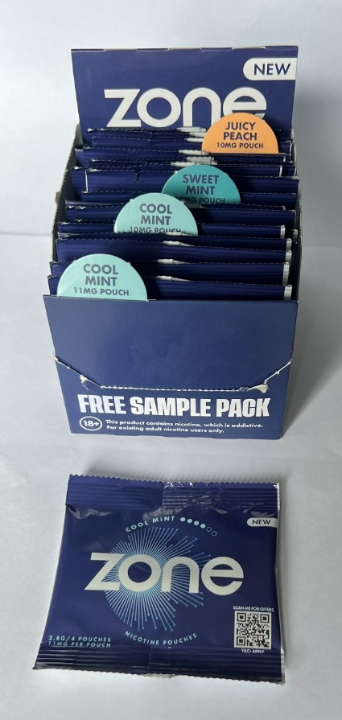
Imperial Brands were not the only company offering free samples. We identified four-pouch Nordic Spirit sample packs in a shop in Aberdeen (Figure 2). The packs are similar to the Zone sample packs and also the five-pouch pocket packs for Nordic Spirit in the Philippines,¹¹ an affordable discreet format that may also appeal to younger people or encourage trial.

Figure 2: Nordic Spirit nicotine pouch sample packs
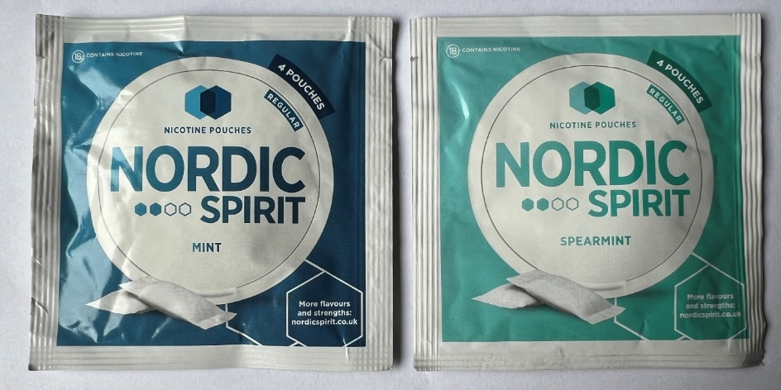

Japan Tobacco International appear, based on our observations, to be the most active company with free retail pouch samples in Scotland. Adverts for a free can of Nordic Spirit Raspberry or Sweet Mint were visible on shop windows and in-store in Dundee, Edinburgh and Glasgow. One advert in-store required individuals to scan a QR code (either to receive a message by SMS or WhatsApp) and reply with the code on the advert (Figure 3). Doing so prompted a message from the Nordic Partnership Programme explaining that this should be presented to the shopkeeper to receive the free sample. A subsequent message gave the option of opting-in to Nordic Spirit marketing. We identified a different offer for Nordic Spirit in Dundee, prominently displayed at the retail counter, which again required a QR code to be scanned for a free can of any Nordic Spirit variant. Despite the marketing materials for two of the Nordic Spirit offers, and the Zone sample packs, stating that the product was ‘for existing adult nicotine users only’, there was no mention of this in the Nordic Partnership Programme communication and no request about our nicotine use from any retail staff.

Figure 3: Advert used in-store for free can of Nordic Spirit
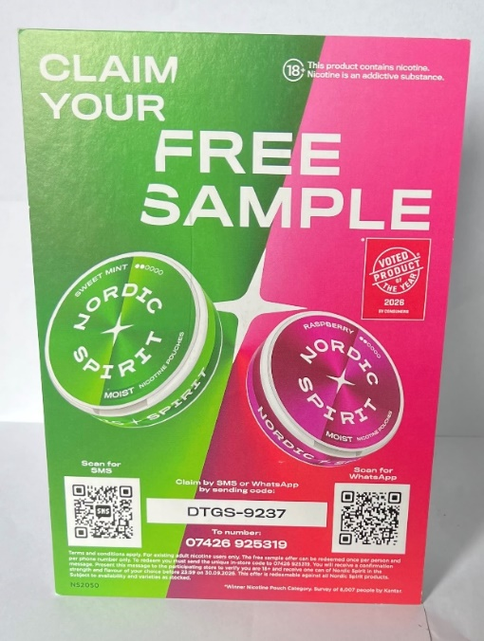
We also identified a Velo sample offer in Glasgow. Sampling staff for British American Tobacco (BAT) who had a pop-up stand in a convenience store explained that they were promoting Velo nicotine pouches and Vuse vapes, two BAT brands. After asking about cigarette and vape use, they offered a free sample of Velo nicotine pouches (Figure 4).

Figure 4: Free Velo sample
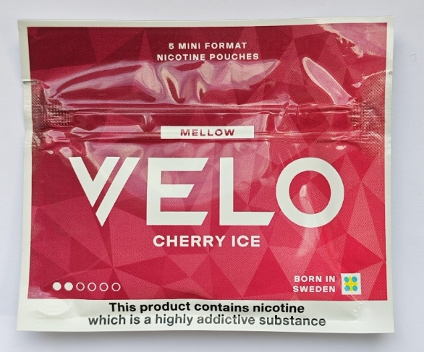

In Scotland and across the United Kingdom the Tobacco and Vaping Act will ban free samples in October 2026. For the many governments yet to regulate nicotine pouches,¹² companies will likely take advantage of this regulatory gap to encourage product trial.

Contributors: CM and GA conceived and drafted the manuscript. CM is guarantor.
Funding: This project was funded by the Chief Scientist Office (CSO) of the Scottish Government (CSO Project Reference: HIPS/25/20).
Competing interests: None.
Patient consent for publication: Not applicable.
Provenance and peer review: Not commissioned, externally peer reviewed.

References
1. Bawa K, Shoemaker R. The effects of free sample promotions on incremental brand sales. Market Sci 2004;23(3):345-63.
2. Heitzler CD, Asbury LD, Kusner SL. Bringing “play” to life: the use of experiential marketing in the VERB™ campaign. Am J Prev Med 2008;34(6):S188-93.
3. Moore ES, Lutz RJ. Children, advertising, and product experiences: A multimethod inquiry. J Consum Res 2000;27(1):31-48.
4. Heilman CM, Lakishyk K, Radas S. An empirical investigation of in-store sampling promotions. Br J Manag 2011;22(4):723-42.
5. Davis RM, Jason LA. The distribution of free cigarette samples to minors. Am J Prev Med 1988;4(1):21-6.
6. Altman DG, Levine DW, Coeytaux R, Slade J, Jaffe R. Tobacco promotion and susceptibility to tobacco use among adolescents aged 12 through 17 years in a nationally representative sample. Am J Public Health 1996;86(11):1590-3.
7. Donaldson EA, Robinson JN, Zarndt AN. Association between free tobacco product sample receipt and tobacco use in youth and adults in the PATH Study, 2014–2016. Prev Med 2020;131:105951.
8. Colter J. Alarm as free nicotine pouches handed out at Scottish train station. The National,
21 February 2025. www.thenational.scot/news/24952280.alarm-free-nicotine-pouches-handed-scottish-train-station/?callback=in&code=MTVIZDYYZDITYJFKZS0ZYMYXLWFJZGYTMZUWODKWZDZMYJM5&state=352118fa03384c75ab983d3e20e31bd9
9. Better Retailing. Imperial Tobacco launches ZoneX nicotine pouches in Booker trial. Better Retailing, 26 February 2020. www.betterretailing.com/zonex-nicotine-pouches/#:~:text=Nicotine/%20Product%20News-,EXCLUSIVE:%20Imperial%20Tobacco%20launches%20ZoneX%20nicotine%20pouches%20in%20Booker%20trial,1%20min%20read
10. Scottish Grocer and Convenience Retailer. Imperial Brands moves into the nicotine pouch Zone. Scottish Grocer and Convenience Retailer, 27 November 2025. https://scottishgrocer.co.uk/2025/11/27/imperial-brands-moves-into-the-nicotine-pouch-zone/#:~:text=Andrew%20Malm%2C%20UK%20market%20manager,'%20current%20nicotine%20pouch%20offer.%E2%80%9D
11. Donahue T. Nordic Spirit Booming in Philippines. Tob Asia, 15 July 2025.
www.tobaccoasia.com/news/nordic-spirit-booming-in-philippines/
12. Duren M, Atella L, Welding K, Kennedy RD. Nicotine pouches: a summary of regulatory approaches across 67 countries. Tob Control 2024;33(e1):e32-40.

